Configuring

Internet Connection Sharing

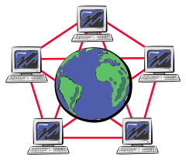



Synopsis:

This lab takes you through the steps in connecting several PCs using straight through cables and a HUB. You will be working in a group environment in which each person will be responsible for configuring his or her own workstation. However cooperation is needed between group members to decide on global settings. Initially, you will build a simple peer-to-peer. Then you will reconfigure one of the workstations to provide access to the Internet for the other computer(s) on your network.

Materials/Conditions Required:

This lab will require the following:

At least 4, Windows 2000 Server PC's each equipped with at least two network interface card. (If you are performing this in the CET lab, these cards are already installed).

2 network switches or hubs with a free port for each computer (the CET lab provides one 10Mb hub that's mounted on the bench).

A straight-thru (CAT-3 grade or better) twisted-pair network cable terminated with RJ-45 connectors for each computer. And one crossover cable to connect the two pc-routers

Verify initial configuration

- Before configuring the workstation, write in the table below the initial configuration.

IP Address
Subnet Mask
MAC Address
Default Gateway
DNS Server

Change the Computer Name

- Boot up into Windows 2000 Server

- Follow the next step to change your computer name to something unique. The computer name should have six characters. The first three should be VCC. The last three should be the value of your last octet in your IP address. Use the IPCONFIG to check your IP Address.

- Click on the Start>>Settings>>Control Panel>>System. Next click on Properties and enter the new name in the Computer Name field. You will need to restart the PC.

Identify and Configure the NIC Card

Each PC has three NIC cards installed. You need to identify all three NIC cards in order to Enable and Disable the appropriate cards. One NIC card is connected to the Valencia Campus Network. The other two cards are connected to the jacks on the bench. There is a top jack and a bottom jack that corresponds to each PC.

- From the Desktop, right click on My Network Places and select Properties.

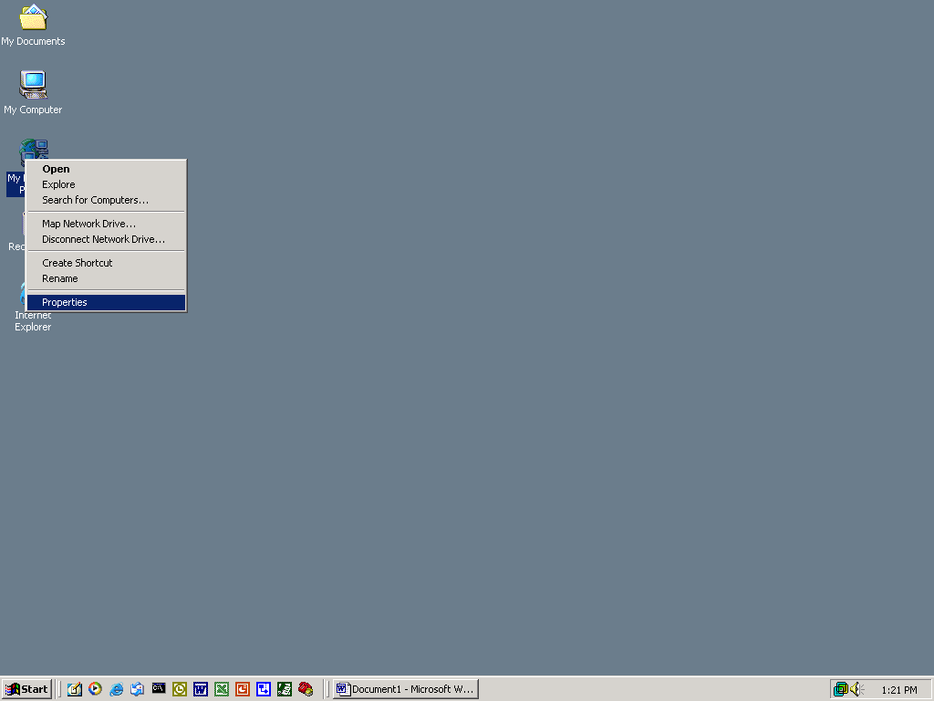

- After clicking on Properties you should see the Network and Dial Up Connections window.

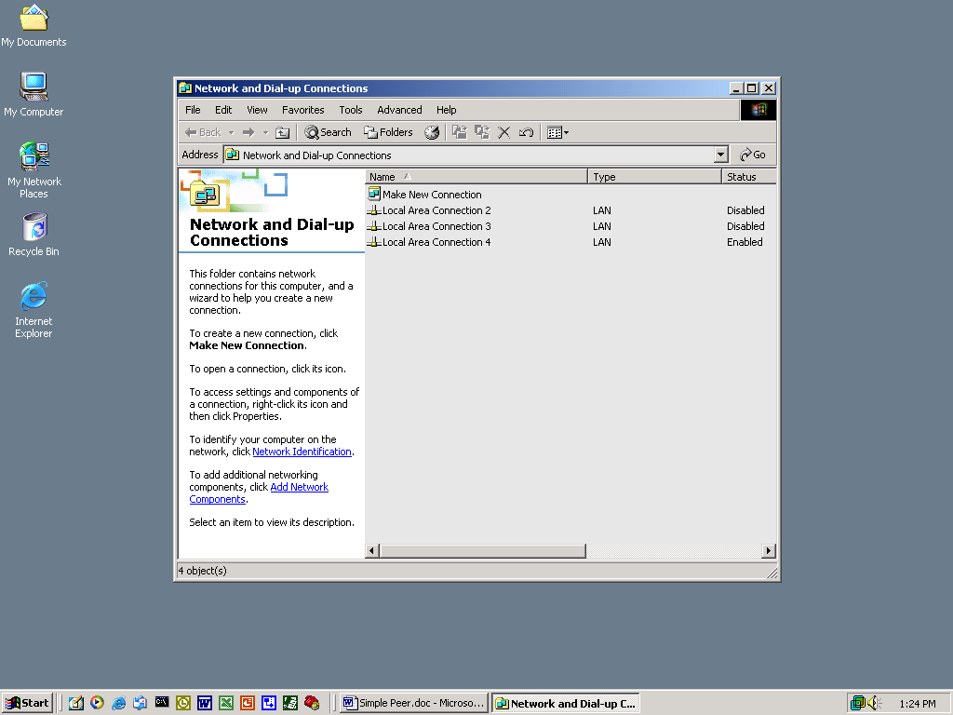

- Note that the window displays three connections. Each connection refers to each of the installed NIC cards. Local Area Connection 4 (hereafter referred to as LAC4) is the connection to the Valencia network. You can tell from the Properties window that LAC4 is enabled and LAC2 and LAC3 are disabled.
  - Local Area Connection - Top Jack connection
  - Local Area Connection 2- Bottom Jack connection
  - Local Area Connection 3 - Valencia Network

- We will be using the top jack to connect our Peer-To-Peer network. Proceed to disable LAC3 by right clicking on LAC3 and selecting Disable.

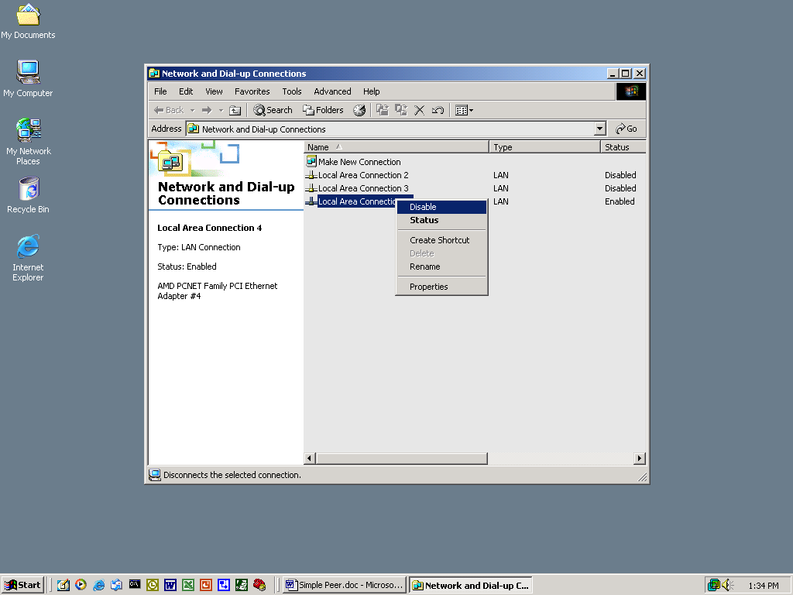

- Now right click on LAC and select Properties. This should open the LAC Properties window.

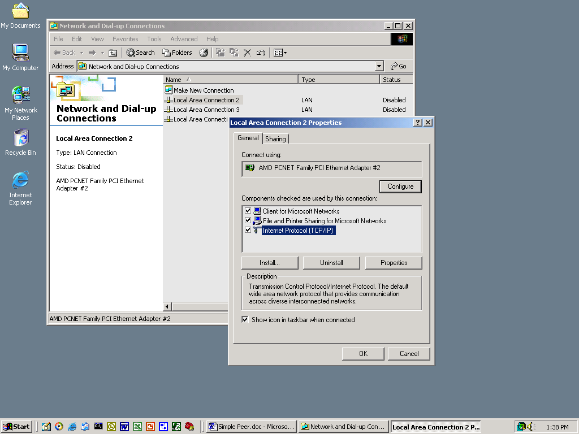

- The LAC Properties window contains installed components. We will be configuring the TCP/IP protocol. In order for TCP/IP to work within a LAN segment, we need to configure an IP address and subnet mask.

- Select Internet Protocol (TCP/IP) from the LAC Properties window and then click on Properties. This should open the Internet Protocol (TCP/IP) Properties window.

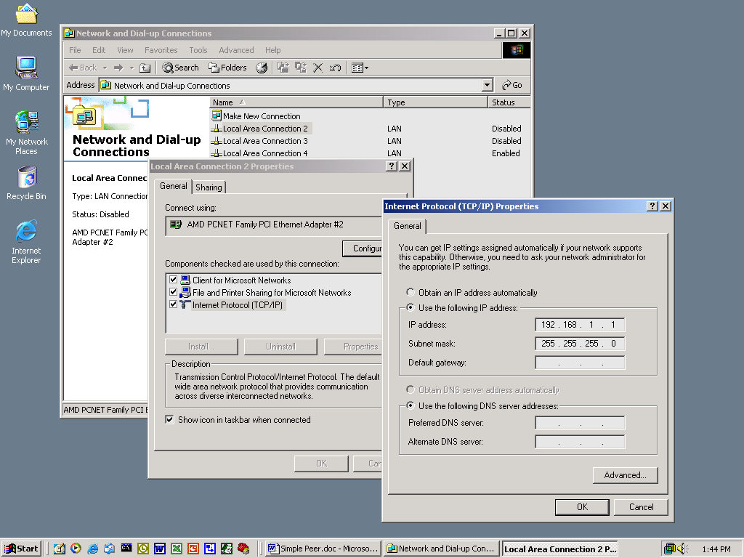

- Re-configure the IP address and subnet mask. Based on what you know so far about TCP/IP, choose an IP address from one of the following:

192.168.16.1
192.168.16.2
192.168.16.3
192.168.16.4
Subnet Mask: 255.255.255.0

Click OK on the Internet protocol Properties window
Click OK on the LAC Properties window

- Next, from the Network and Dial Up connection window, right click on LAC and select Enable.

- Now make sure that your changes have taken places. Open a command prompt window and use the IPCONFIG /all command to check your configuration.

- Write down your configuration.

IP Address ________________
Subnet Mask _________________

Peer To Peer

In this section you will connect your PC to the nearest hub. As in previous labs, you will need to connect two hubs back-to-back. Your goal is to build a peer-to-peer network with 4 workstations.

- Connect your PC to the nearest HUB.

- Using a crossover cable, connect your HUB to the HUB of the closest group. By doing this, you expand your 2 PC peer-to-peer network to a 4 PC peer-to-peer network.

- Using the PING utility try to establish connectivity to all PCs.

Were you successful? _____
If not why?
________________________________________________________________________________________________________________________________________________________________________________________________________________________________________________________________

- Enter the IP Address and MAC address of each PC on your network

IP Address | MAC Address

- Your network at this point should consist of four PCs and two HUBS. However you do not have access to the Internet. (open Internet Explorer, you should not be able to connect to the Interent).

Internet Connection Sharing

This section will provide instruction on reconfiguring a workstation with ICS. The workstation is acting like a router using NAT. Even though only one workstation must be re-configured to provide ICS, all other workstations will be affected by the change. They too must be re-configured if they intend on accessing the Internet.

- As a group, decide which of the workstations will be re-configured to provide access to the Internet. This station ( and this station only) will be configured with Internet Connection Sharing Services as follows:

- From the desktop, right click on My Network Places and select Properties.

- After clicking on Properties you should see the Network and Dial Up Connections window.

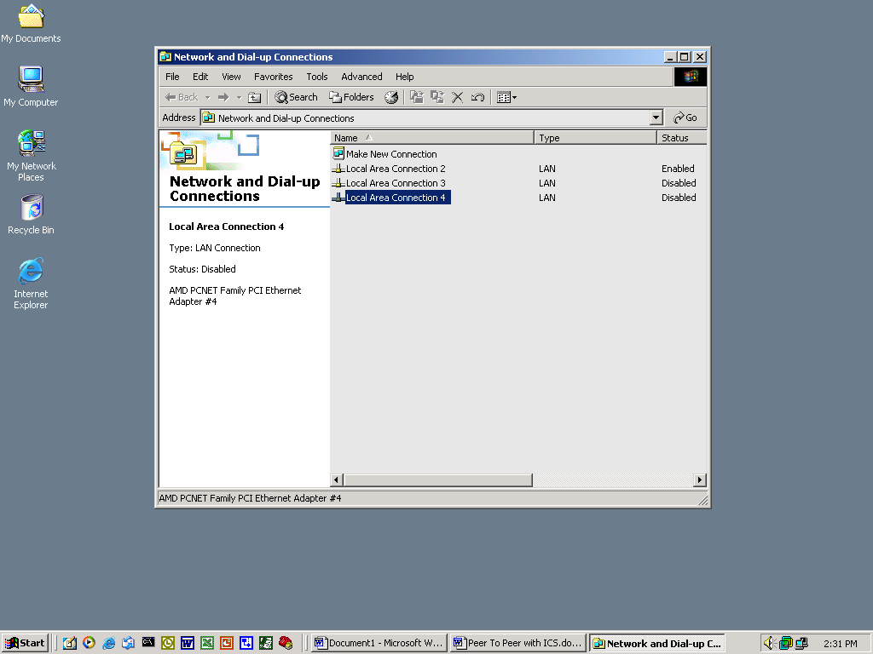

- Note that the window displays three connections. Each connection refers to each of the installed NIC cards. Local Area Connection 3 is the connection to the Lab's network.

- Right click on LAC3 and select Enabled. Both LAC and LAC3 must be enabled.

- LAC is the interface that is connected to the peer-to-peer network (Local Network) and LAC3 is the interface that is connected to the Lab's Network (simulates a WAN connection just like your dialup or broad band connection at home). Traffic from the local network will make its way to the LAC interface. If this traffic is outward bound to the Internet the re-configured workstation will route the traffic out LAC3.

- During the course of enabling ICS. You will be prompt by the workstation to confirm your action. Take note of the message for ICS will reconfigure your LAC IP Address. You will need to re-configure your LAC interface after you are done enabling ICS.

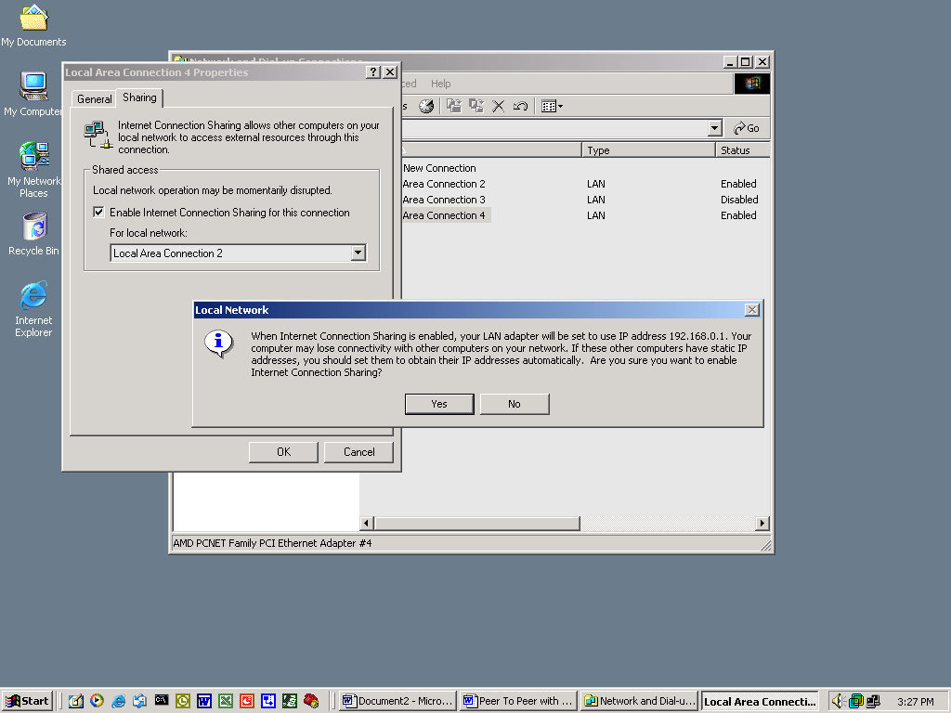

- Right click on LAC3 and select Properties. Then click on the tab called Sharing.

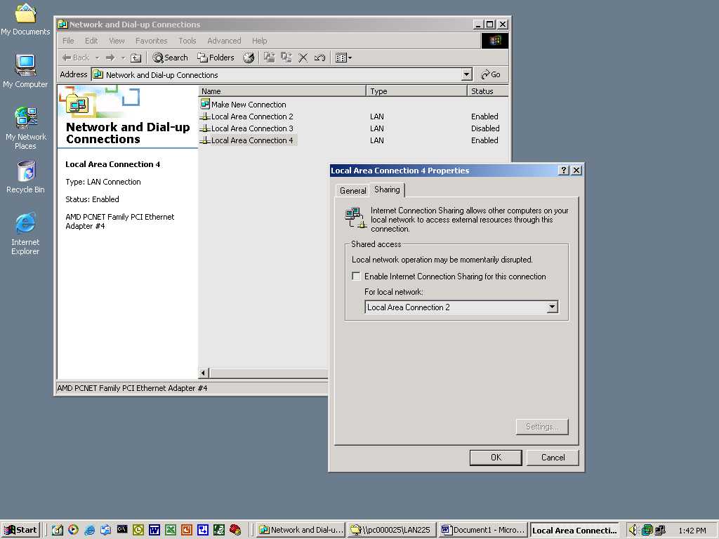

- Check the box label Enable Internet Connection Sharing for this Connection

- Next from the same window, use the pull down menu to select LAC for the local network.

- You have just configured ICS. LAC is configured automatically by a DHCP server. You will not need to make any changes to LAC3. Record the following information For the ICS server:

Local Area Connection 3
IP Address
Subnet Mask
Default Gateway
DNS Server

Local Area Connection
IP Address
Subnet Mask
Default Gateway
DNS Server

Re-configuring Workstations to access the Internet

What three things does TCP/IP need in order for a workstation in one LAN Segment to access a different LAN Segment?

Answer

- Check your workstations TCP/IP configuration which you assigned statically before. Does it need to be changed and why? ______________________________________________________
- The ICS server will also act as a DHCP server. For your workstation to dynamically obtain an IP address from the DHCP server select “obtain an IP address automatically” from the TCP/IP properties window of your local area connection. (only workstations will do this step).

- Using the PING utility try to establish connectivity to all the PCs in your network and write their IP Address in the table below. Make sure you ping both interfaces (LAC and LAC3) of the workstation that is acting as a ICS server.

IP Address

- Do not continue unless you have established connectivity with all workstations in your Peer To Peer

- Open an Internet Explorer window.

- In the URL enter www.yahoo.com

Are you able to view the web page? _____

- Now type the following IP Address in the URL 216.109.125.71

Are you able to view the web page? _____

- Enter a DNS server IP Address for LAC. Use the DNS server IP you obtained in step one at the beginning of the lab.

- In the URL enter www.yahoo.com

- Are you able to view the web page? _____

Name:_____________________ Class:_____________
Date:______________________

Review Questions

1. List the three main services that are automatically started on a server that is configured with Internet Connection Sharing:
a.______________________________
b.______________________________
c.______________________________

2. Describe the function of Network Address Translation:

3. What is the importance of a DNS server?

4. What is the purpose of the default Gateway?

5 . Why were you able to access the web server when you used the IP Address instead of the Domain Name of the web sever?

