Using routers to segment

Local Area Networks

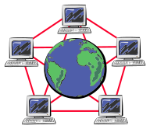


Synopsis:

This lab takes you through the steps required to install and configure a router to segment a network. Two Windows 2000 Server-based PC’s will be configured as routers. You will be working in a group environment in which each student will be responsible for configuring his or her own computer. However cooperation is needed between group members to decide on global settings (settings that must be communicated and agreed upon between group members).

Materials/Conditions Required:

This lab will require the following:

At least four, Windows 2000 Server-based PC's each equipped with at least two network interface card. (If you are performing this in the CET lab, these cards are already installed).

2 network switches or hubs with a free port for each computer (the CET lab provides one 10Mb hub that's mounted on the bench).

A straight-thru (CAT-3 grade or better) twisted-pair network cable terminated with RJ-45 connectors for each computer. A crossover cable to connect the two PC-routers

Topology

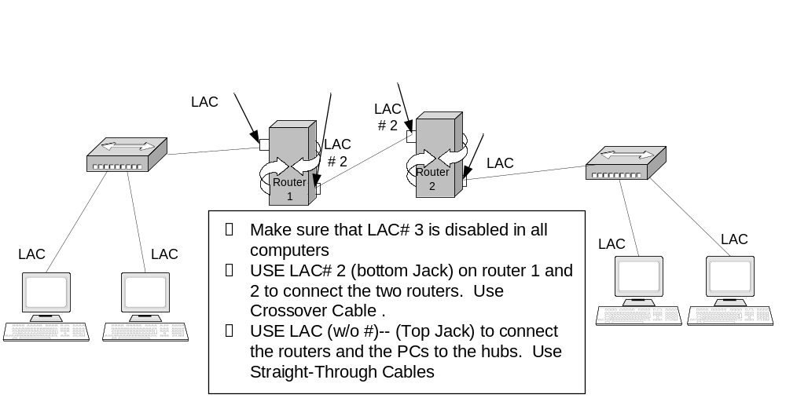
Subnetting
- Determine how many segments exist in the above topology and accordingly proceed to subnet the following network address to provide the needed sub networks. Network address => 193.25.25.0
  - How many bits were borrowed________________________
  - How many subnets were created_______________________
  - How many hosts per subnet were created_________________
  - What is the bit mask now_____________________________
  - What is the subnet mask now_________________________
  - List the subnets in the following table
Sub network | First Usable | Last Usable | Broadcast

- Change the NetBIOS name on the two routers to Router 1, and Router 2

- Connect devices as indicated in the topology

- You have also decided to use the first available subnet to address the segment between the two routers (use the first available IP on Router 1 and the second available IP on Router 2). And to use the second available subnet to address Router 1’s LAN segment (Use the first available IP address for the router). And to use the third available subnet to address the Router 2’s LAN segment (Use the first available IP address for the router). Accordingly, complete the following table:

 | Router1’s NIC# 2 | Router1’s NIC | Router2’s NIC# 2 | Router2’s NIC | Your PC’s NIC
IP address
Subnet Mask
Default Gateway | N/A | N/A | N/A | N/A

- Configure the NIC(s) using the information you documented on the above table.
- Use the ipconfig /all utility to check on the TCP/IP properties. Notice that both pc-routers have total of two configured NICs.
- Test the connectivity between devices by doing the following:

  - Ping your neighbor’s PC on the same LAN. Was the Ping successful? If not troubleshoot.
  - Ping your default gateway. Was the Ping successful? If not troubleshoot.
  - Ping any of the two stations on the remote LAN. The Ping should fail! Why? _________________________________________

Router

In this section you will configure two of the computers running Windows 2000 Server into Routers. Each router must have two Network Interface Cards enabled. We will be using Local Area Connection and Local Area Connection# 2. By now both NIC’s on each router should be configured with an IP address and subnet mask.

- Enable Routing and Remote Access. (Only routers will perform this step) Go to Start>>Control Panel>>Administrative Tools>>Routing and Remote access.

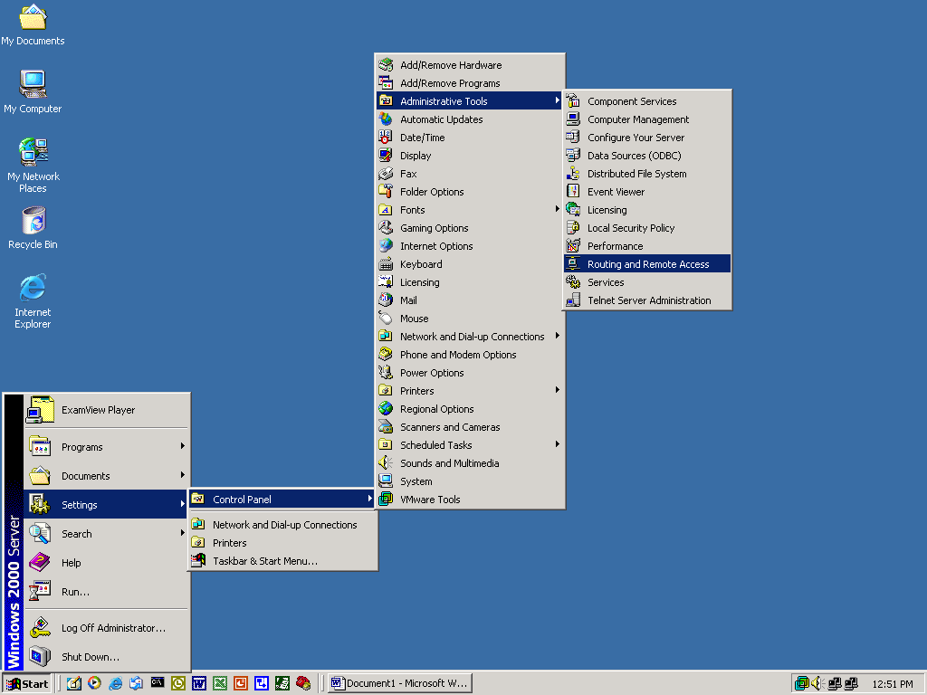

- This should open the Routing and Remote Access window.

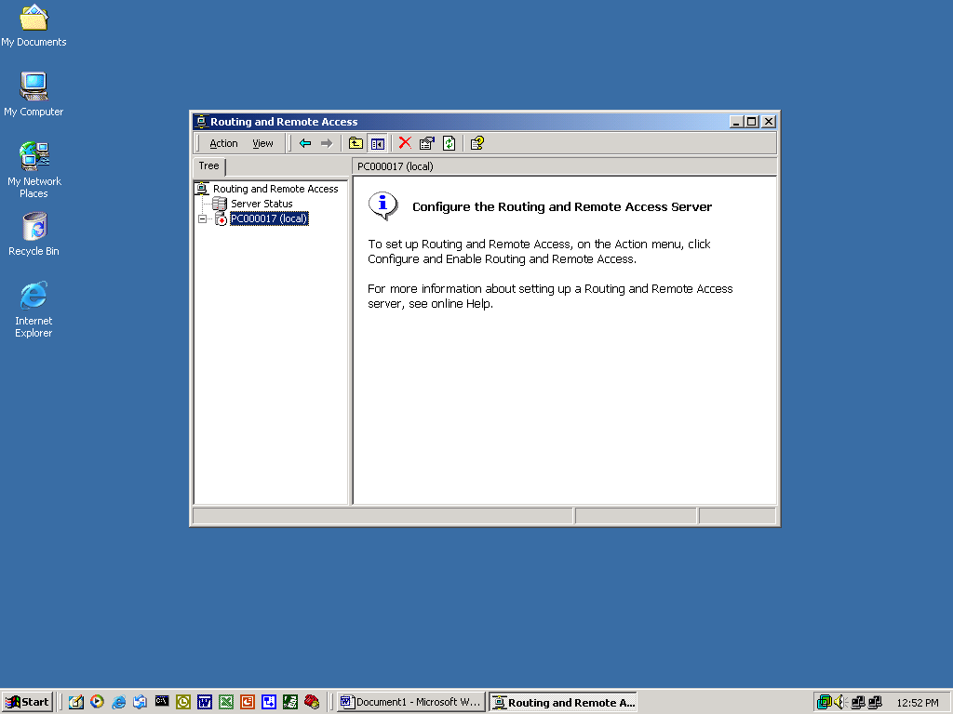

- Click on action and select the Configure and Enable Routing and Remote Access.

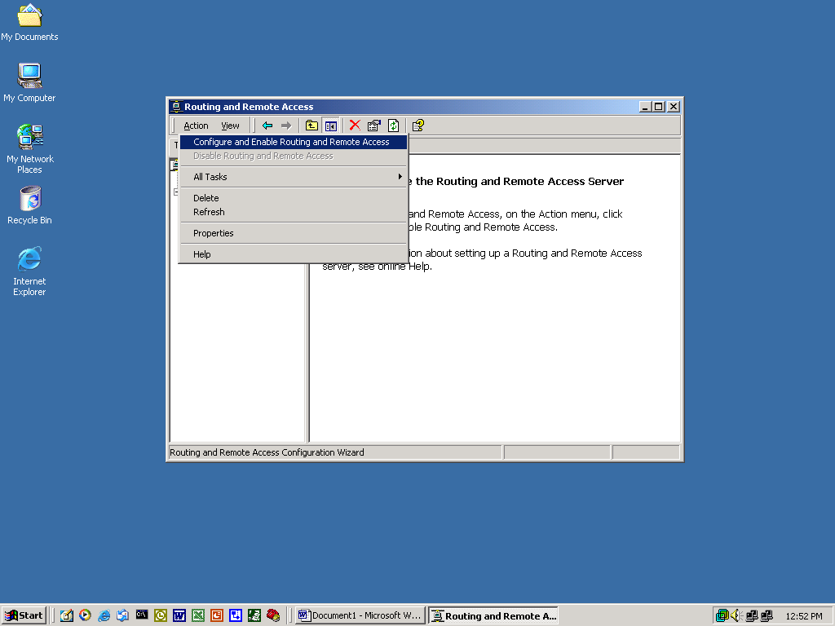

- You should now see the Routing and Remote Access Server Setup Wizard. Click on Next.

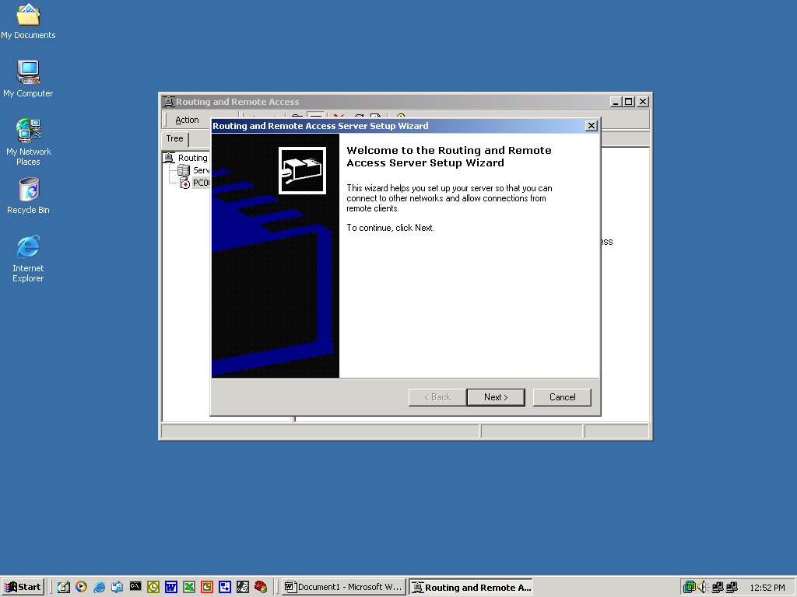

- The Wizard will take you through a series of steps, which will help you configure the router.

- Select Network Router and click on Next.

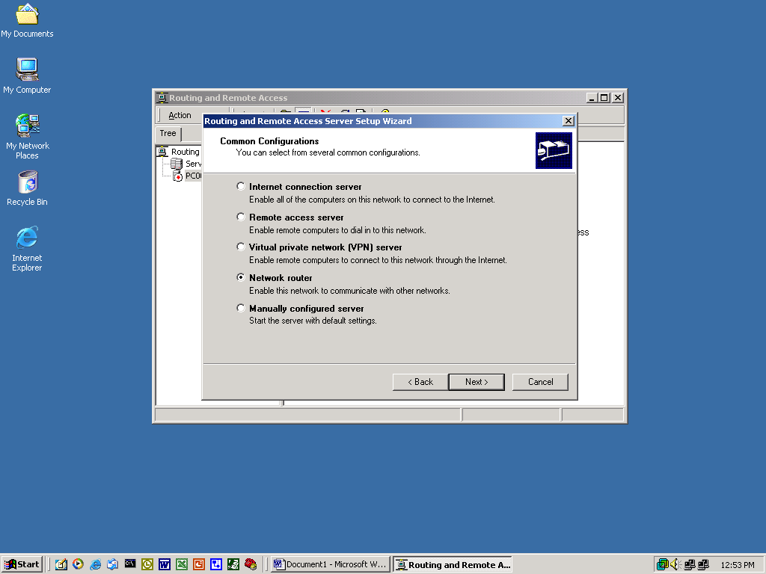

- Select the default for the following screens.

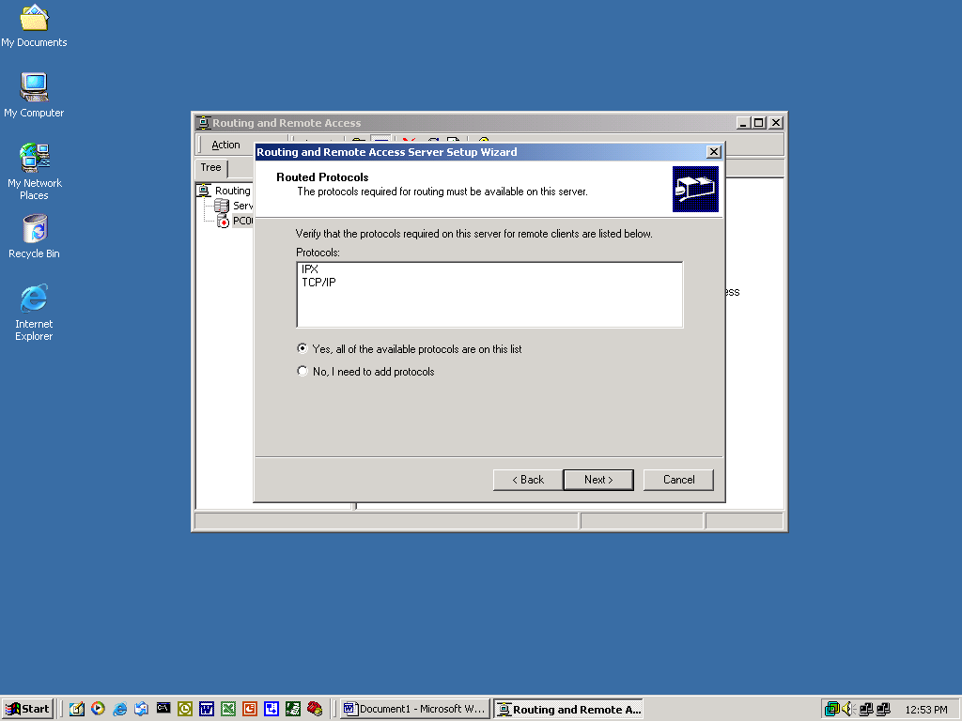

- Select No for Dial on Demand and click Next.

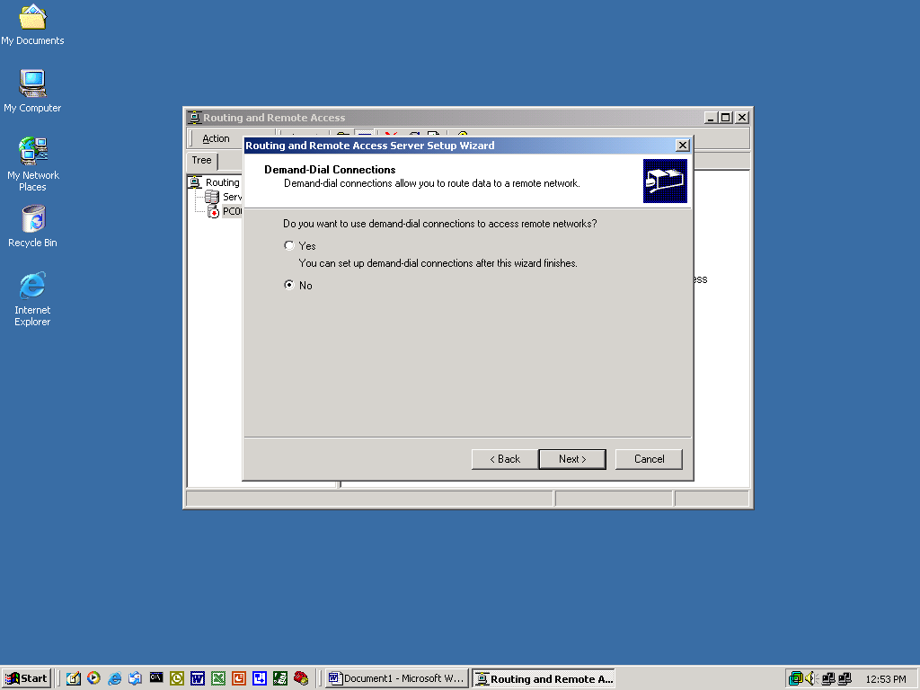

- Once you have reached the last window on the Wizard click on Finish.

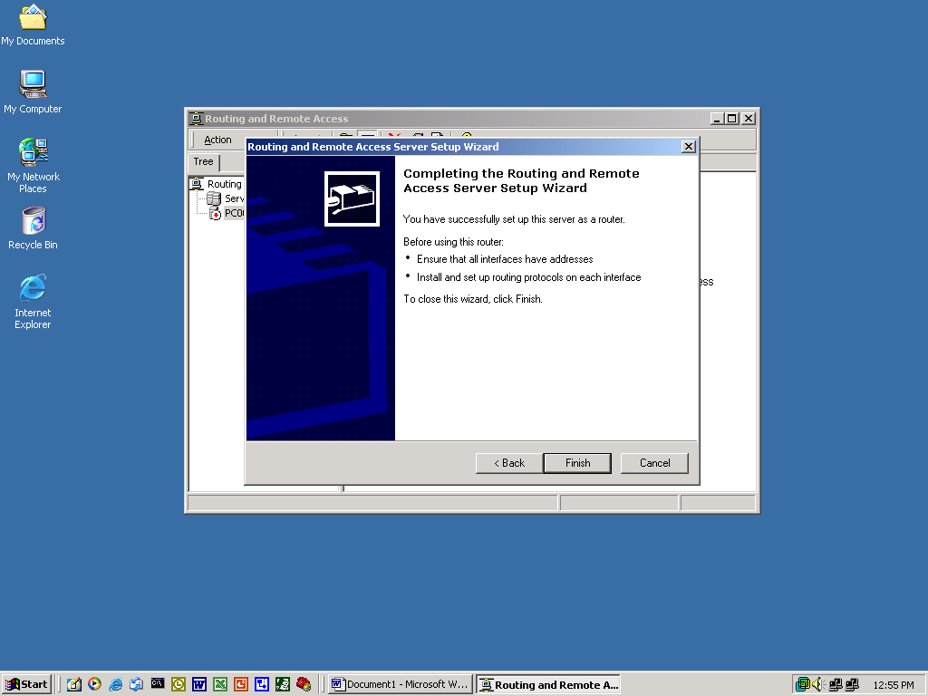

Establishing Connectivity

At this point the network should be properly configured and each interface should have all the necessary TCP/IP information.

- From each workstation and router try to ping each and every interface. Enter the IP address and ping results below.

IP Address | PING Results

- From the results of the table above, what conclusions can you make as to why you were successful establishing connectivity with some PC’s and not others?
____________________________________________________________________________________________________________________________________________________________________________________________________________________________________________________________________________________________________________________________________________________________________________________________________________

Configuring Default Routes

Each router is aware of the LAN segment that is directly connected to it (the router has an interface on the LAN). In order to route traffic to LAN segments that are not directly attached, routers need specific instructions as to where to send the packets. Static routes can achieve this.

- A static route must be entered into each router to teach the router how to get to the remote LAN
- Open the Routing and Remote Access window (see step 27), and click on the box that is next to your computer name on the left side of the screen.

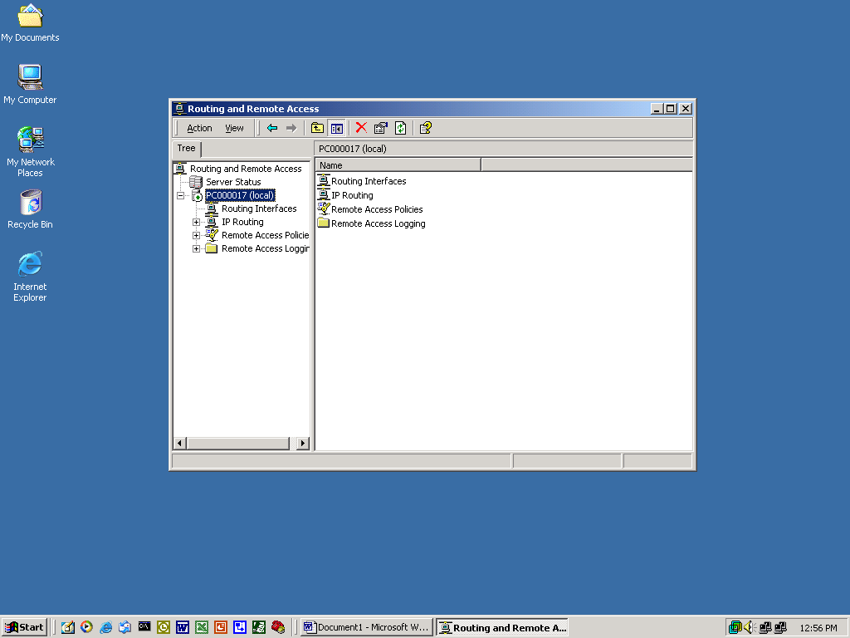

- Next, expand IP Routing

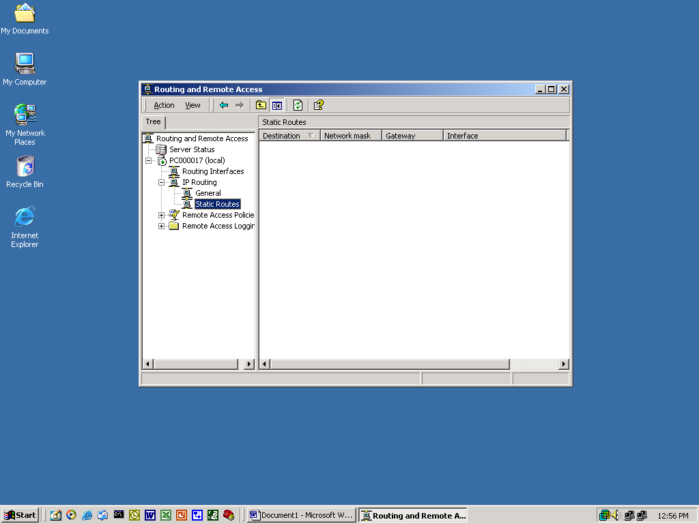

- Right click on Static Routes and select New Static Route

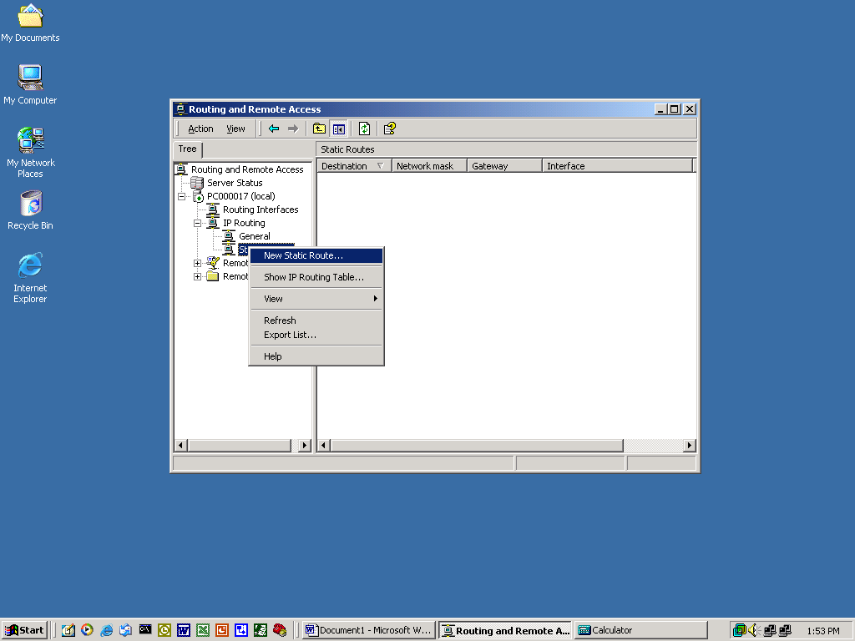.

- You should now see a window like the one illustrated below. Here you will enter configuration information that will enable the router to route traffic to a remote LAN on a given NIC. Enter the following information:
  - For Interface, choose your local interface that connects your router to the other router.
  - For Destination, enter the remote LAN subnet ID
  - For Network Mask, enter the remote LAN subnet mask
  - For Gateway, enter the next hop IP address (the IP address of the inbound interface of the next router up towards the destination)

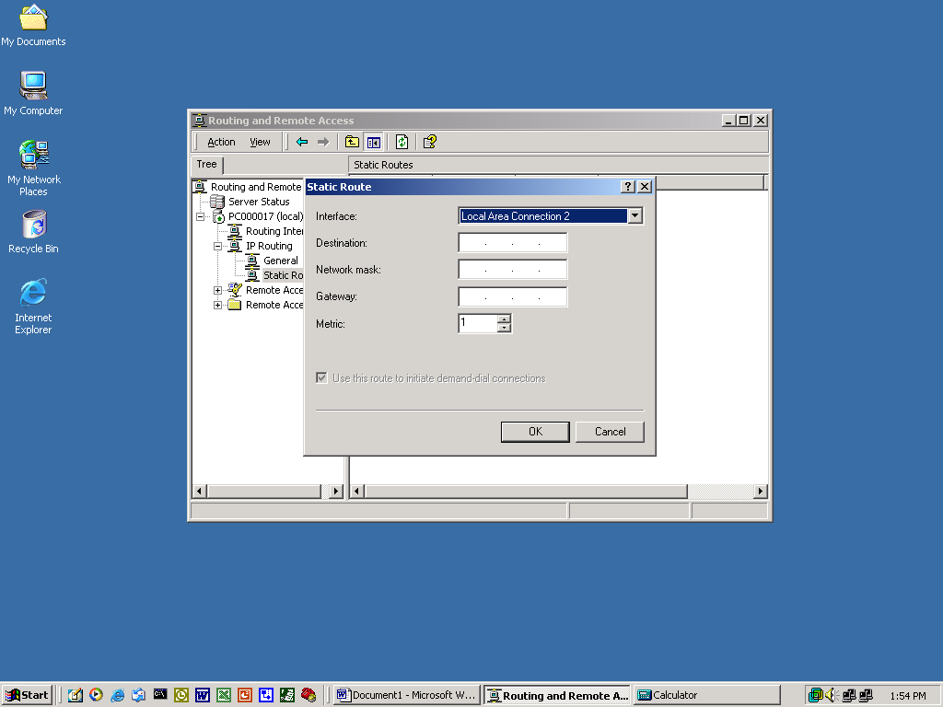

- You have just configured a router with a static route.

Establishing Connectivity

Now that you have configured default routes on your routers, let’s ping each interface on the network.

- From each workstation and router try to ping each and every interface. Enter the IP address and ping results in the table below.

IP Address | PING Results

- From the results of the table above, what conclusions can you make as to why you were successful establishing connectivity to each interface? To help you answer this question, go to the command prompt on both routers and use this command: Route Print. Do you see the remote LAN ID under “Network Destination” column!
____________________________________________________________________________________________________________________________________________________________________________________________________________________________________________________________________________________________________________________________________________________________________________________________________________

