CWNA
Final Exam – Skills

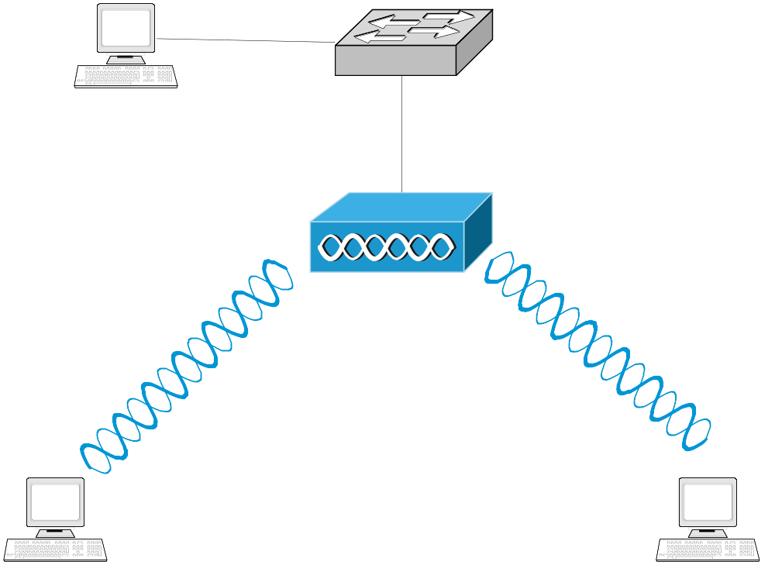

- Reset all equipment before you start
- Interconnect devices as shown in the topology
- Use the following information to configure the network
  - Create an BSS with the following SSID: group# (all lower case, and no spaces)
  - Network Address: 192.168.(group#).0/24
  - Gateway Address: 192.168.(group#).254/24
  - Cisco AP IP Address: 192.168.(group#).1/24
  - PC Ethernet Card (LAC# 11): 192.168.(group#).(100+PC#)/24
  - PC Wireless Card: 192.168.(group#).(200+PC#)/24
  - Laptops’ Wireless Card Addresses: 192.168.(group#).3/24, and 192.168.(group#).4/24
- Disable the broadcasting of the SSID on the AP
- Use WPA-PSK Authentication with TKIP Encryption on the Cisco AP and on wireless Clients
- Create an IP filter to disable Telnet

Date:______________________________
Group# _____________________________
Name: ______________________________
Name: ______________________________

