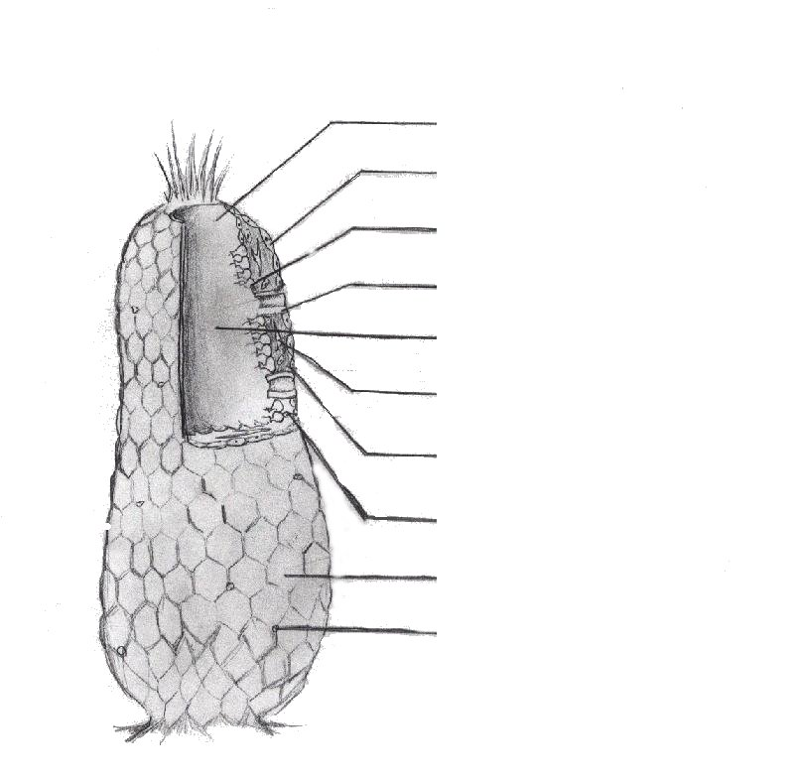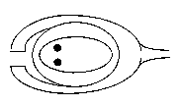
Features | Moss | Fern | Conifer |  | Flowering Plant
Dominant generation
Vascular tissue (+/-)
Seed (+/-)
Fruit (+/-)
Water
required for
fertilization
Pollen grain +/-
Homosporous or
heterosporous
Examples
_____1. Population A. Change in DNA of genes that can create genetic diversity.
____ 2. Selection B. Individuals of one species living in the same geographical area
_____3. Random mating C. Movement of individuals from one area to another
_____4. Migration D. No inbreeding or special selection of mates
_____5. Mutation E. Favoring of the propagation of some chance variations over others.
_____6. T/F A population in Hardy-Weinberg Equilibrium can only change due to mutation for future generations to still be in the H-W Equilibrium.
A population has 4000 individuals. The genotypes of the population are as follows:
{ AA } 40% { Aa } 40% { aa } 20%
______7 How many { A } genes are present in this gene pool?
______8. Gow many { a } genes are present in this gene pool?
______9. What is the % of { A } to { a }?
_____10. What is the frequency of the genotype { Aa } in this population.
Gram Staning Put into the correct order, list numbers on answersheet. correct order


