THE CLAM

Clams are economically and ecologically important. They have evolved highly developed mechanisms for survival in the sea. Many of the mechanisms relate to straining and sorting microscopic food material suspended in the water. The gills of the clam serve a dual purpose: (1) to provide oxygen to the organism and (2) to move food particles toward the mouth. This is a "ciliary mucoid feeder" or organism that uses hair-like cilia combined with mucus secretions to catch microscopic food particles and pass them on to the mouth. To aid this process, the clam circulates water in through the incurrent siphon, over and under the gills, and out through the excurrent siphon.

PURPOSE:
The purpose of this lab is to observe the body plan of the clam and the extreme modifications of the various members of this phylum which includes the snails, slugs, lams, chitons, squids, nautili, and octupi.

MATERIALS:
Clam Dissecting Kit Microscope slide Microscope Stain (Methylene blue)
Specimen mollusks
PROCEDURE:
USE THE DRAWINGS TO HELP LOCATE THE ORGANS
I. A. Study the shell of the clam and note that it consists of two valves hinged together along the dorsal side. On the anterior part of each valve is a swollen region, the umbo. Concentric lines extend outward from the umbo and represent lines of growth, much like the growth rings of a tree. The growth lines are a result of non-uniform growth and are more closely spaced during winter growth than in summer. According to this theory, each set of close rings and wide rings represent a year's growth.
1. Estimate the age of the clam you are studying:_________________________
2. Changes in the rings can also be produced by sudden changes in temperature, lack of food, disease and other stress. Based on this, is your clam probably older or younger than your estimate of age?___________
Explain your answer.______________________________________________________
______________________________________________________________
B. The valves (shell) are held together by two large mussels located on opposite ends of the shell. To open the clam, CAREFULLY cut these mussels by inserting the scalpel between the shell and cutting in the direction where the shells are joined together.
3. What is the shape of the mussels you cut?_____________________________
C. As you open the shell you should see the mantle, the membrane next to the shell. Near the posterior end, the mantle thickens and forms the siphons which the water enters (the incurrent siphon) and water exits (the excurrent siphon).
4. Describe the location of each siphon(top/bottom).________________________
D. Remove the mantle layer from a part of one valve. Note the smooth, fine grained inner surface of the valve. The shell lining is called mother of pearl.
5. What is the advantage to having this smooth inner surface?_______________________________________________________Locate the large muscular structure which makes up a large part of the body. This tissue is known as the foot. Locate the gills which hang down into the mantle cavity .
6. How many gills are there?_______________________
F. Dorsal to the gills is the pericardial sac that encloses the heart. Carefully cut open this sac and locate the heart. The heart has three chambers, 2 lateral auticles and one ventricle. Cut away the gills and locate the kidney which appears as a dark-colored organ lying near the gills and just below the pericardial cavity.
7. What is the function of this organ?________________________________
G. Use scissors or a scalpel blade to cut a small piece of gill tissue and place the tissue on a clean microscope slide. Add a drop of water, put on a coverslip and examine under the microscope.Also examine the prepared slide of the clam gill.
8. What structures cover the outside of the gill?_________________________
9. What substance is being carried to the gills for disposal? ____________
_____________________________________________________________
10. What substance is the blood picking up in the gills?___________________
H. Most of the digestive system is located in the visceral mass. Carefully cut the visceral mass into left and right halves. The mouth is located between the palps and leads to a short esophagus and into an expanded stomach which is flanked on either side by two large digestive glands. Remove these glands and note where the stomach leads into the intestine that winds through the visceral mass and then passes into the pericardial sac as the rectum. The rectum empties into the excurrent siphon via the anus. Locate as many sections of the digestive tract as possible in your dissection.
11. The gills of the clam serve a food gathering function as well as a gas exchange function. The gills produce a mucous covering which traps small particles of food. How might ciliary movements aid the clam in feeding? ______________________________________________________________
12. In which group of animals, free-swimming or attached marine animals, would you expect to find the "ciliary-mucoid" method of feeding more common? Why? __________________________________________________________ ______________________________________________________________
13. While the clam lives in the sand or mud, it obtains its food from the water above the bottom. How does the clam achieve this goal?__________ ______________________________________________________________
II. A. Examine the specimens of other mollusks. Answer the questions about them.
1. Examine the chitons. How many shells are found on these?_____________
2. What type of substrate does the chitin shell look like it is adapted for? Explain._______________________________________________________

3. Examine a representative of the Cephalopods (squids). How is this different from the clam you just dissected? __________________________ ______________________________________________________________
4. Examine some of the shells of gastropods. What difference do you see in these compared to the clam?____________________________________________
- Examine the outer edge of the gastropod shell. This is the growing edge. Describe how the shell has grown starting from the apex (tip)._________ ______________________________________________________________

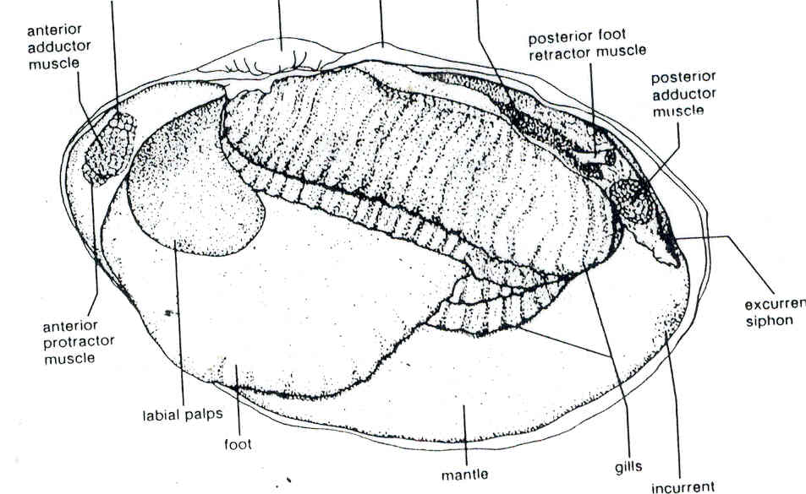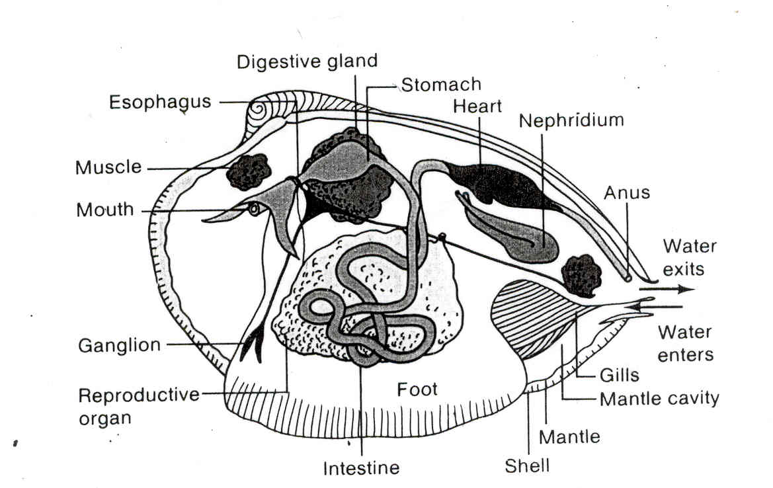
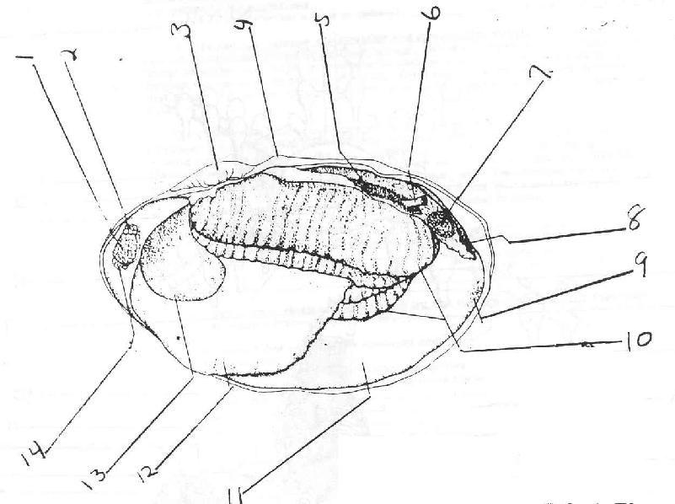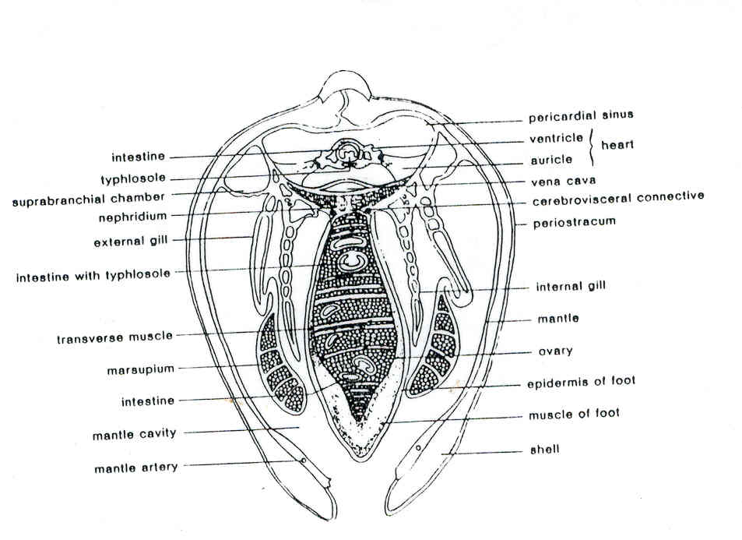

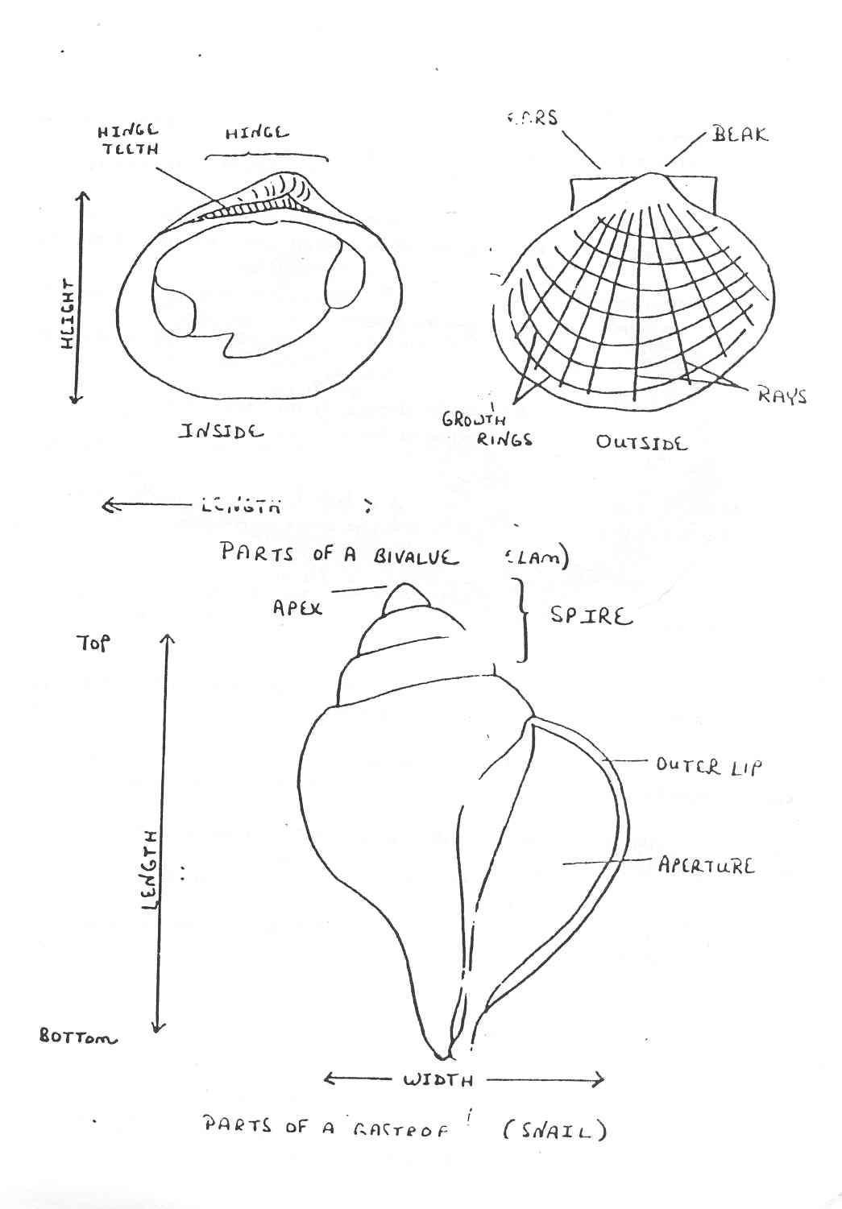

Shell Lab

1a | Shell had two halves and you have only half of it (bivalve) | GO TO NUMBER 2
1b | Shell is a snail shell and does not have two halves (gastropod) | GO TO NUMBER 11
2a | The shell’s hinge has a straight row of many tiny, evenly spaced “teeth” | GO TO NUMBER 3
2b | The shell’s hinge does not have “teeth,” but may have points or scars where the hinges join; or the hinge may not be visible at all | GO TO NUMBER 4
3a | The hinge is straight (and the shell has brown zebra-like stripes) | TURKEY WING
3b | The hinge is not completely straight (shell is white) | ARK SHELL
4a | Part of the hinge seems to be rolled outward (and the shell is white with may ribs) | ANGEL WING
4b | No part of the hinge rolls out. | GO TO NUMBER 5
5a | Shell is much longer than it is high (check diagram for difference between length and width); or may have a wedge shape | GO TO NUMBER 6
5b | 5he11 is not much longer than it is high it is more round or oval | GO TO NUMBER 8
6a | Ends of the shell are blunt; shell very rectangular in shape | GO TO NUMBER 7
6b | Ends of the shell are rounded; shell is wedge-shaped; shell is no longer than one inch | FLORIDA COQUINA
7a | Shell is more than four times as long as It is high (and looks like an old-fashioned razor) | JACKKNIFE or RAZOR CLAM
7b | Shell length is less than four times the height (and the beak is almost in the center) | TAGELUS
8a | Shell has rays | GO TO NUMBER 9
8b | Shell does not have rays | GO TO NUMBER 10
9a | Hinge line has ears | SCALLOP
9b | Hinge line does not have ears | COCKLE
10a | Shell is fragile, no hinge is visible, and you can almost see through it | JINGLE SHELL
10b | Shell is not as above, but has concentric growth rings | DOSINIA
11a | Shell is fairly flat and dish-like | GO TO NUMBER 12
11b | Shell is not as above (more round in cross-section) | GO TO NUMBER 14
12a | Shell is coiled (but only at one end) | GO TO NUMBER 13
12b | Shell is not coiled (and is shaped like a small, low cone) | LIMPET
13a | Shell has a deck or shelf inside | SLIPPER or BOAT SHELL
13b | Shell not as above, but has a row of several open holes) | ABALONE
14a | Shell has visible spire at top (although it may be tiny) | GO TO NUMBER 15
14b | Shell is smooth and has no spire at all | GO TO NUMBER 21
15a | Aperture is roundish or oval in outline (it is less than twice as long as it is wide) | GO TO NUMBER 16
15b | Aperture is not round, but is at least twice as long as it is wide | GO TO NUMBER 18
16a | Shell is compressed and has a deep umbilicus (a large, funnel-shaped hole underneath) | SUNDIAL
16b | Shell not as above | GO TO NUMBER 17
17a | Shell Is globular (ball-shaped) and has smooth surface | MOON SNAIL
17b | Shell Is top-shaped and dark in color | PERIWINKLE
18a | Shell has very flattened spire (and is quite thin, with a cris-crossed surface pattern) | FIG SHELL
18b | Shell not as above | GO TO NUMBER 19
19a | Shell has knobs on spire (or where spire begins) | GO TO NUMBER 20
19b | Shell has no knobs on spire | OLIVE SHELL
20a | Aperture is much wider at the top than the bottom | KNOBBED WHELK
20b | Aperture is wide all the way down and has a notch at the bottom | CONCH
21a | Teeth are present inside aperture (and outer lip of aperture curls inward) | COWRIE
21b | Teeth are not present inside aperture | GO TO NUMBER 22
22a | Shell has a ridge running at right angles to aperture (and is creme-colored with orange edges) | FLAMINGO TONGUE
22b | Shell does not have a ridge across the back; but the apex (where the spire should be)has a small hole in it | BUBBLE SHELL
1a | Shell had two halves and you have only half of it (bivalve) | GO TO NUMBER 2
1b | Shell is a snail shell and does not have two halves (gastropod) | GO TO NUMBER 11
2a | The shell’s hinge has a straight row of many tiny, evenly spaced “teeth” | GO TO NUMBER 3
2b | The shell’s hinge does not have “teeth,” but may have points or scars where the hinges join; or the hinge may not be visible at all | GO TO NUMBER 4
3a | The hinge is straight (and the shell has brown zebra-like stripes) | TURKEY WING
3b | The hinge is not completely straight (shell is white) | ARK SHELL
4a | Part of the hinge seems to be rolled outward (and the shell is white with may ribs) | ANGEL WING
4b | No part of the hinge rolls out. | GO TO NUMBER 5
5a | Shell is much longer than it is high (check diagram for difference between length and width); or may have a wedge shape | GO TO NUMBER 6
5b | 5he11 is not much longer than it is high it is more round or oval | GO TO NUMBER 8
6a | Ends of the shell are blunt; shell very rectangular in shape | GO TO NUMBER 7
6b | Ends of the shell are rounded; shell is wedge-shaped; shell is no longer than one inch | FLORIDA COQUINA
7a | Shell is more than four times as long as It is high (and looks like an old-fashioned razor) | JACKKNIFE or RAZOR CLAM
7b | Shell length is less than four times the height (and the beak is almost in the center) | TAGELUS
8a | Shell has rays | GO TO NUMBER 9
8b | Shell does not have rays | GO TO NUMBER 10
9a | Hinge line has ears | SCALLOP
9b | Hinge line does not have ears | COCKLE
10a | Shell is fragile, no hinge is visible, and you can almost see through it | JINGLE SHELL
10b | Shell is not as above, but has concentric growth rings | DOSINIA
11a | Shell is fairly flat and dish-like | GO TO NUMBER 12
11b | Shell is not as above (more round in cross-section) | GO TO NUMBER 14
12a | Shell is coiled (but only at one end) | GO TO NUMBER 13
12b | Shell is not coiled (and is shaped like a small, low cone) | LIMPET
13a | Shell has a deck or shelf inside | SLIPPER or BOAT SHELL
13b | Shell not as above, but has a row of several open holes) | ABALONE
14a | Shell has visible spire at top (although it may be tiny) | GO TO NUMBER 15
14b | Shell is smooth and has no spire at all | GO TO NUMBER 21
15a | Aperture is roundish or oval in outline (it is less than twice as long as it is wide) | GO TO NUMBER 16
15b | Aperture is not round, but is at least twice as long as it is wide | GO TO NUMBER 18
16a | Shell is compressed and has a deep umbilicus (a large, funnel-shaped hole underneath) | SUNDIAL
16b | Shell not as above | GO TO NUMBER 17
17a | Shell Is globular (ball-shaped) and has smooth surface | MOON SNAIL
17b | Shell Is top-shaped and dark in color | PERIWINKLE
18a | Shell has very flattened spire (and is quite thin, with a cris-crossed surface pattern) | FIG SHELL
18b | Shell not as above | GO TO NUMBER 19
19a | Shell has knobs on spire (or where spire begins) | GO TO NUMBER 20
19b | Shell has no knobs on spire | OLIVE SHELL
20a | Aperture is much wider at the top than the bottom | KNOBBED WHELK
20b | Aperture is wide all the way down and has a notch at the bottom | CONCH
21a | Teeth are present inside aperture (and outer lip of aperture curls inward) | COWRIE
21b | Teeth are not present inside aperture | GO TO NUMBER 22
22a | Shell has a ridge running at right angles to aperture (and is creme-colored with orange edges) | FLAMINGO TONGUE
22b | Shell does not have a ridge across the back; but the apex (where the spire should be)has a small hole in it | BUBBLE SHELL

1.____________________________________________________________________________________
2.____________________________________________________________________________________ 3.____________________________________________________________________________________ 4.____________________________________________________________________________________ 5.____________________________________________________________________________________ 6.____________________________________________________________________________________ 7.____________________________________________________________________________________ 8.____________________________________________________________________________________ 9.____________________________________________________________________________________ 10.____________________________________________________________________________________
Name the following mollusks using any information you can find the lab


