Exam 3 Name:
CHM 2211
Spring 2011

- Name or draw the following (22 pts)

  - 4-mercapto-2-(1-oxoethyl)cyclohexane carboxylic acid

  - (E) – 3-pentenamide

  - 1-cyanopropyl ethanoate

  - N-ethyl-N-methyl-1,2-dimethylbutanamine

  - 2-chloropropanoic 2,2-dimethylbutanoic anhydride

  - 2-ethoxycyclopentane carbonylchloride

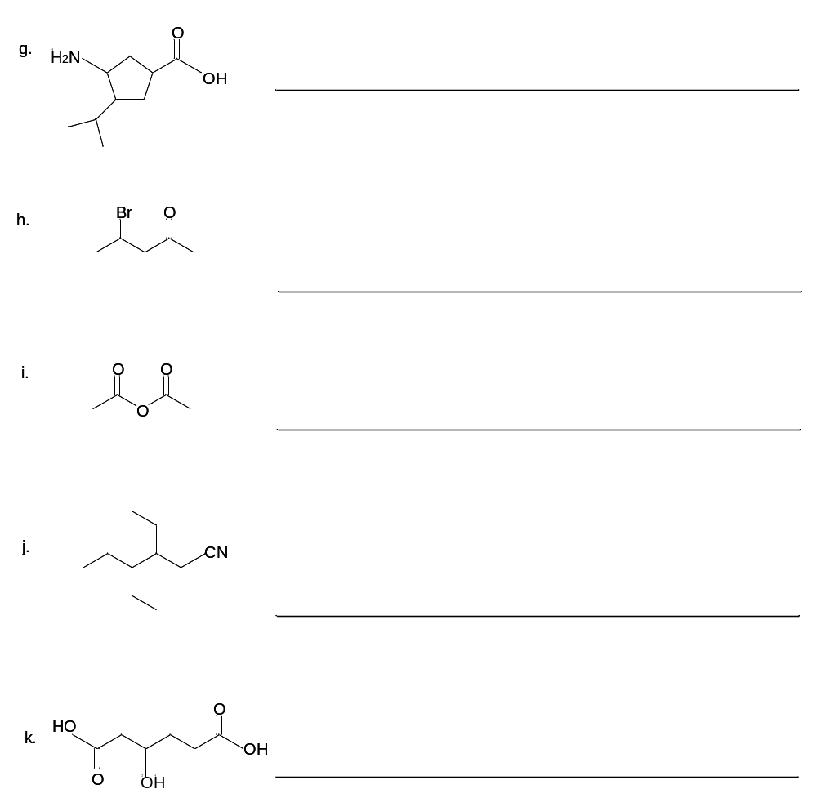

- Fill in the box (48 pts)

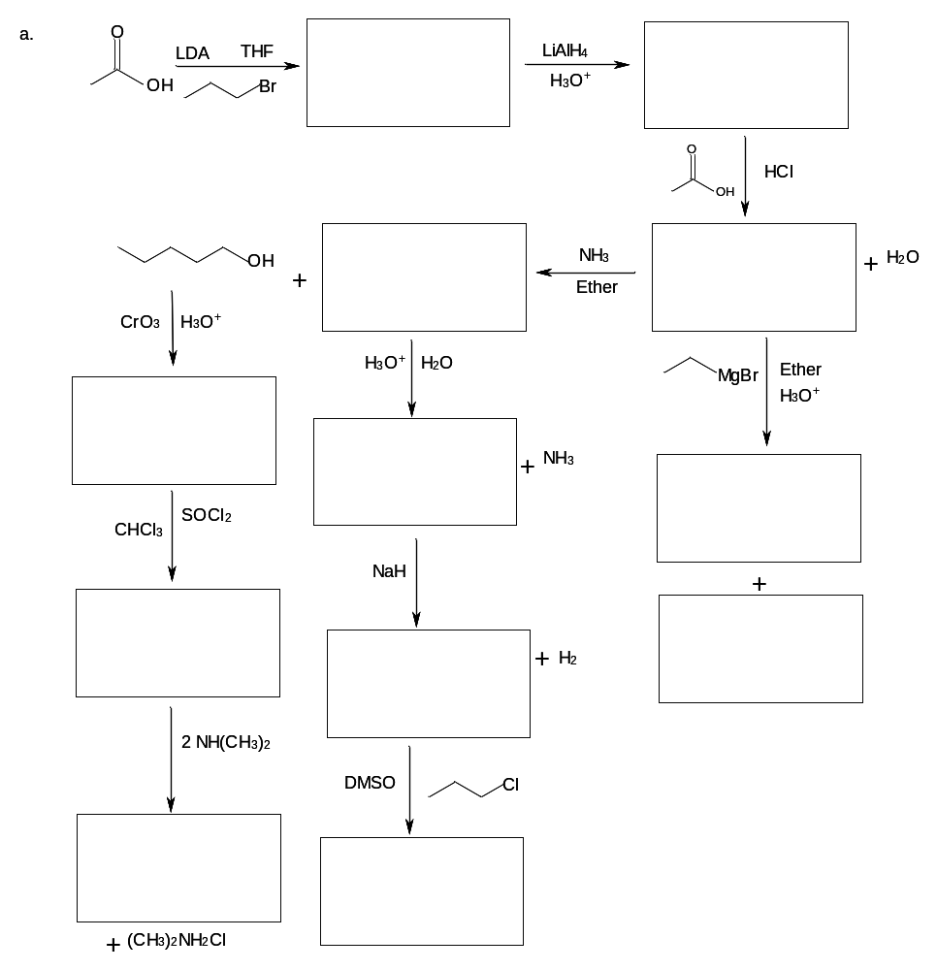

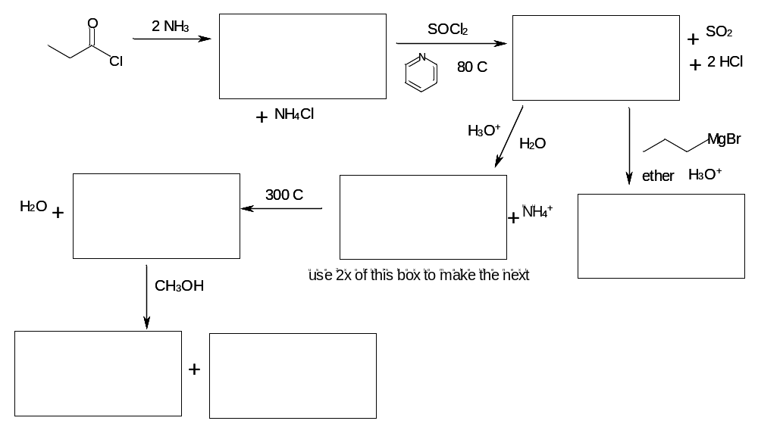

- Draw the complete mechanisms for the following (30 pts)

  - Fischer Esterification

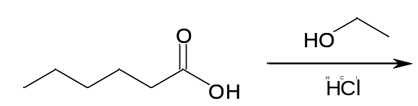

  - Aldol
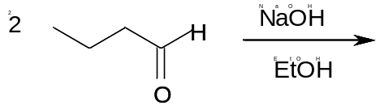

  - Hydrolysis of nitriles



