CH 23
Prepare
CHM 2211
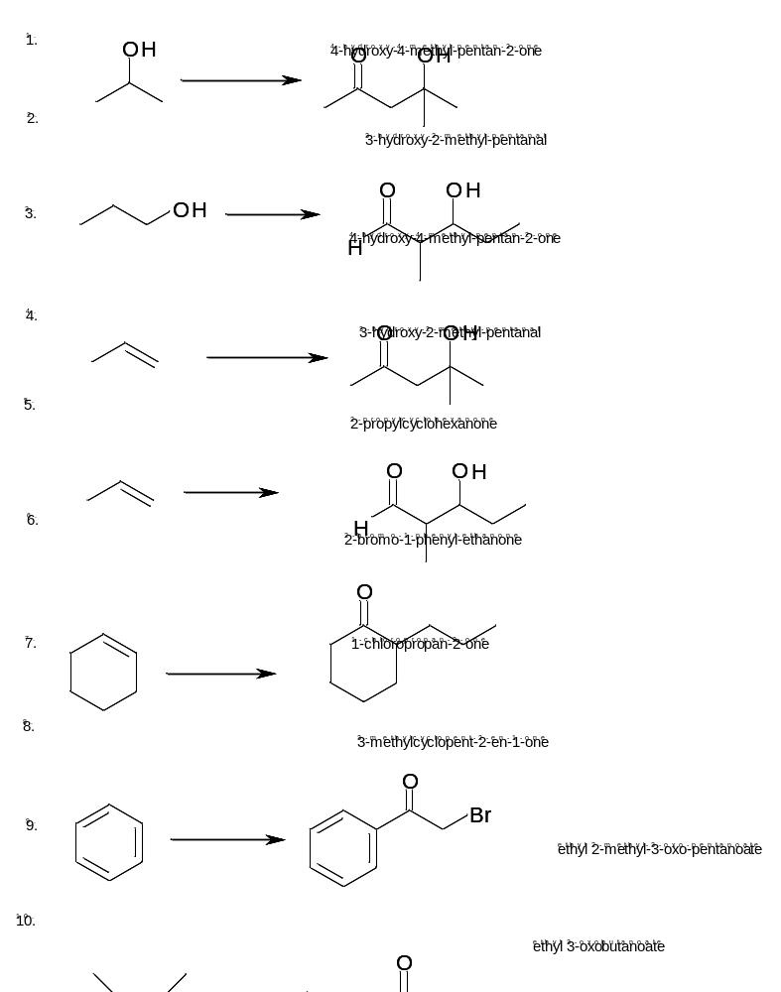

For CH 23 you are responsible for:

Reactions
Aldol
Alpha sub (both)
Internal Aldol
Claisen condensation

Mechanisms
Aldol
Alpha sub – halogenations
Claisen Condensation
Dieckmann cyclization

