CHM 2210 Name:
Exam 2
Fall 2009

- Name or draw the following (3 pt each)
  - 1-ethyl-3-methyl-1,3-cyclobutadiene

  - (E)-1-bromo-1-chloro-2-methyl-1-hexene

  - Cis-1-iodo-2-methylcyclopentane

  - Trans-2-butene

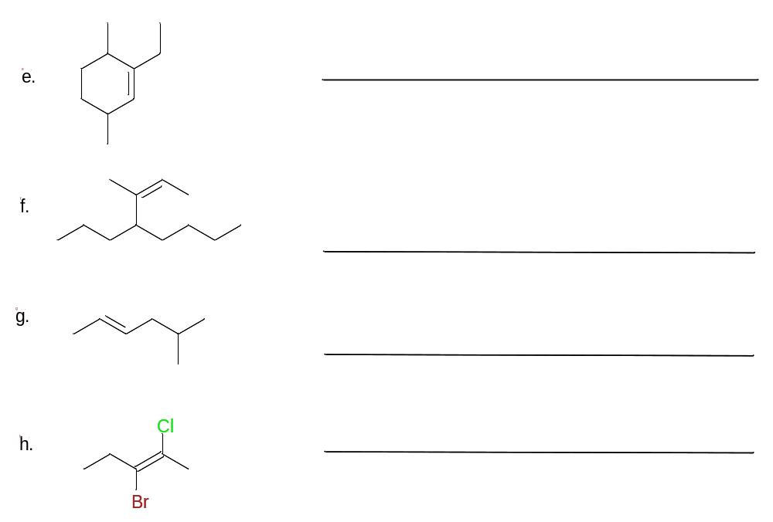

- Mechanisms (11 pt each)
  - Draw the complete mechanism for the bromination of (E)-pentene

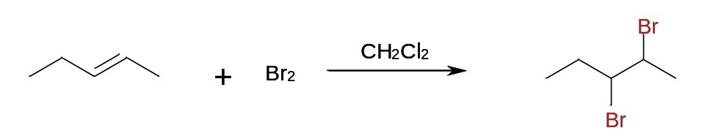

Does this reaction show anti or syn addition? WHY?

  - Draw the complete mechanism for the hydration of 1-methylcyclohexene

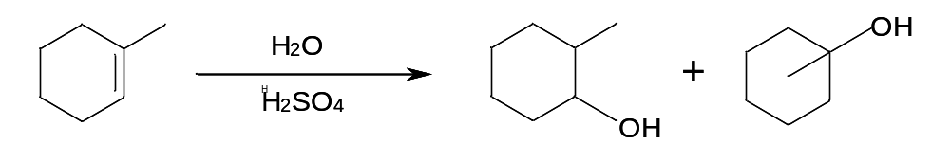

Which of the organic products is major and which is minor? WHY?

- Fill in the boxes (3 pt each)



