Class Assignment Group 1
CHM 2210
Substitution & Elimination Rxns

Label each of the following reactions as S_{N}1, S_{N}2, E1 or E2, write the complete mechanism

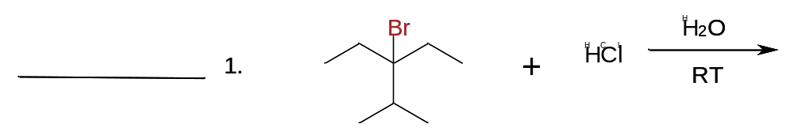

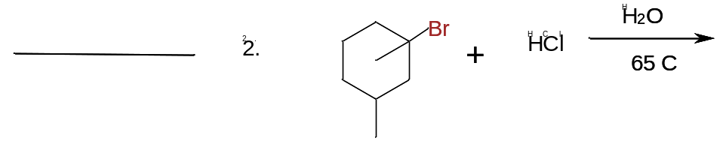

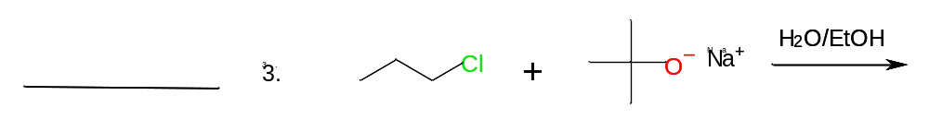

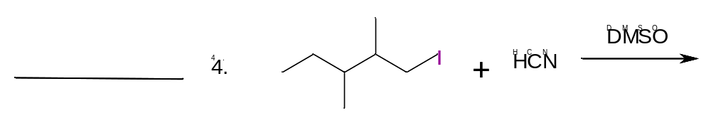

Class Assignment Group 2
CHM 2210
Substitution & Elimination Rxns

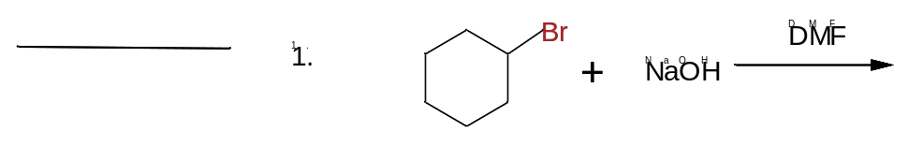

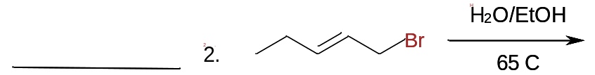

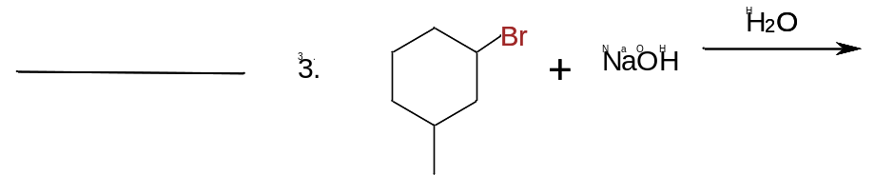

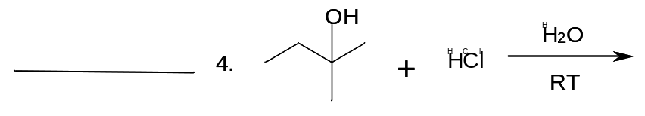

Class Assignment Group 3
CHM 2210
Substitution & Elimination Rxns



