Exam 1 Name:
CHM 1025
Summer 2010

MC: Pick the best answer (2 pt each)

- In the measurement, 15 inches, which of the following is true?
  - 15 is a number
  - Inches is a number

- Which of the following instruments would be used to measure mass?
  - Ruler
  - Electronic balance
  - Graduated cylinder

- Which of the following correctly describes the difference between mass and weight?
  - You would have the same mass and weight on the Earth as on the moon
  - You would have a different weight but the same mass on the Earth as on the moon
  - You would have a different mass but the same weight on the Earth as on the moon
  - You would have a different mass and weight on the Earth and on the moon

- In the following dart boards, which shows the placement of the darts as precise but not accurate?
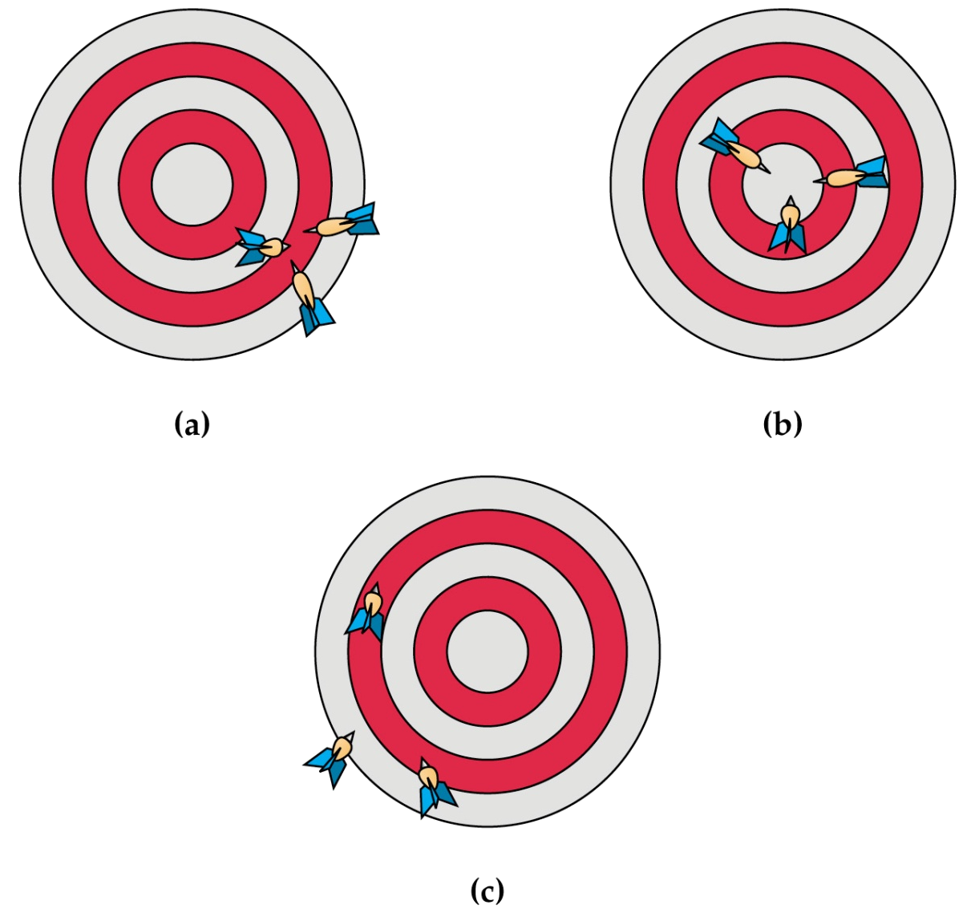

- How many significant figures does 14.030 have?
  - 3 b. 4 c. 5

- How many significant figures does 01.03 x 10⁻³ have?
  - 3 b. 4 c. 5

- How many significant figures does 1400 have?
  - 2
  - 4
  - 2, 3, or 4

- Round 45.673 to 4 significant figures
  - 45.67
  - 45.68
  - 45.66

- I have to measure the length of a candycane, I have a choice as to which ruler I can use, Ruler A or Ruler B. Which ruler would give the most precise and most accurate measurement? A or B
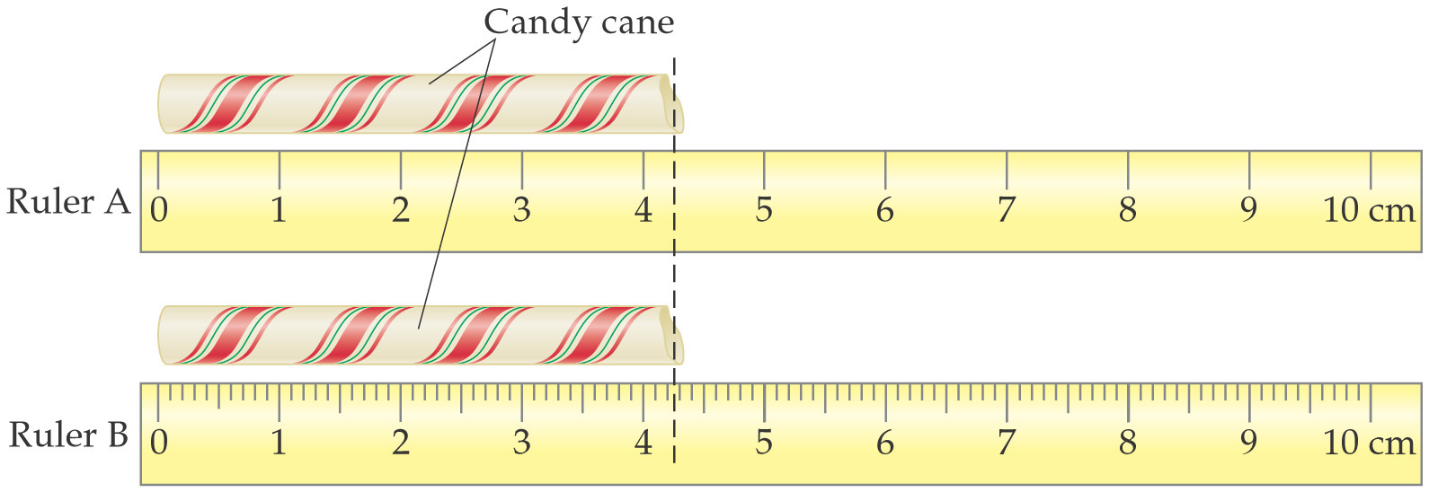

- What is the SI unit for length?
  - meter b. kilometer c. millimeter

- In general which is the least dense?
  - Gas
  - Liquid
  - Solid

- Which type of matter has no definite shape and no definite volume?
  - Solid
  - Liquid
  - Gas

- Which of the following types of matter can be compressed?
  - Solid
  - Liquid
  - Gas

- Is the following statement true or false?
Elements cannot be broken down further
  - True b. False
- Looking at the following graduated cyclinder which contains, Liquid 1, water, Liquid 2, Solid 1, Solid 2, and Solid 3, which of the following statements is true?
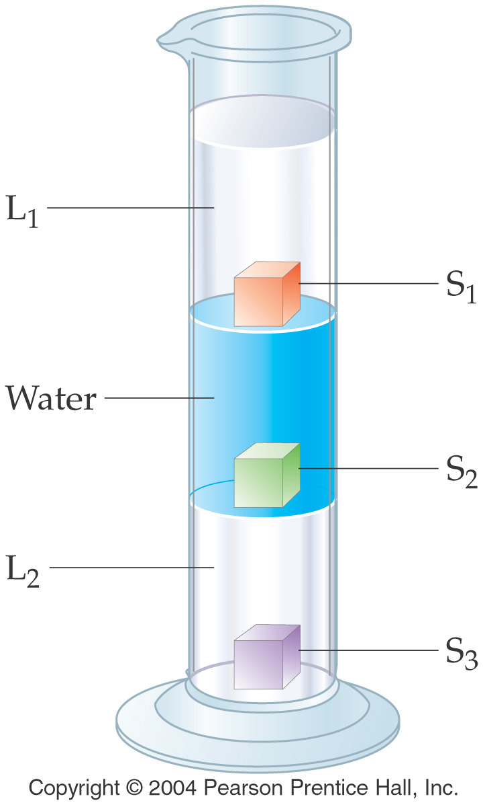

  - Liquid 1 is more dense than liquid 2
  - Solid 2 is less dense than solid 1
  - Solid 3 is more dense than water
  - Solid 1 is the most dense solid

- Which of the following statements is true with respect to the 2 beakers shown below?
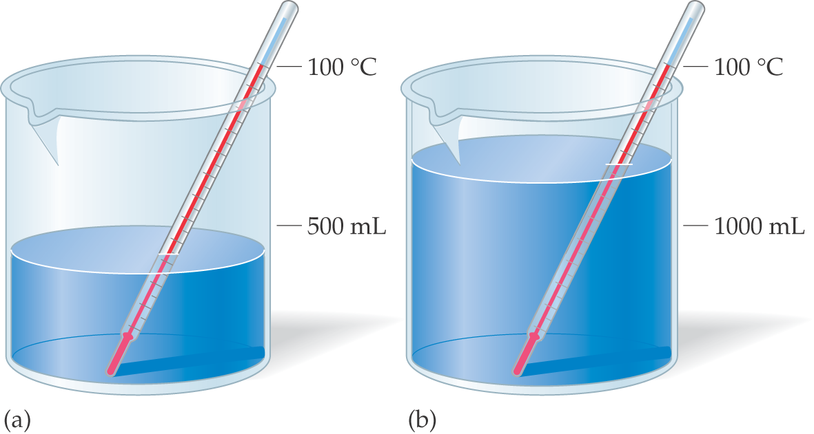

  - Beaker A has more heat than beaker B
  - Beaker B has less heat than Beaker A
  - Beaker B has more heat than beaker A

- In which of the following types of matter do you expect the particles to be tightly packed together?
  - Solid
  - Liquid
  - Gas

- What is the phase transition called when a gas changes directly to a solid?
  - Melting
  - Sublimation
  - Condensation
  - Deposition

- What is the phase transition called when a liquid changes to a gas?
  - Vaporization
  - Freezing
  - Sublimation
  - Deposition

- Which of the following are composed of more than one substance that can be physically separated into its component substances?
  - Mixture
  - Pure substance

- Which of the following is a good example of a pure substance?
  - Saltwater
  - Sand and water
  - Water

- Which of the following is an example of a chemical change?
  - HCl_{(g)} → HCl_{(l)}
  - 2 Fe_{(s)} + 3 O_{2(g)} → 2 FeO_{3(s)}
  - H₂O_{(l)} → H₂O_{(g)}

- Using your periodic table, which of the following is a metal?
  - Sodium
  - Oxygen
  - Bromine

- Using your periodic table, which of the following is a non-metal?
  - Aluminum b. Iron c. Sulfur

- Using your periodic table, which of the following is a semi-metal?
  - Cobalt
  - Argon
  - Silicon

- Which of the following would you consider a poor conductor of heat and electricity?
  - Non-metal b. Metal

- Which of the following would be ductile or malleable?
  - Iron
  - Oxygen
  - Sulfur

- What is the atomic number of osmium?
  - 190.2 b. 76

- How many of each type of element are in calcium phosphate, Ca₃(PO₄)₂ ?
  - Ca = 3, P = 1, O = 4
  - Ca = 3, P = 2, O = 8
  - Ca = 3, P = 2, O = 4

- Which of these has the least potential energy?
  - A ball at the top of a hill
  - A ball half way down a hill
  - A ball at the bottom of a hill

- Which of the following has the least kinetic energy?
  - Solid b. Liquid c. Gas

- Find the mass of CO₂ in the following reaction, when you have added 26.5 g of carbon to 70.7 g of oxygen
C_{(s)} + O_{2(g)} → CO_{2(g)}
  - 44.2 g
  - 97.2 g
  - 114.9 g
  - -44.2 g

- Which of the following is an indication that reaction has occurred?
  - Gas formation
  - Precipitate formation
  - Color change
  - All of the above

LA 1: (8 pts) DO the following mathematical operations and make sure that the answer has the correct sig. figs

- 4.562 / 32.4 =

- 89.7 x 320.9 =

- 32.46 + 85 =

- 722.34 – 87.9 =

LA 2: (6 pts) DO the following temperature conversions

- 672 K → °C

- 672 K → °F

- 92 °F → °C

LA 3: (12 pts) Using dimensional analysis to solve the following, SHOW YOUR WORK!!! (don’t forget sig figs)

  - 72.5 mi → km

  - 32.94 yd → cm

  - 3.64 x 10³ qt → L

  - 8.79 x 10⁶ oz → kg

  - 1.28 x10⁸ cm → nm

  - 5280 mL → L

LA 4: (8 pts) Solve for the following density calculations, SHOW YOUR WORK!!! (don’t forget sig figs)

- What is the density (in g/cm³) of a metal nugget that has a mass of 250.68 g and a volume of 9.86 cm³?

- What is the volume (in mL) of an unknown substance if it’s mass is 23.5 g and it’s density is 6.553 g/mL?

Equations:

D = m/V

