The limit of a function (Basics)
Consider the function $f\left(x\right)=x^{2}-x+2$ for values of x near 2. The table below gives the values of $y=f\left(x\right)$when x is closed to 2, but not equal to 2. We can see that the closer x approaches 2 from either side, the closer $f\left(x\right)$ approaches 4.
To express this situation we can write$\lim_{x→2}{f\left(x\right)=\lim_{x→2}{x^{2}-x+2=4}}$.
In general, the limit of the function $f\left(x\right)$ tell us what value the function is “approaching to” when $x$ is approaching a number say $x=a$ in the domain of the function. The limit of the function does not refer to f (a) (the value the function takes at$x=a$.)
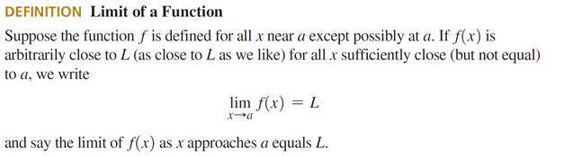
Example1: Consider the piecewise function$g\left(x\right)=\left\{\begin{aligned}\frac{x^{2}-1}{x-1} if x≠1 \\ -1 if x=1\end{aligned}\right\}$. Find$\lim_{x→1}{g\left(x\right)}$, and $g\left(1\right).$
Solution: This is a linear function with a discontinuity at$x=1$. We can see that when x approaches 1, $g\left(x\right)$ approaches 2, so$\lim_{x→1}{g\left(x\right)}=2$, whereas$g\left(1\right)=-1$.
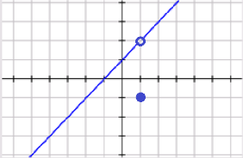
From this example we can see that$\lim_{x→1}{g\left(x\right) ≠g(1)}$.

Example 2: Find$\lim_{x→3}{f\left(x\right)}$, and $f\left(3\right)$ in the figure below:
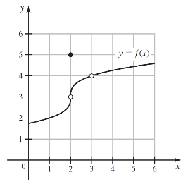
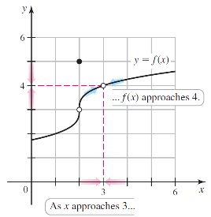
Solution: We can see that when x approaches 3, $f\left(x\right)$ approaches 4, so$\lim_{x→3}{f\left(x\right)}=4$. Since 3 is not in the domain of$f$ ,$f\left(3\right)$ is undefined.
From this example we can see that the limit exists at 3 even though $f\left(3\right)$ is undefined.
One- Sided Limits
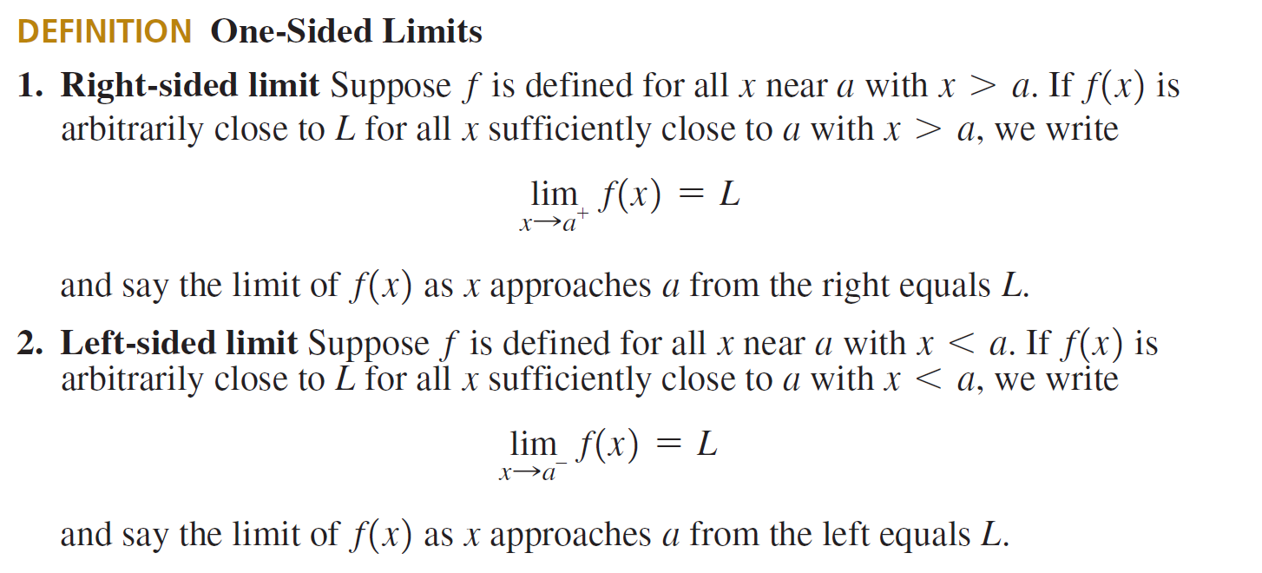
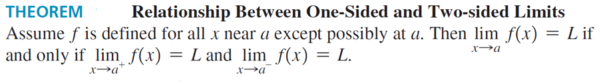
The theorem tells us that for the limit to exist, the limit from the right has to equal the limit from the left.
Example 3: A Function with a Jump Find$\lim_{x→2^{-}}{g\left(x\right), \lim_{x→2^{+}}{g\left(x\right)}}$and $\lim_{x→2}{g\left(x\right)}$ in the figure below:
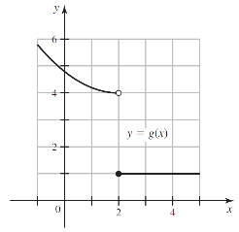
Solution: As x approaches 2 from the left, $g$ approaches 4. Therefore, $\lim_{x→2^{-}}{g\left(x\right)=4}.$
As x approaches 2 from the right, $g$ approaches 1. Therefore, $\lim_{x→2^{+}}{g\left(x\right)=1}.$
$\lim_{x→2}{g\left(x\right)}$ does not exist (DNE) because $\lim_{x→2^{-}}{g\left(x\right)≠ \lim_{x→2^{+}}{g\left(x\right)}}$. (The right limit differs than the left limit)

Finding Limits Algebraically (Limits Laws)
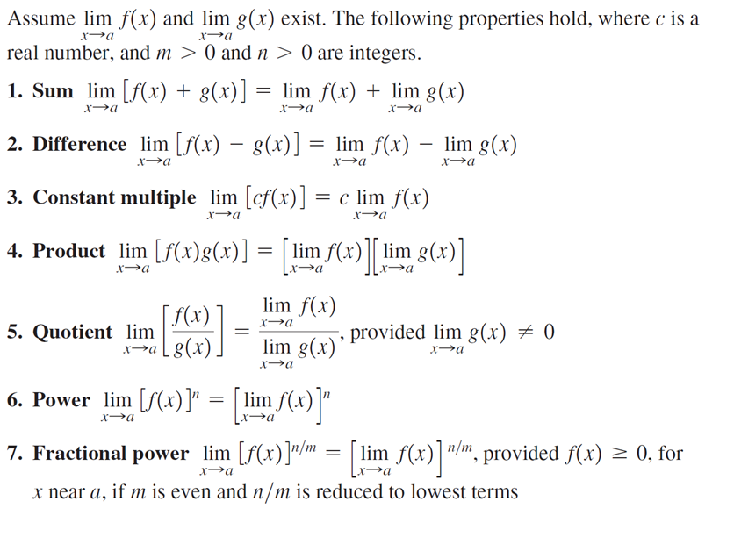
Example 5: Using the Limit Laws
Solution: (a) From the graph, we see that $\lim_{x→-2}{f\left(x\right)=1}$and$\lim_{x→-2}{g\left(x\right)=-1}$.
Therefore $\lim_{x→-2}f\left(x\right)+5{g\left(x\right)=\lim_{x→-2}{f\left(x\right)}+\lim_{x→-2}{5g\left(x\right)} }$ Using Law 1 (Limit of a Sum)
$=\lim_{x→-2}{f\left(x\right)}+5\lim_{x→-2}{g\left(x\right)}$ Using law 3 (Limit of a Constant Multiple)
$=1+5\left(-1\right)=-4$
(b)From the graph, we see that$\lim_{x→1}{f\left(x\right)=1}$, but $\lim_{x→1}{g\left(x\right)}$ does not exist because the limit from the right does not equal the limit from the left; so $\lim_{x→1}{f\left(x\right)g(x)}$ does not exist. We cannot use Law 4 (Limit of a Product)
(c)From the graph, we see that$\lim_{x→2}{f\left(x\right)≈1.4}$, but$\lim_{x→2}{g\left(x\right)=0}$. We cannot use Law 5 (Limit of
a Quotient). The limit does not exist because the denominator approaches 0.
(d)From the graph, we see that$\lim_{x→1}{f\left(x\right)=2}$, so using Law 6 (Limit of a Power), we get
$\lim_{x→1}{{[f\left(x\right)]}^{3}=}{[\underset{x→1}{lim⁡}f\left(x\right)] }^{3}={2^{3}=8}$
Example 6: Finding Limit by Canceling Common Factors. Find$\lim_{x→1}{\frac{x^{2}-1}{x-1}}$ .
Solution: $\lim_{x→1}{\frac{x^{2}-1}{x-1}}= \lim_{x→1}{\frac{\left(x-1\right)\left(x+1\right)}{x-1}=\lim_{x→1} x+1=2} .$
Example 7: Finding Limit by Simplifying. Find$\lim_{h→0}{\frac{{(3+h)}^{2}-9}{h}}$ .
Example 8: Finding Limit by Rationalizing. Find$\lim_{x→1}{\frac{\sqrt{x}-1}{x-1}}$
Solution: $\lim_{x→1}{\frac{\sqrt{x}-1}{x-1}}=\lim_{x→1}{\frac{(\sqrt{x}-1)(\sqrt{x}+1)}{(x-1)(\sqrt{x}+1)}}$ where we have multiplied numerator and denominator by the conjugate of the numerator$\left(\sqrt{x}+1\right)$. This makes the numerator a difference of squares, so $\lim_{x→1}{\frac{(\sqrt{x}-1)(\sqrt{x}+1)}{(x-1)(\sqrt{x}+1)}}=\lim_{x→1}{\frac{(x-1)}{(x-1)(\sqrt{x}+1)}}=\lim_{x→1}{\frac{1}{(\sqrt{x}+1)}}=\frac{1}{2}$.
Example 9: Comparing Right and Left Limits. Find$\lim_{x→0}{\frac{|x|}{x}}$ .
Solution: Since $\left|x\right|=x$ for $x≥0$ and $\left|x\right|=-x$ for$x<0$, $\frac{|x|}{x}=\frac{x}{x}=1$for $x≥0$ and $\frac{|x|}{x}=\frac{-x}{x}=-1$ for$x<0$. Since the right-hand and left-hand limits are different, it follows that $\lim_{x→0}{\frac{|x|}{x}}$ does not exist.
Example 10: The Limit of a Piecewise Function. Find$\lim_{x→4}f(x)$ if it exist, where
$$f\left(x\right)=\left\{\begin{aligned}\sqrt{x-4} if x>4 \\ 8-2x if x<4\end{aligned}\right\}$$
Solution: Since$f\left(x\right)=\sqrt{x-4} if x>4$,$\lim_{x→4^{+}}f\left(x\right)=\lim_{x→4^{+}}\sqrt{x-4} =0$.
Since$f\left(x\right)=8-2x if x<4$,$\lim_{x→4^{-}}f\left(x\right)=\lim_{x→4^{-}}8-2x =0$.
Since the right and left-hand limits are equal, the limit exist, and $\lim_{x→4}f\left(x\right)=0$.

Infinite Limits
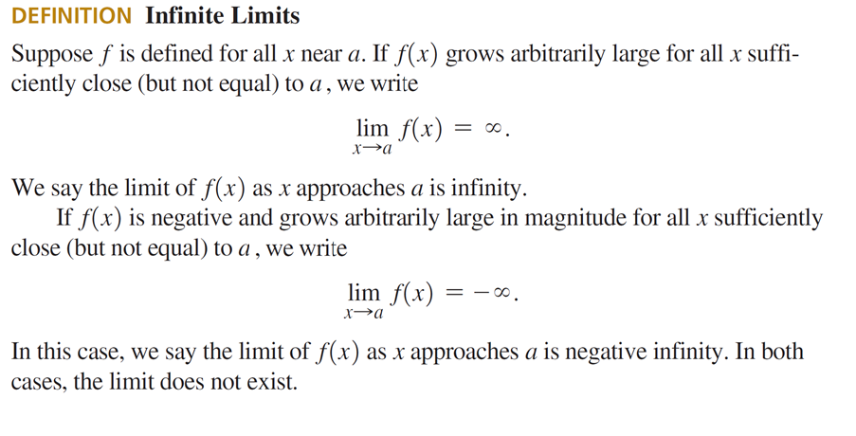
Example 4: An Infinite Limit Find $\lim_{x→1}{\frac{x}{{\left(x^{2}-1\right)}^{2}}}$and $\lim_{x→-1}{\frac{x}{{\left(x^{2}-1\right)}^{2}}}$
Solution: The graph of $f\left(x\right)=\frac{x}{{\left(x^{2}-1\right)}^{2}}$ in figure below shows that as x approaches 1 from either side, the values of $f$ grow arbitrarily large, so the limit does not exist and we write $\lim_{x→1}{\frac{x}{{\left(x^{2}-1\right)}^{2}}}=∞$
As x approaches −1 from either side, the values of $f$ are negative grow arbitrarily large in magnitude, so the limit does not exist and we write $\lim_{x→-1}{\frac{x}{{\left(x^{2}-1\right)}^{2}}}=-∞$
