**Chapter 3**

**3.1 Limits**

The limit of a function

Consider the function $f\left(x\right)=x^{2}-x+2$ for values of *x* near 2. The table below gives the values of $y=f\left(x\right)$ when *x* is closed to 2, but not equal to 2. We can see that the closer x approaches 2 from either side, the closer $f\left(x\right)$ approaches 4.

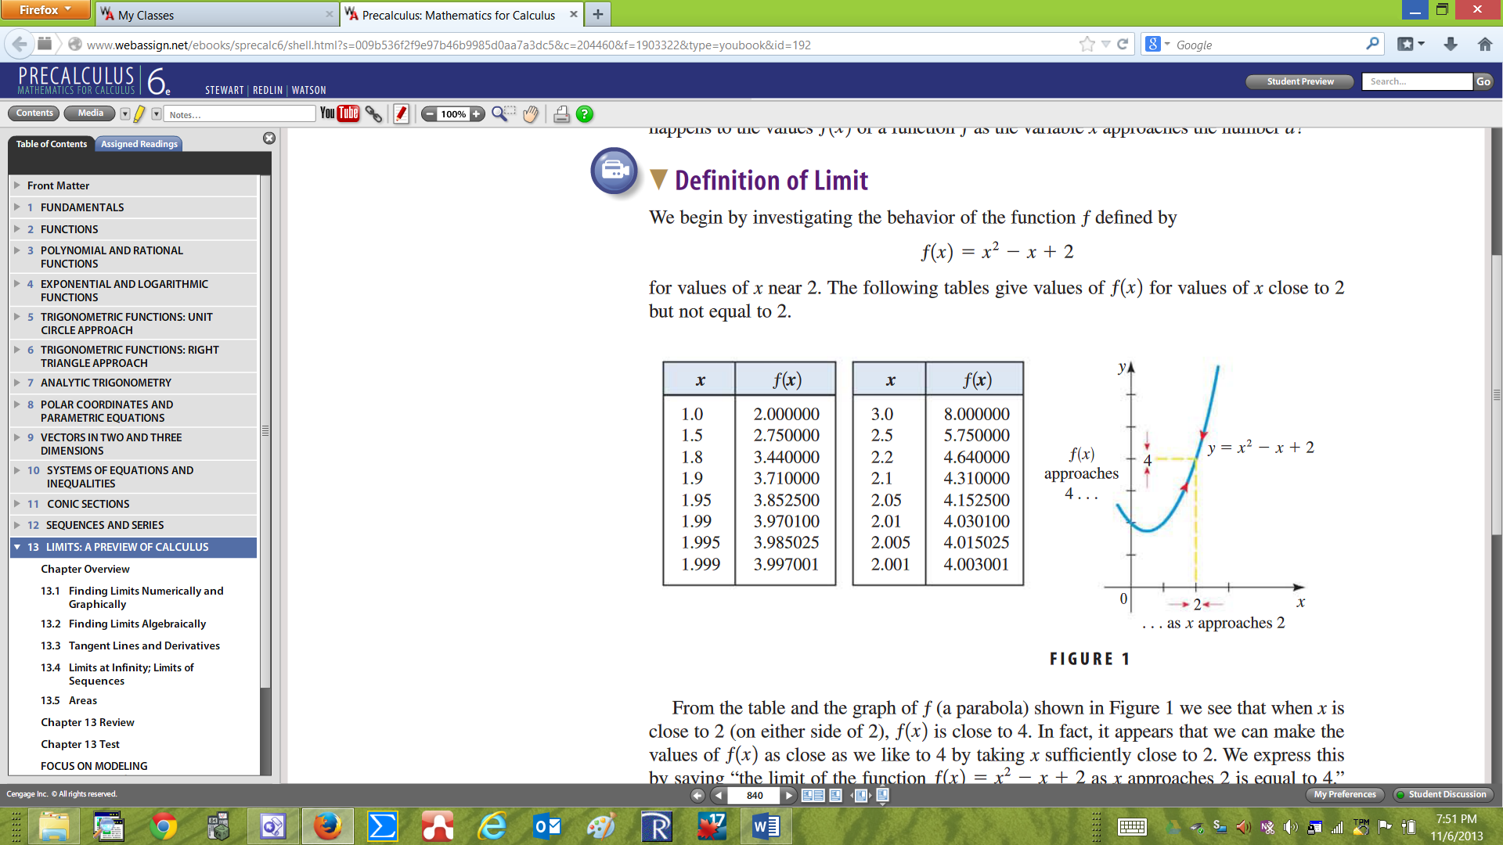

To express this situation, we can write $\lim_{x→2}{f\left(x\right)=\lim_{x→2}{x^{2}-x+2=4}}$.

In general, the limit of the function $f\left(x\right)$ tell us what value the function is “approaching to” when $x$ is approaching a number say $x=a$ in the domain of the function. The limit of the function does not refer to *f* (a) (the value the function takes at $x=a$.)

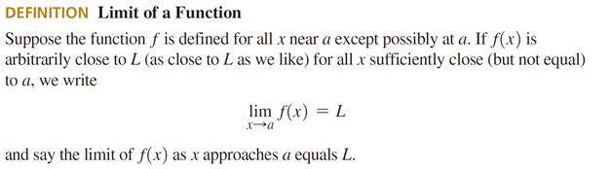

**Example1**: Consider the piecewise function $g\left(x\right)=\left\{\begin{aligned}\frac{x^{2}-1}{x-1} if x≠1 \\ -1 if x=1\end{aligned}\right\}$. Find $\lim_{x→1}{g\left(x\right)}$, and $g\left(1\right).$

Solution: This is a linear function with a discontinuity at $x=1$. We can see that when x approaches 1, $g\left(x\right)$ approaches 2, so $\lim_{x→1}{g\left(x\right)}=2$, whereas $g\left(1\right)=-1$.

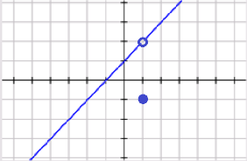

From this example we can see that $\lim_{x→1}{g\left(x\right) ≠g(1)}$.

**Example 2**: Find $\lim_{x→3}{f\left(x\right)}$, and $f\left(3\right)$ in the figure below:

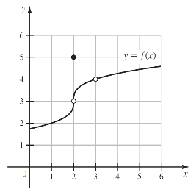 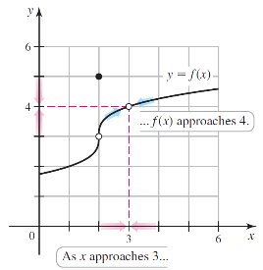

Solution: We can see that when x approaches 3, $f\left(x\right)$ approaches 4, so $\lim_{x→3}{f\left(x\right)}=4$. Since 3 is not in the domain of $f$, $f\left(3\right)$ is undefined.

From this example we can see that the limit exists at 3 even though $f\left(3\right)$ is undefined.

**One- Sided Limits**

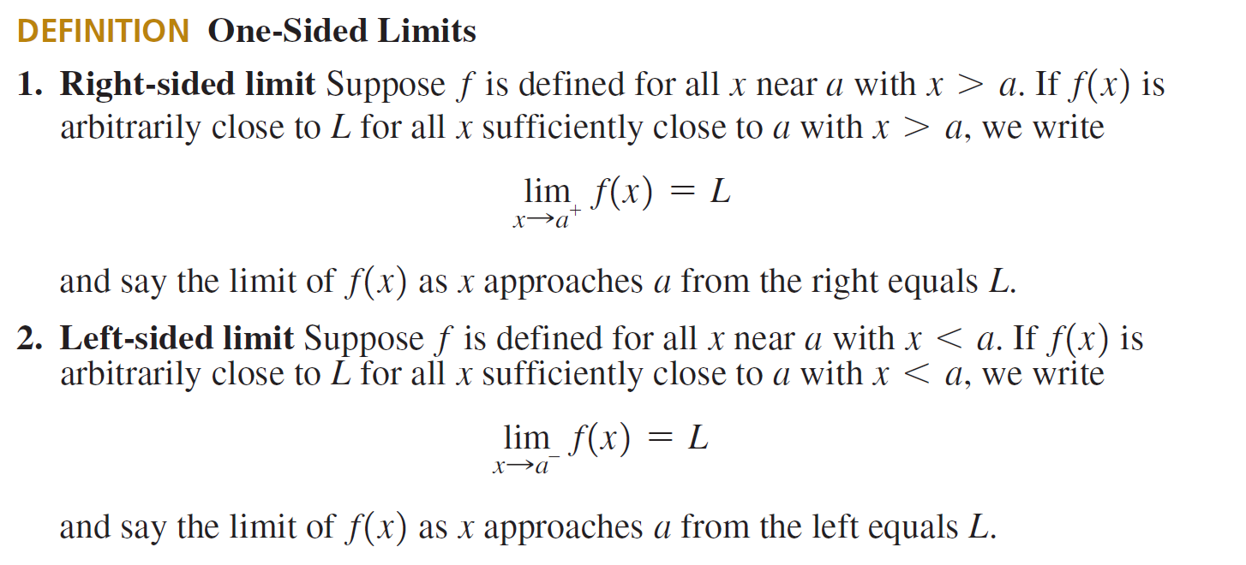

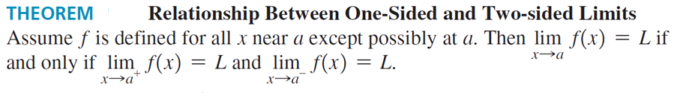

The theorem tells us that for the limit to exist, the limit from the right has to equal the limit from the left.

**Example 3**: **A Function with a Jump:** Find $\lim_{x→2^{-}}{g\left(x\right), \lim_{x→2^{+}}{g\left(x\right)}}$ and $\lim_{x→2}{g\left(x\right)}$ in the figure below:

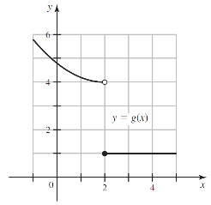

Solution: As x approaches 2 from the left, $g$ approaches 4. Therefore, $\lim_{x→2^{-}}{g\left(x\right)=4}.$

As x approaches 2 from the right, $g$ approaches 1. Therefore, $\lim_{x→2^{+}}{g\left(x\right)=1}.$

$\lim_{x→2}{g\left(x\right)}$ does not exist (DNE) because $\lim_{x→2^{-}}{g\left(x\right)≠ \lim_{x→2^{+}}{g\left(x\right)}}$. (The right limit differs than the left limit)

Finding Limits Algebraically (Limits Laws)

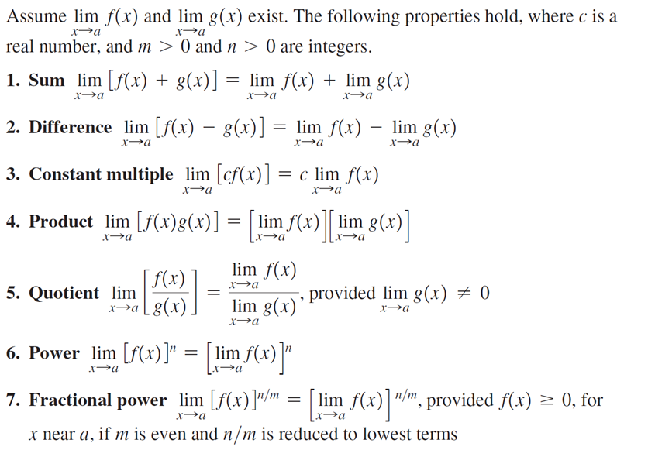

**Example 4**: **Finding Limit by Canceling Common Factors:** Find $\lim_{x→1}{\frac{x^{2}-1}{x-1}}$**.**

**Solution: $\lim_{x→1}{\frac{x^{2}-1}{x-1}}= \lim_{x→1}{\frac{\left(x-1\right)\left(x+1\right)}{x-1}=\lim_{x→1} x+1=2} .$**

**Example 3**: **Finding Limit by Simplifying:** Find $\lim_{h→0}{\frac{{(3+h)}^{2}-9}{h}}$**.**

**Example 4**: **Finding Limit by Rationalizing:** Find $\lim_{x→1}{\frac{\sqrt{x}-1}{x-1}}$

**Solution: $\lim_{x→1}{\frac{\sqrt{x}-1}{x-1}}=\lim_{x→1}{\frac{(\sqrt{x}-1)(\sqrt{x}+1)}{(x-1)(\sqrt{x}+1)}}$**  where we have multiplied numerator and denominator by the conjugate of the numerator $\left(\sqrt{x}+1\right)$. This makes the numerator a difference of squares, so $\lim_{x→1}{\frac{(\sqrt{x}-1)(\sqrt{x}+1)}{(x-1)(\sqrt{x}+1)}}=\lim_{x→1}{\frac{(x-1)}{(x-1)(\sqrt{x}+1)}}=\lim_{x→1}{\frac{1}{(\sqrt{x}+1)}}=\frac{1}{2}$. If you realize that $x-1$ is a difference of squares, you have $\lim_{x→1}{\frac{\sqrt{x}-1}{x-1}}=\lim_{x→1}{\frac{(\sqrt{x}-1)}{(\sqrt{x}-1)(\sqrt{x}+1)}}=\frac{1}{2}$

**Example 5**: **The Limit of a Piecewise Function:** Find $\lim_{x→4}f(x)$ if it exist, where

$$f\left(x\right)=\left\{\begin{aligned}\sqrt{x-4} if x>4 \\ 8-2x if x<4\end{aligned}\right\}$$

**Solution:** Since $f\left(x\right)=\sqrt{x-4} if x>4$, $\lim_{x→4^{+}}f\left(x\right)=\lim_{x→4^{+}}\sqrt{x-4} =0$.

Since $f\left(x\right)=8-2x if x<4$, $\lim_{x→4^{-}}f\left(x\right)=\lim_{x→4^{-}}8-2x =0$.

Since the right and left-hand limits are equal, the limit exist, and $\lim_{x→4}f\left(x\right)=0$**.**

**Infinite Limits**

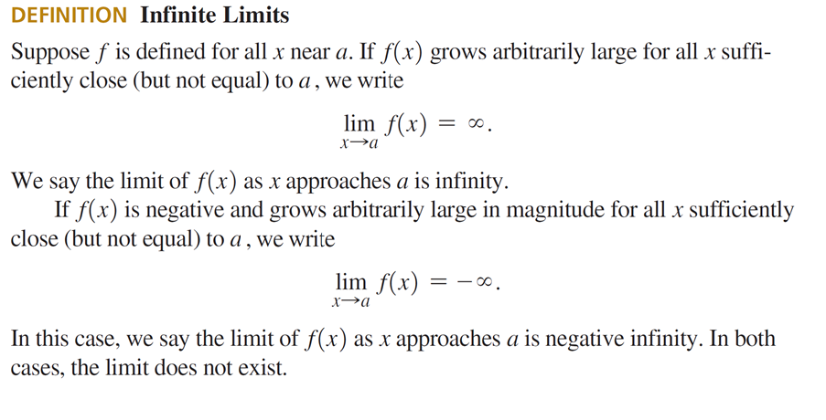

**Example 6**: **An Infinite Limit from the Graph:** Find $\lim_{x→1}{\frac{x}{{\left(x^{2}-1\right)}^{2}}}$ and $\lim_{x→-1}{\frac{x}{{\left(x^{2}-1\right)}^{2}}}$

Solution: The graph of $f\left(x\right)=\frac{x}{{\left(x^{2}-1\right)}^{2}}$ in figure below shows that as x approaches 1 from either side, the values of $f$ grow arbitrarily large, so the limit does not exist and we write $\lim_{x→1}{\frac{x}{{\left(x^{2}-1\right)}^{2}}}=∞$

As x approaches −1 from either side, the values of $f$ are negative grow arbitrarily large in magnitude, so the limit does not exist and we write $\lim_{x→-1}{\frac{x}{{\left(x^{2}-1\right)}^{2}}}=-∞$

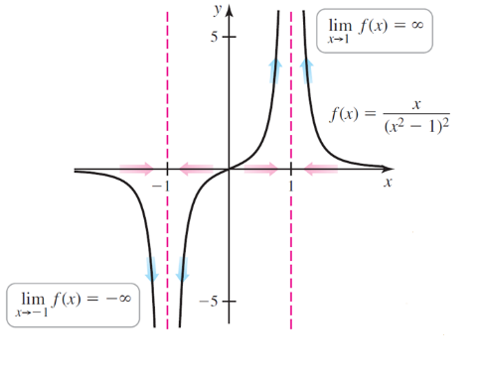

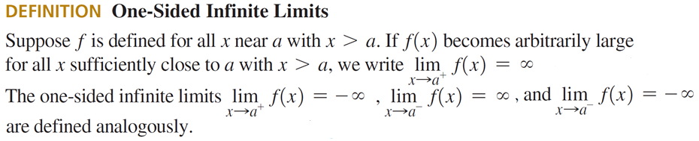

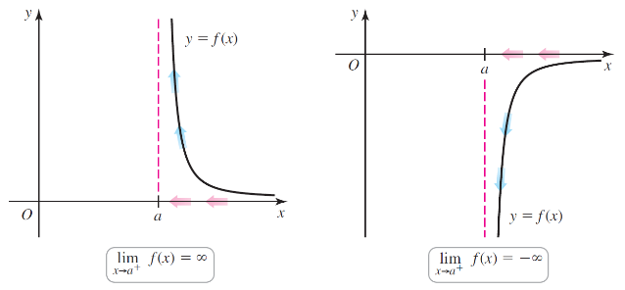 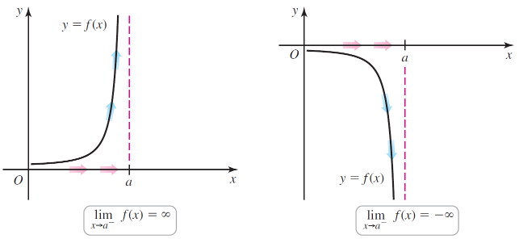

**Example 7**: **Evaluating Limits Analytically:** Find $\lim_{x→1^{+}}{\frac{x^{2}+x-2}{{\left(x-1\right)}^{2}}}$, $\lim_{x→1^{-}}{\frac{x^{2}+x-2}{{\left(x-1\right)}^{2}}}.$ and $\lim_{x→1}{\frac{x^{2}+x-2}{{\left(x-1\right)}^{2}}}.$

Solution: $\lim_{ x→1^{+}}{\frac{x^{2}+x-2}{{\left(x-1\right)}^{2}}}=\lim_{x→1^{+}}{\frac{x+2}{x-1}=∞}$ since the function is positive approaching $x=1$ from the positive side.

$\lim_{x→1^{-}}{\frac{x^{2}+x-2}{{\left(x-1\right)}^{2}}}=\lim_{x→1^{-}}{\frac{x+2}{x-1}=-∞}$, since the function is negative approaching $x=1$ from the negative side.

$\lim_{x→1}{\frac{x^{2}+x-2}{{\left(x-1\right)}^{2}}}=\lim_{x→1}{\frac{x+2}{x-1}DNE}$ since the right limit differs from the left limit.

**Limits at Infinity**

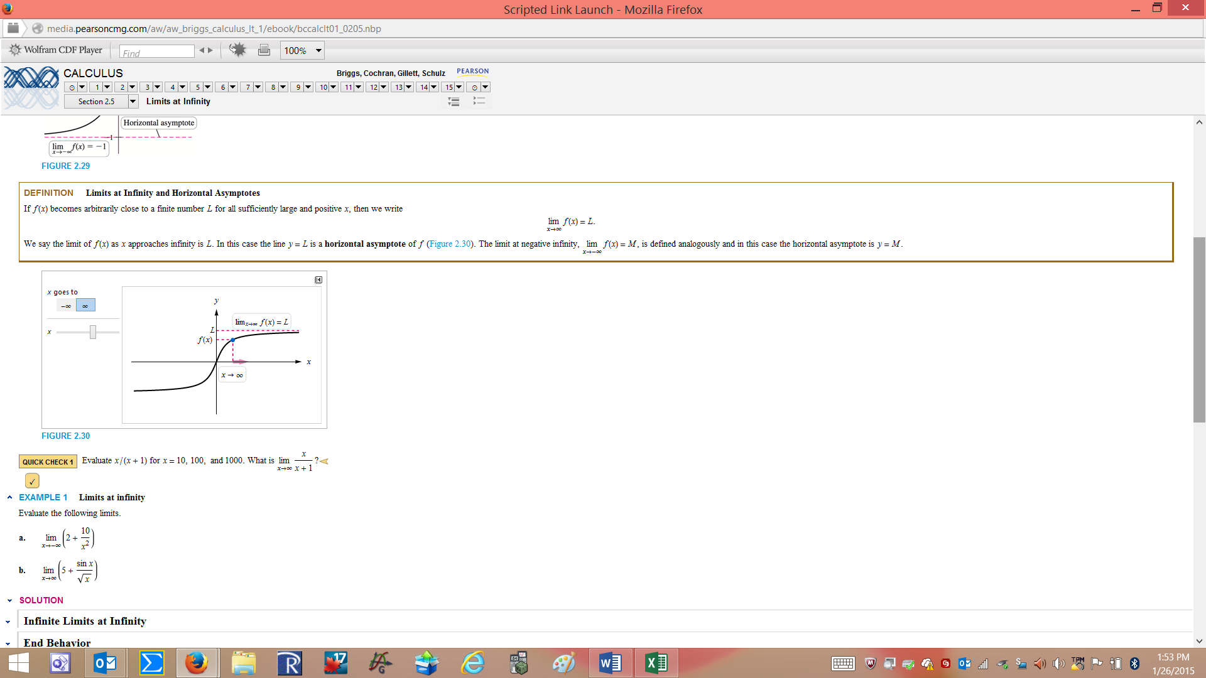

If $f\left(x\right)$ becomes arbitrarily close to a finite number *L* for all sufficently large positive *x*, then we write $\lim_{x→∞}{f\left(x\right)=L}$.We say that the limit of $f$ as *x* approaches ∞ is *L*. In this case the line *y = L* is a horizontal asymptote. The limit at negative infinity $\lim_{x→-∞}f\left(x\right)=M$, is defined analogously and in this case the horizontal assymptore is the line *y = M*.

**Example 8**: **Limits at Infinity:** Find $\lim_{x→±∞}{\frac{1}{x^{2}}}$.

Solution: As the denominator becomes infinitely large, both for positive and negative numbers, the numerator tends to zero, so $\lim_{x→±∞}{\frac{1}{x^{2}}}=0$.

**Example 9**: **Limits at Infinity of Rational Functions:** Find $\lim_{x→±∞}{\frac{6x^{2}+2x+1}{3x^{2}+3x-2}}$.

Solution: Divide both the numerator and denominator by *x* raised to the highest power in the denominator, so

$\lim_{x→±∞}{\frac{6x^{2}+2x+1}{3x^{2}+3x-2}}=\lim_{x→±∞}{\frac{6+\frac{2}{x}+\frac{1}{x^{2}}}{3+\frac{3}{x}-\frac{2}{x^{2}}}}=2$.

**Example 10**: **Infinite** **Limits at Infinity:** Find $\lim_{x→-∞}{\frac{6x^{3}}{x^{2}+1}}$.

Solution: $\lim_{x→-∞}{\frac{6x^{3}}{x^{2}+1}}=\lim_{x→-∞}{\frac{6x}{1+\frac{1}{x^{2}}}}=-∞$.

**Example 11**: **Limits with Absolute Values:** Find $\lim_{x→-0}{\frac{|x|}{x}. }$

Solution: Since $\left|x\right|=\left\{\begin{aligned} x if x≥0 \\ -x if x<0\end{aligned}\right.$, $\frac{|x|}{x}=\left\{\begin{aligned} 1 if x≥0 \\ -1 if x<0\end{aligned}\right.$ so $\lim_{x→-0}{\frac{|x|}{x}}$ does not exist (DNE)

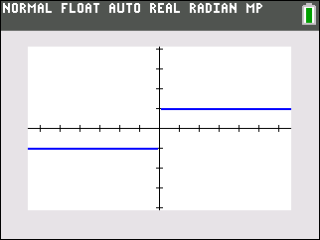

Your Turn:

1. Find the Following limits. If the limit does not exist (DNE) explain why.

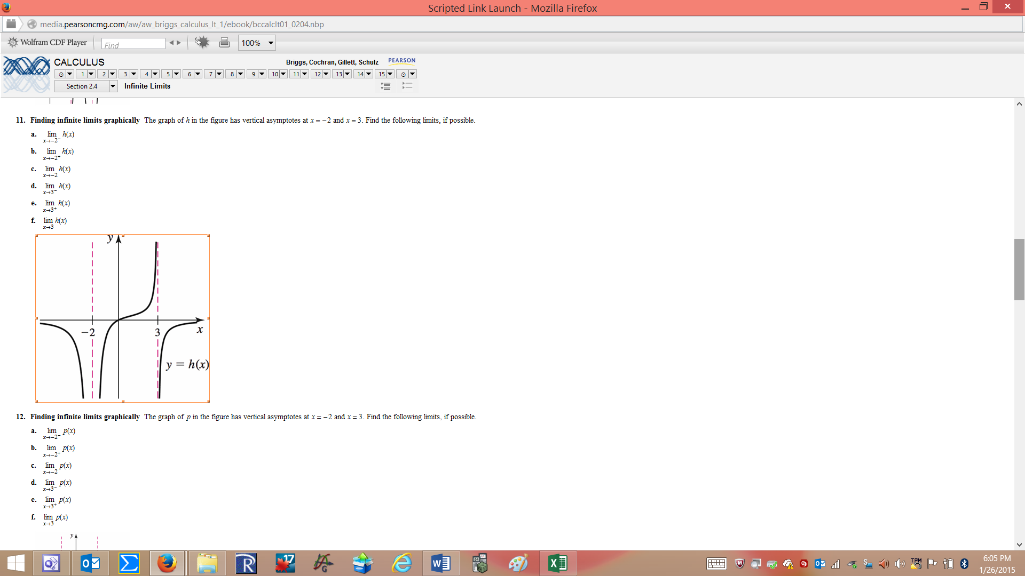



5)

6)

7) Find

8)

9) $\lim_{x→-∞}{\frac{x+1}{4x^{2}+1}}=$

10) $\lim_{x→∞}{e^{-x}}=$

**3.2 Continuity**

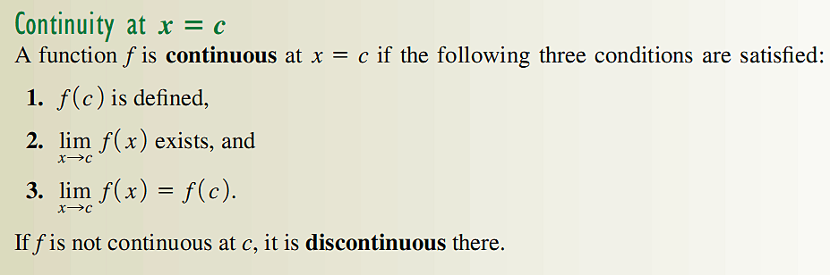

1. Determine if each of the functions below are continuous. If not, describe the condition it does not satisfy.

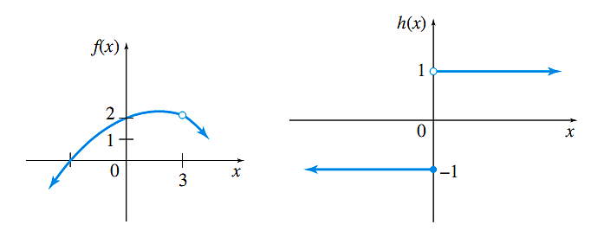  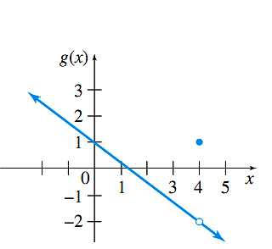

1. Find all values of *x* where the piecewise function is discontinuous.



1. Find the points of discontinuity of $f\left(x\right)=\frac{|x-1|}{x-1}$. Give the limit of the function at the points of discontinuity.
2. Use limit to find *k* such that $h\left(x\right)=\left\{\begin{aligned}2x+2 if x<1 \\ \frac{k}{2} if x≥1\end{aligned}\right\}$ is continuous at *x*=1.

**3.3 Average Rate of Change**

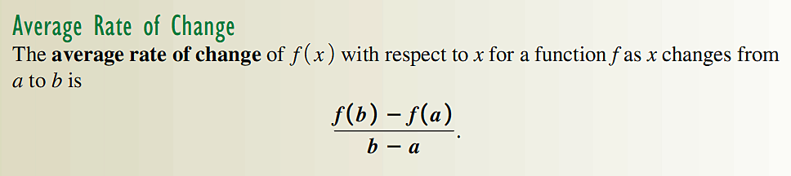

1. The graph below shows the percentage of households in the United State with landlines telephones for the years 2005-2009. Find the average rate of change in the percent of households with landlines between 2007 and 2009.

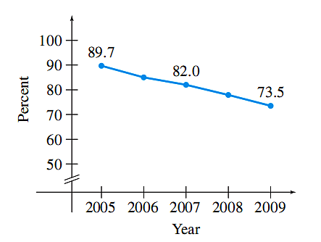

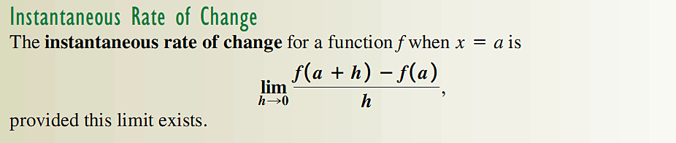

1. Find the instantaneous rate of change of $f\left(x\right)=x^{2}-3x+4$ at the point $x=2$.
2. A company determines that the cost of manufacturing *x* cases of DVD is given by

$C\left(x\right)=x^{2}-2x+12$. Find (a) the average rate of change of cost per case for manufacturing between 3 and 5 cases, (b) the cost when production is increased from 4 to 5 cases, and (c) the instantaneous rate of change of cost with respect to the number of cases produced when 4 cases are produced.

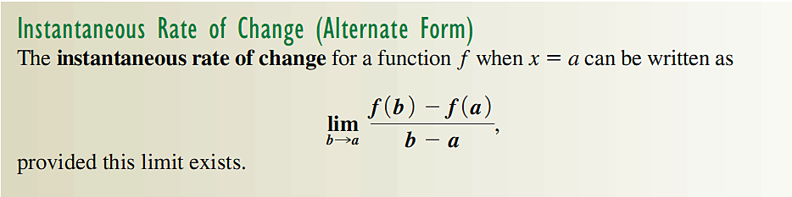

1. Use the alternate form to find part c of the previous problem.

**3.4 Definition of the Derivative**

Slope of the Secant Line

The slope of the secant line at the point between the points $x=a$ and $x=b$ on the function

$y=f\left(x\right)$ is given by $m_{sec}=\frac{f\left(b\right)-f(a)}{b-a}$. This is the same expression we used on the last section to find the Average Rate of Change.

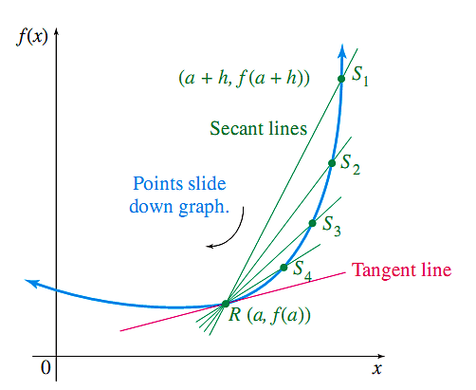

Slope of the Tangent line

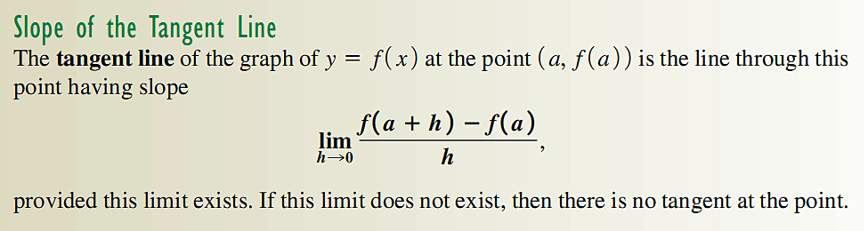

This is the definition we used on the last section to find the Instantaneous Rate of Change.

1. For the graph of $f\left(x\right)=x^{2}-x$, find (a) the equation of the secant line through the points $x=-2$ and $x=1$, and (b) the equation of the tangent line at $x=1$.

The Derivative

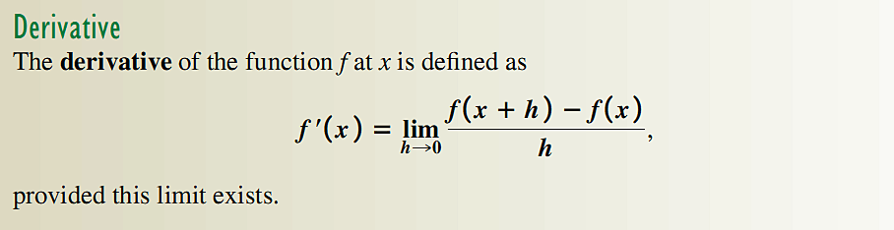

The derivative is denoted with a prime, and $f'\left(x\right)$ is read “*f* -prime of *x*”.

The process of finding derivatives is called differentiation.

The difference quotient and the derivative have many interpretations.

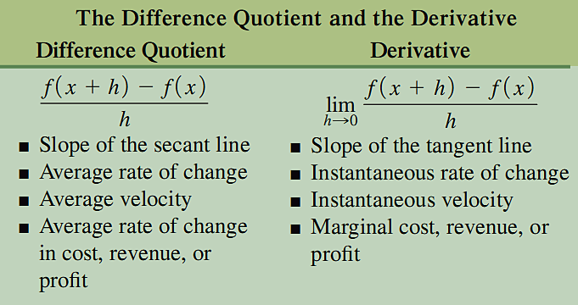

The difference quotient is the same expression $\frac{f\left(b\right)-f(a)}{b-a}$, if we let $a=x$, and

$b=a+h$

There is an alternate form of the derivative

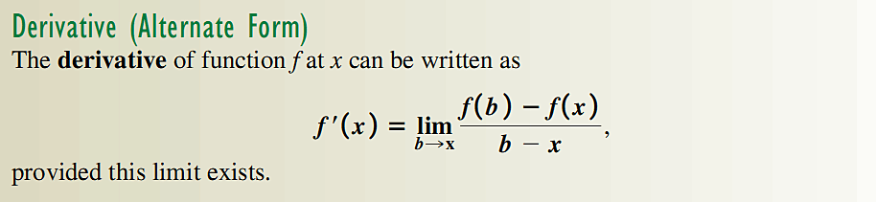

1. Find the derivative of $f\left(x\right)=x^{2}-x$, and then find $f'\left(-2\right)$.
2. The cost in dollars of manufacturing *x* graphing calculator is given by

$C\left(x\right)=10x-0.002x^{2}$, find the rate of change of the cost when producing 100 calculators.

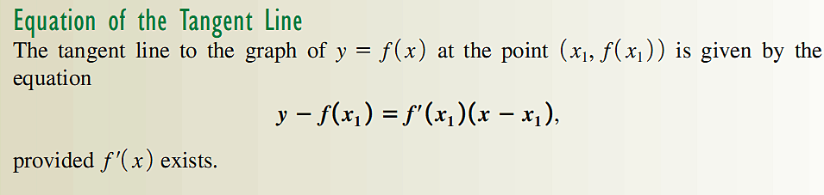

1. Find the equation of the tangent line to the graph of $f\left(x\right)=\sqrt{x}$ at $x=4$

Existence of the Derivative

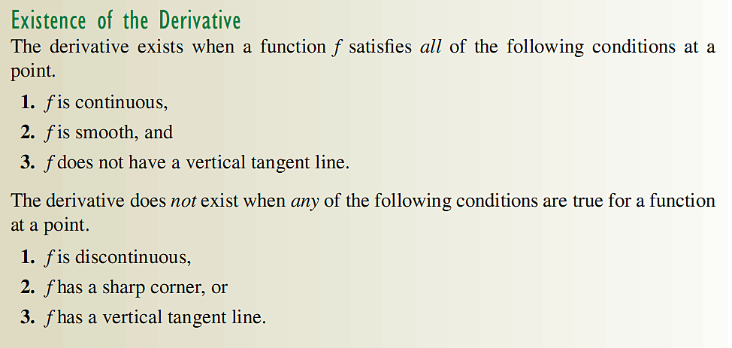

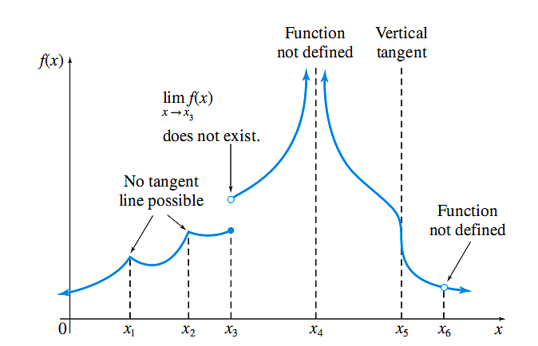

**Chapter 4**

**4.1 Techniques for Finding Derivatives**

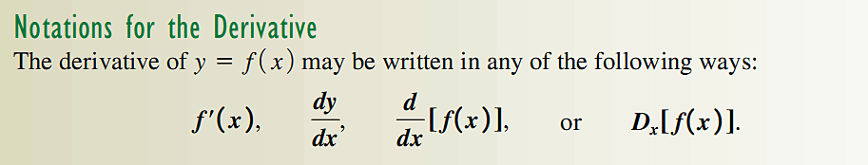

Constant Rule: If $f\left(x\right)=k$, $f'\left(x\right)=0$ for any real number $k$.

Power Rule: If $f\left(x\right)=x^{n}$, $f'\left(x\right)={nx}^{n-1}$ for any real number $n$.

Constant times a Function; If $f\left(x\right)=kg(x)$, and $g'(x)$ exists, $f'\left(x\right)=kg'(x)$ for any real number $k$.

Sum or Difference Rule: If $f\left(x\right)=u(x)±v(x)$, where $u'(x)$ and exist,

.

1) Find the derivative of the following functions:

a) .

b) .

c)

d)

e)

f)

2) For , find all values of $x$ where the tangent line is horizontal.

Marginal Analysis:

The Marginal Cost $C^{'}\left(x\right)$, where $x$ is the number of items, is an approximation of the cost of producing the $x+1$ item.

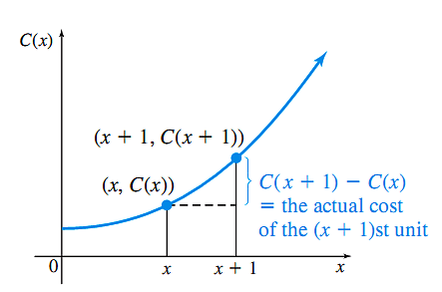 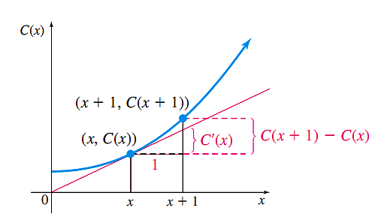

1. Suppose that the total cost in hundreds of dollars to produce $x$ thousand barrels of a beverage is given by $C\left(x\right)=5x^{3}-10x^{2}+75$. Approximate the cost of producing the 101st thousand barrels. Find the actual cost.

The Marginal Revenue $R^{'}\left(q\right)$, where $q$ is the number of units, is an approximation of the revenue of selling the $q+1$ unit.

1. If the demand function is given by $p\left(q\right)=16-1.25q$, find the marginal revenue when $q=5.$ Recall that the demand function, defined by $p=D(q)$, relates the number of units $q$ of an item that consumers are willing to purchase at the price $p$. The revenue

$$R\left(q\right)=pq$$

The Marginal Profit $P^{'}\left(q\right)$, where $q$ is the number of items, is an approximation of the profit of producing and selling the $q+1$ item.

1. The cost of producing *x* items is given by $C\left(x\right)=-0.02x^{2}+50x+100$, at a price of $p=100-0.01x$. Find the profit obtained by selling the next item, given that 500 have already sold.

**4.2 Derivatives of Products and Quotients**

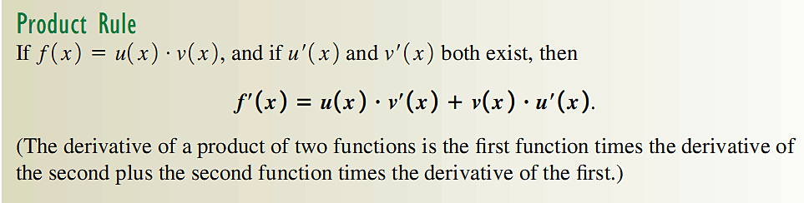

4) Use the product rule to find the derivative of $h\left(x\right)=x^{2}(x+1)$.Compare your answer when you differentiate by expanding the function first.

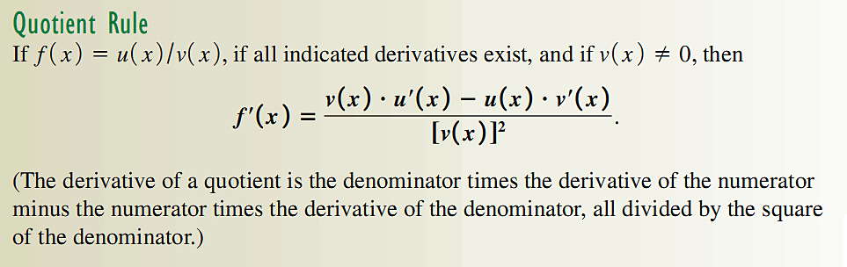

7) Use the quotient rule to find the derivative of $f\left(x\right)=\frac{x^{2}-1}{x-1}.$ Compare your answer when you differentiate by simplifying the function first.

Average and Marginal Average Cost

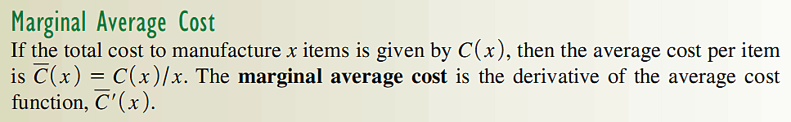

8) Suppose the cost is given by $C\left(x\right)=\frac{4x+50}{x+2}.$ Find the marginal average cost.

**4.3 The Chain Rule**

The chain rule is used to find derivatives of composition of functions.

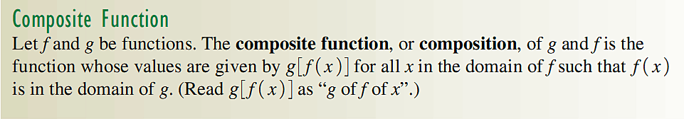

9) Write as a composition of two functions $f$ and $g$ so that .

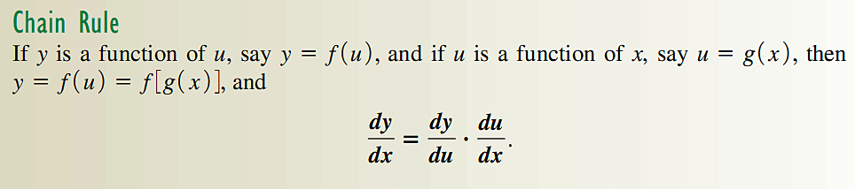

10) Find if

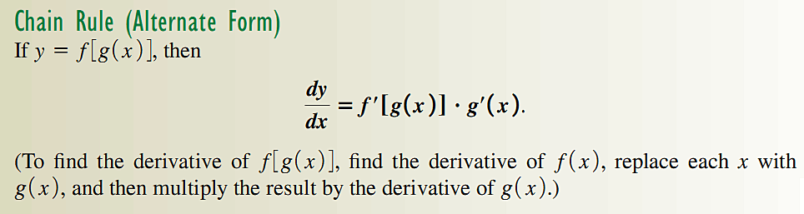

11) Find

12) If, then find .

13)

14) Find if .

15) Find if $h\left(x\right)=\frac{x}{{\left({2x}^{2}+6x\right)}^{4}}$.

**4.4 Derivatives of Exponential Functions**

**Derivative of ex**

To find the derivative of *f*(*x*) = *e*x we will use the definition of the derivative.





Using a law of exponents  and so the above limit becomes



The numerator can be factored and we get



To get an estimate of the limit above we will look at a table of values.

|  |  |
| --- | --- |
| h |  |
| 0.1 | 1.052 |
| 0.01 | 1.005 |
| 0.001 | 1.0005 |
| 0.0001 | 1.0001 |
| 0.00001 | 1.000005 |

This gives the formula



1. Find the equation of the tangent line to y = *ex* at x = 0.

**Solution**: The point on the curve y = *ex* at x = 0 is (0, *e*0) = (0,1). The slope of the tangent line is  . At x = 0 the slope = *e*0 = 1. Thus the equation of the tangent line is y – 1 = 1(x – 0) or simplified we get y = x + 1.

1. Find the derivative of *f*(*x*) = *x*2*ex*.

**Solution**: Using the product rule gives



.

In most applications the function involved is not just $e^{x}$ but rather instead functions which have the form . As we will see, this type of function can be differentiated using the Chain Rule.

Suppose that y =  . Let *u* = *f*(*x*). Then y =  . By the Chain Rule





This result is worth emphasizing.



1. Find the derivative of .

**Solution**: Using the formula in the box above we get





**Derivative of $a^{x}$**

For any positive constant $a$ ≠ 0

$$\frac{da^{x}}{dx}=\frac{d{[e}^{lna^{x}}]}{dx}=\frac{d{[e}^{xlna}]}{dx}=\frac{d{[e}^{(lna)x}]}{dx}=\ln\left(a\right)e^{(lna)x}=a^{x}ln⁡(a)$$

1. Find the derivative of $y=2^{x}$.

**Solution**: Using the formula above, 

Suppose that, The derivative will be given by



1. Find the derivative of $f\left(x\right)=3^{\sqrt{x}}$.

**Solution**: Using the formula above, $\frac{d}{dx}3^{\sqrt{x}}=\frac{3^{\sqrt{x}}}{2\sqrt{x}}ln⁡(3)$.

1. Find the derivative of each of the following functions.

1.  2.  3. 

4.  5.  6. 

7.  where *A* and *c* are constants. 8. 

9.  10. 

7) After the introduction of a new product, the percentage of public that is aware of the product can be approximate by $A\left(t\right)=10t^{2}2^{-t}$, where *t* is the time in months. Find the rate of change of the percentage of public that is aware of the product after 2 months.

**4.5 Derivatives of Logarithmic Functions**

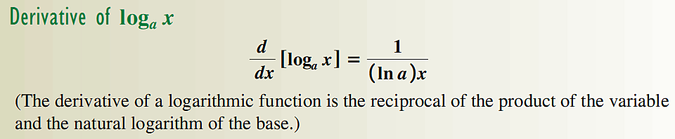

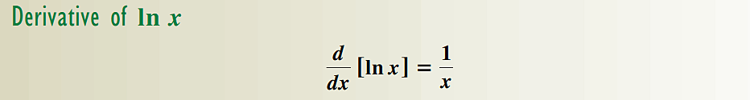

1. Find the derivative of $f\left(x\right)=logx$.
2. Find the derivative of $f\left(x\right)=\log_{3}x$.
3. Find the derivative of $f\left(x\right)=ln⁡(x^{2}-2x+1)$.
4. Find the derivative of $g\left(x\right)={log⁡}_{3}({5x}^{2}-2)$.
5. Find the derivative of $h\left(x\right)=ln⁡x^{2}\sqrt{x^{2}-1}$.

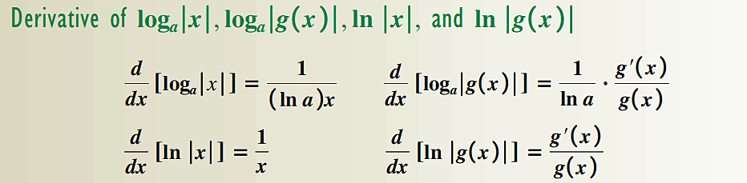

1. Find the derivative of $v\left(t\right)=ln⁡|3t^{2}|$.
2. The cost function for q units of a certain item is $C\left(q\right)=87q+100$.The revenue function for the same item is $R\left(q\right)=87q+\frac{40q}{ln⁡(q)}$.

a. Find the marginal cost.

b. Find the profit function.

c. Find the profit from one more unit sold when 8 units are sold.

1. Suppose the cost is given by $C\left(x\right)=\frac{xln\left(x\right)-50x}{x+2}.$ Find the marginal average cost.