* 1. **Slopes and Equations of Lines:**

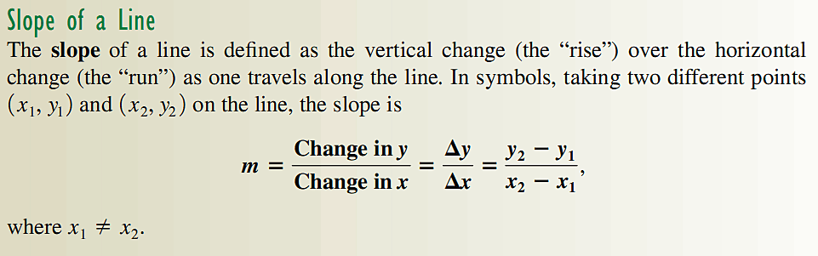 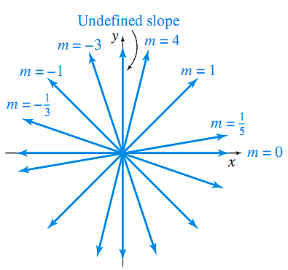

1. Find the slope of the line through (−3,2) and (4, −6). Ans: -8/7

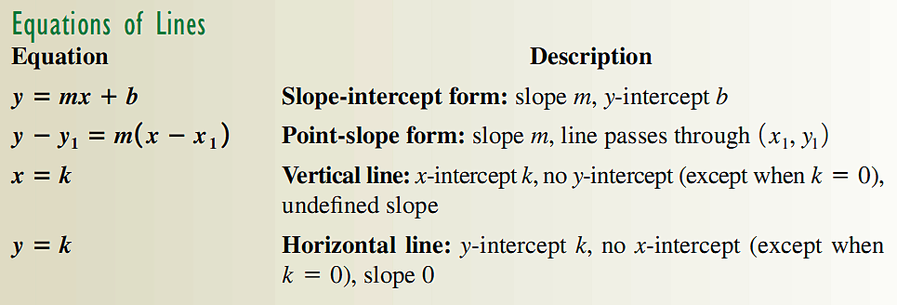

1. Find the equation of the line with *x*-intercept 2 and *y*-intercept −5. Ans: *y* =5*x*/2 −5
2. Find the slope of the line whose equation is 3*x*−2*y* =3. Ans: m =3/2
3. Find the equation of the line through (−3,3) and (5,7). Express your answer in point-slope form and slope-intercept form. Ans: *y*−7=1/2(*x*−5); *y*=1/2*x*+9/2
4. Find the equation of the line through the points (5, −2) and (5,3). Ans: *x*=5
5. Find the equation of the line through the points (2,3) and (5,3). Ans: y =3
6. Find the equation of the lines through the point (1,2) that are parallel and perpendicular to the line 3*x*−6*y* =3. Ans: *y*=1/2*x*+3/2; *y*=−2*x*+4
7. Graph the line 3*x*−6*y* =12.
8. In 2000, a house was purchased for $320K. In 2010 it was appraised for $450K.
9. Write an equation for the value (V), in thousands of dollars, of the house in terms of t, which represent the years since 2000. Ans: V=13t+320
10. What will the house be worth in the year 2018 if the appraised value of the house increases linearly? Ans: 554K
11. Support your answer graphically.
12. What does the slope of the line represent? Ans: Value increase by 13k/yr.
    1. **Linear Functions and Applications**

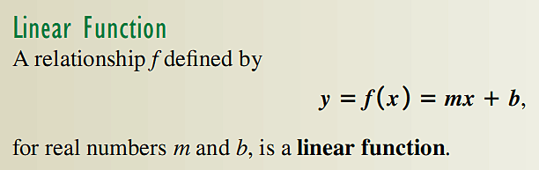

Supply and Demand

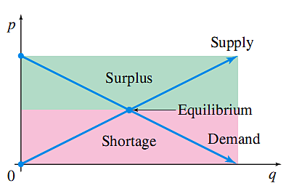

1) The demand for sunflower seeds at Centerville Farmer’s Market is given by p= -.02q+13.2, where p is the price per bushel, and q the number of bushels sold per day. The supply of sunflower seeds is given by p= .05q+6.9.

1. Find the equilibrium value of q (number of bushels). Ans: q=90 bushels
2. Find the market-clearing price p. Ans: p=$11.40
3. Check your answer graphically.

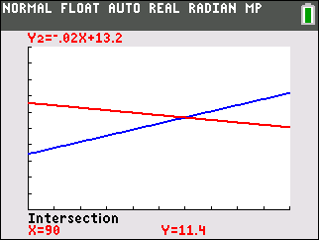

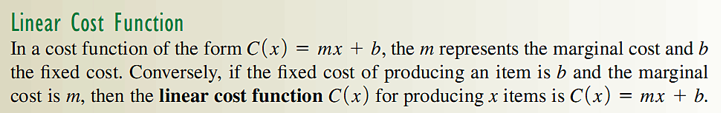

2) The marginal cost to make *x* batches of a prescription medication

is $15 per batch, while the cost to produce 80 batches is $1930.

Find the cost function *C*(*x*), given that it is linear. Ans: C(x)=15x+730

Hint: m=ΔC/Δ*x*

Break-Even Analysis

3) A firm producing poultry feed finds that the total cost *C*(*x*) in

dollars of producing *x* units, is given by *C*(*x*)=20x+100.

Management plans to charge $24 per unit for the feed.

1. How many units must be sold for the firm to break even?
2. What is the profit if 100 units of feed are sold?
3. How many units must be sold to produce a profit of $900?

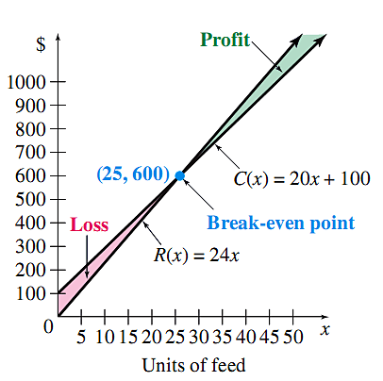

Ans: (a) 25; (b) $300; (c) 250

4) Busicalc business calculators can be sold at a constant price of $90 each. Manufacturing these calculators requires fixed costs of $360 per hour and variable costs of $60 per unit. Up to 30 calculators can be manufactured every hour.

1. Obtain the profit as a function of output q with a suitable domain. Ans: P(q)=30q-360
2. Determine the break-even point. Ans: (12,1080)
3. If the plant is operated at capacity, what is the resulting hourly profit. Ans: $540
4. How many calculators are manufactured on an hour when total production costs are $1800. Ans: 24
5. Check your answers graphically.

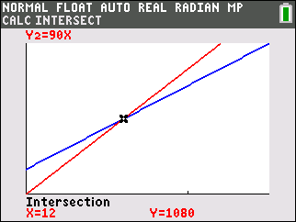 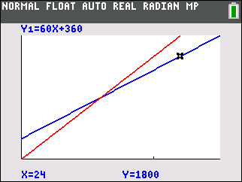

5) Yoga is an ancient physical and spiritual discipline and branch of philosophy that originated in India. Yoga began to grow in popularity in the United States in the 1960s and is now considered part of the mainstream of American culture. Meditation Studio charges $12 per drop-in session, plus a one-time fee of $17 for a special microfiber towel to place on top of the floor mats for absorbing perspiration. Yoga Retreat Studio charges $8 per drop-in session plus $33 for the microfiber towel. Let *x* represent the number of sessions and *y* be the total cost for yoga lessons.

a. Write an equation for the total cost of membership to the Meditation Studio.

Ans: *y* = 12*x* + 17

b. Write an equation for the total cost of membership to the Yoga Retreat Studio.

Ans: *y* = 8*x* + 33

c. Solve the system of equations algebraically and interpret the solution. Answer in a

complete sentence.

Ans: We know *y* = 12*x* + 17 and *y* = 8*x* + 33, therefore12*x* + 17 = 8*x* + 33, The solution is (4, 65). This means that a total cost of $65 will be the same in both studios for 4 yoga sessions.

d. If you wanted to take 9 yoga lessons in one of these two studios, which will be more cost-effective?

*Algebraically:*

Meditation Studio: *y* = 12(9) + 17 = 125 dollars

Yoga Retreat Studio:  *y* = 8(9) + 33 = 105 dollars

When *x* = 9, the Yoga Retreat Studio will be more cost-effective.

*Graphically:*

Note: Must choose an appropriate viewing window; we are using [0, 10, 1] by [0, 150, 20]

Meditation Studio: *Y1* = 12*x* + 17

Yoga Retreat Studio: *Y2* = 8*x* + 33 (bolded line)

* *

Observe that for *x* = 9, the Yoga Retreat Studio line is below the Meditation Studio

line, which shows that Yoga Retreat Studio will be more cost-effective for 9 sessions.

**2.1 Properties of Functions**

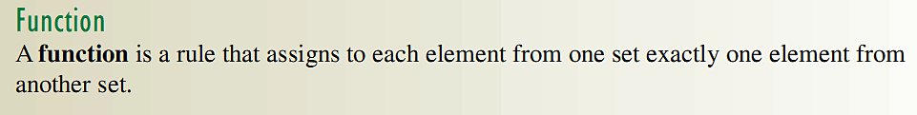

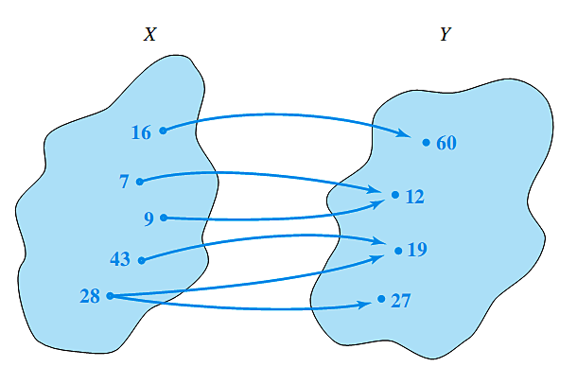

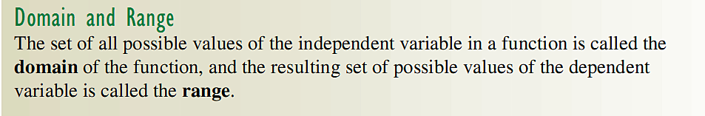

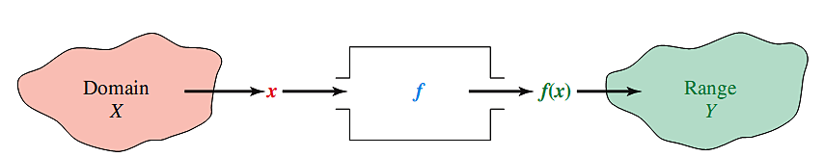

1. Find the domain and range for the function $f\left(x\right)=\sqrt{4-x^{2}}$. Ans: $-2≤x≤2$
2. Given the function $f\left(x\right)=x^{2}-2x+4$, find the difference quotient $\frac{f\left(x+h\right)-f(x)}{h}$.

Ans 2*x+*h−2

Symmetry

A function is even if $f\left(-x\right)=f\left(x\right)$ i.e. symmetric about the y-axis

A function is odd if $f\left(-x\right)=-f\left(x\right)$ i.e. symmetric about the origin.

1. Determine whether the following functions are even, odd or neither.
2. $f\left(x\right)=x^{4}-x^{2}$; b) $f\left(x\right)=\frac{x}{x^{2}+1}$; c) $f\left(x\right)=x^{4}-4x^{3}$

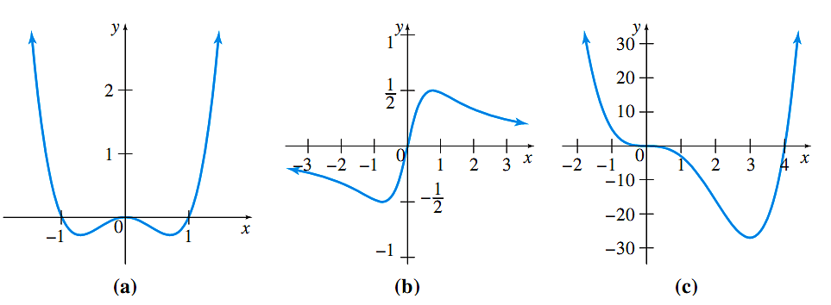

**2.2 Quadratic Functions; Translations and Reflections**

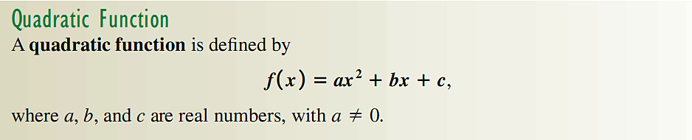

Zeros of Quadratic Functions

To find the zeros (x-intercepts) of a quadratic function, solve $f\left(x\right)=0$.

1. Find the zeros of $f\left(x\right)=x^{2}+3x+2$, by both factoring, and by using the quadratic formula. Ans: *x*= -1, -2

Completing the square

1. For the function $f\left(x\right)={2x}^{2}-6x-1$ (a) complete the square, (b) find the *y*-intercept, (c) find the *x-*intercepts, (d) find the vertex, and (e) sketch the graph. Ans: *v:*(3/2,-11/2), $x=\frac{3}{2}±\frac{\sqrt{11}}{2}$

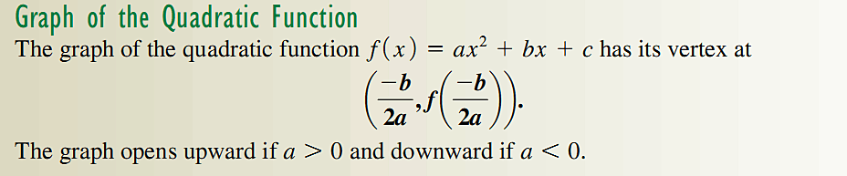

1. When Money Inc. charges $1600 for a seminar, it attracts 800 people. For each $40 decrease in the fee, an additional 80 people will attend. How much will they need to charge to maximize the revenue? What will be the maximum revenue? Ans: x=15,1K,2M
2. A deli owner has found that his revenue from producing $q$ pounds of some type of cheese is given by $R\left(q\right)={-q}^{2}+40q$, while the cost in dollars is given by $C\left(q\right)=8q+192$.

Find (a) the minimum beak-even quantity, (b) the maximum revenue, and (c) the maximum profit. Ans:R(q)=0 for q= 8, R(20)=$400,P(16)=64

Translation and reflection of graphs:

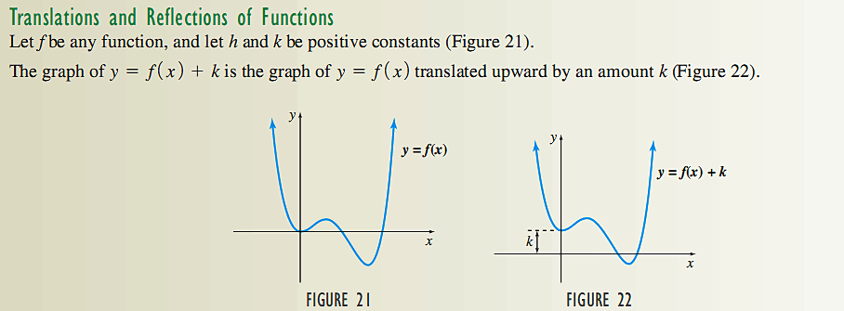  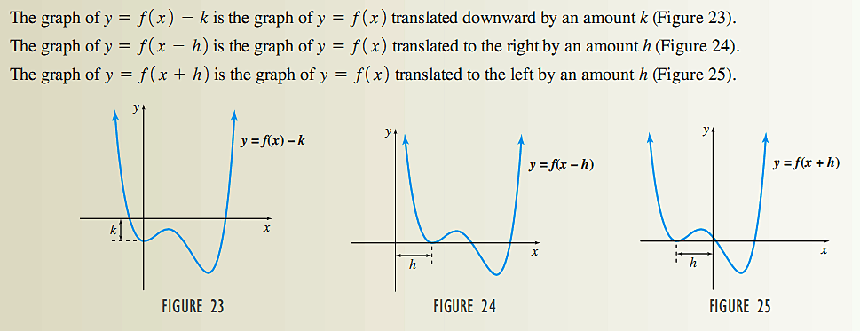 

 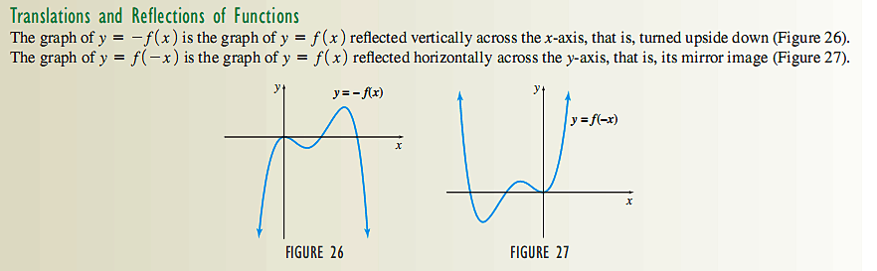 

1. Graph $f\left(x\right)=-{\left(x+2\right)}^{2}+3$
2. Graph $g\left(x\right)=\sqrt{x-2}-4$

**2.3 Polynomial and Rational Functions**

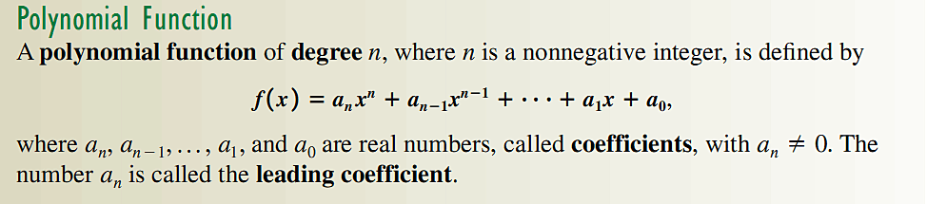

1. Use basic graphs to sketch the graph of $f\left(x\right)=-{\left(x+2\right)}^{3}+3$.

Degree of polynomials

A polynomial of degree n has at most n zeros (x-intercepts).

A polynomial of degree n has at most n-1 zeros turning points.

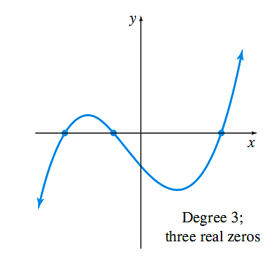 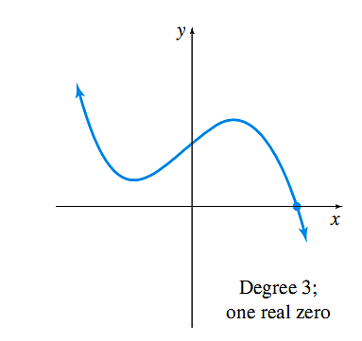 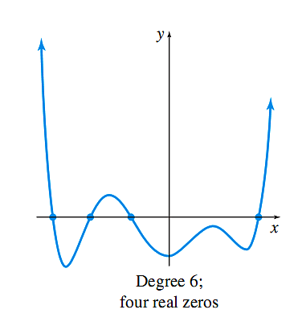

1. Identify the degree of the polynomials in the figure below, and give the sign for the leading coefficient.

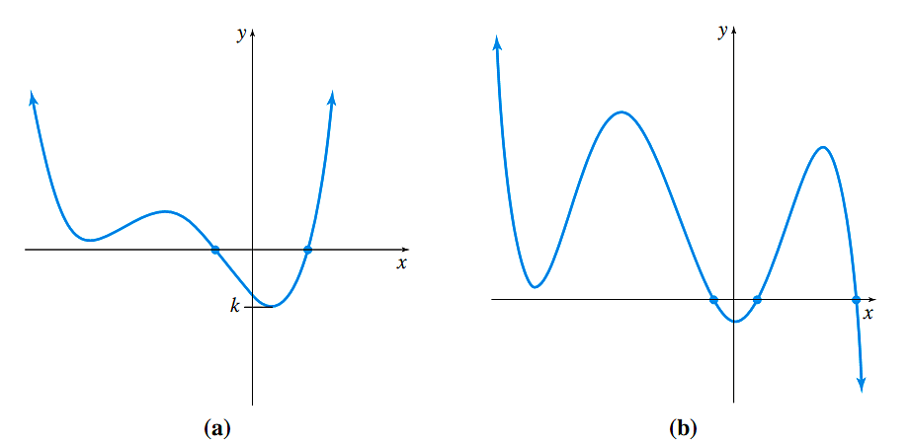

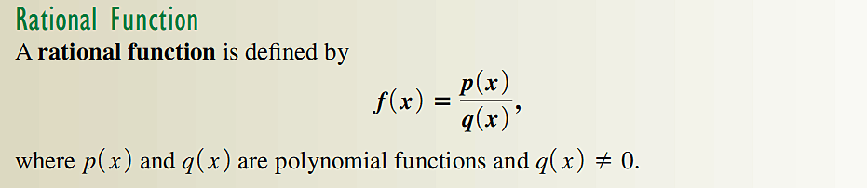

1. Sketch the graph of $f\left(x\right)=\frac{1}{x}$, and $f\left(x\right)=\frac{1}{x^{2}}$

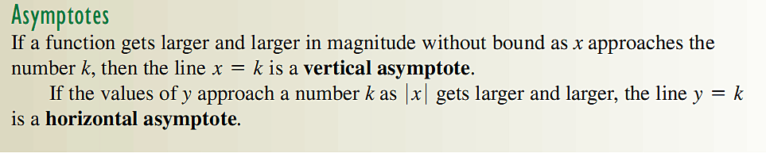

1. Sketch the graph of $f\left(x\right)=\frac{x^{2}-1}{x+1}$. Is $f\left(x\right)$ a rational function?
2. Sketch the graph of $f\left(x\right)=\frac{4x-6}{x-3}$.
3. Given $f\left(x\right)=$ $\frac{x - 18}{x^{2} - 9}$

a. Find the vertical asymptote(s), if any.

b. Find the horizontal asymptote, if it exists.

c. Find the *x*-intercept.

**2.4. Exponential Functions**

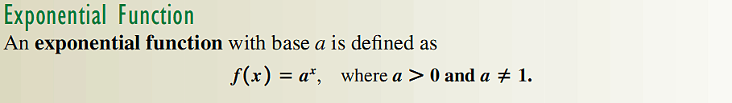

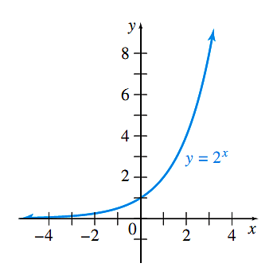 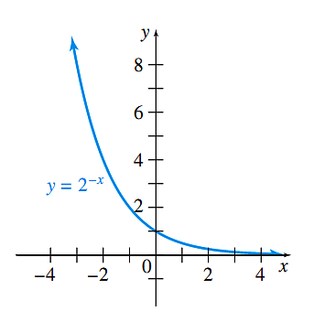

Solving Exponential Equations



1. Solve ${27}^{x}=9^{x^{2}+x}$ for *x*. Ans: x=0,1/2

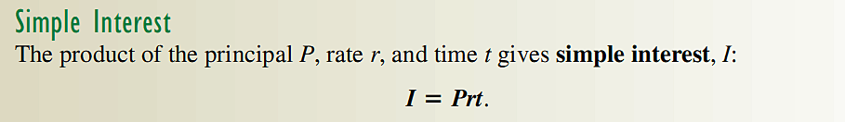

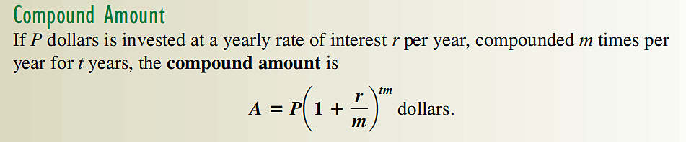

1. Find the interest earned on $4400 at 3.25% compounded quarterly for 5 years. Ans:$5172.97

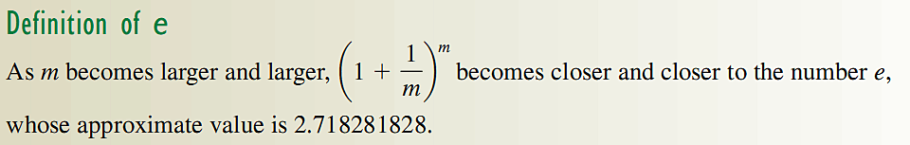

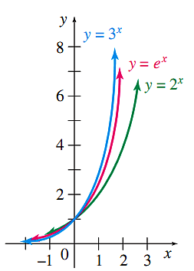

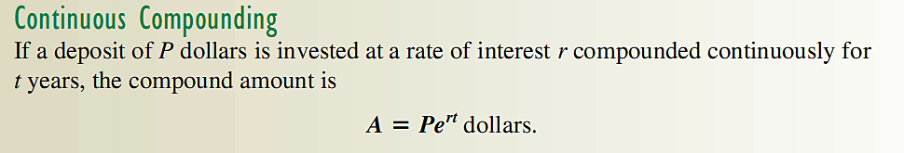

1. Find the amount after 4 years if $800 is invested in an account earning 3.15% compounded continuously. Ans: $907.43

Extra Problems:

1. Identify the exponential function(s).

a. $f(x$) = $3^{x}$**Yes**  b. $f(x$) = $x^{3}$**No** c. $f(x$) = ${(-7)}^{x}$**No**  d. ) = **Yes**

2. Graphs of exponential functions:

a.

|  |  |
| --- | --- |
| ***x*** | ***y*** |
| **0** | $$3^{0}=1$$ |
| **1** | $$3^{1}=3$$ |
| **2** | $$3^{2}=9$$ |
| $-$**1** | $3^{-1}=$**1/3** |
| $-$**2** | $3^{-2}=$**1/9** |

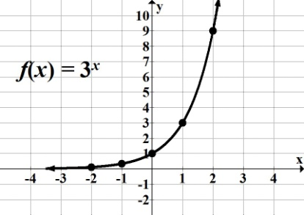

b.

|  |  |
| --- | --- |
| ***x*** | ***y*** |
| **0** | ${(1/3)}^{0}$**= 1** |
| **1** | ${(1/3)}^{1}$**= 1/3** |
| **2** | ${(1/3)}^{2}$**= 1/9** |
| **1** | **= 3** |
| **2** | **= 9** |

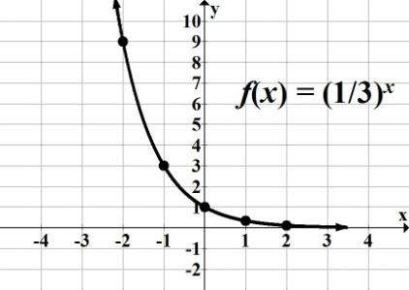

3. Does ) = have an inverse function?

**Yes, it is one-to-one; passes the horizontal line test**

4. Compare graphs of $f(x$) = $2^{x}$ and $f(x$) = $-2^{x}$.

$f(x$**) = $-2^{x}$ is equivalent to $f(x$) = $-1{(2)}^{x}$; reflection about the $x$-axis.**

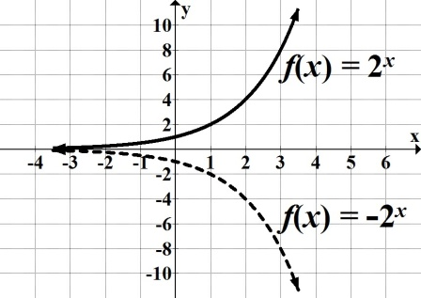

***Reminder*: $f(x$) = $-2^{x}$ ≠ $f(x$) = $(-{2)}^{x}$. $f(x$) = $(-{2)}^{x}$ would not be an exponential function, since it has a negative base.**

5. For each function, do the following without graphing: Find the vertical intercept and state whether it is an increasing or decreasing function.

a. $f(x)$ = $5{(3.2)}^{x}$

**Vertical intercept: (0, 5) $b =$ 3.2 Since 3.2 > 1 increasing**

b. $f(t)$ = $\frac{1}{4}{\left(\frac{8}{3}\right)}^{t}$

**Vertical intercept: (0, 1/4) $b =$ 8/3 Since 8/3 > 1 increasing**

c. $y$ = $0.8{(0.7)}^{x}$

**Vertical intercept: (0, 0.8) $b =$ 0.7 Since 0.7 < 1 decreasing**

d. $f(x)$ = $8^{x}$ = $1({8)}^{x}$

**Vertical intercept: (0, 1) $b =$ 8 Since 8 > 1 increasing**

e. $f(x)$ = ${\left(\frac{4}{3}\right)}^{-x}$ = ${\left(\frac{3}{4}\right)}^{x}$ = ${1\left(\frac{3}{4}\right)}^{x}$

**Vertical intercept: (0, 1) $b =$ 3/4 Since 3/4 < 1 decreasing**

6. State any transformations on each exponential function.

a. $f(x$) = $3^{x}+ 5$**Graph of $f(x$) = $3^{x}$ has been shifted 5 units up**

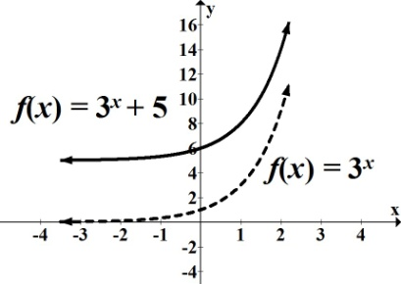

b. $f(x$) = $3^{x + 5}$ **Graph of $f(x$) = $3^{x}$ has been shifted 5 units left**

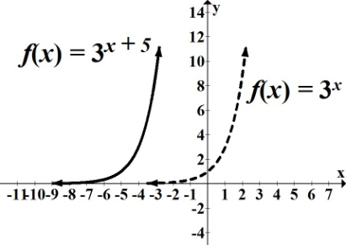

c. $f(x$) = $3^{x- 6}-2$ **Graph of $f(x$) = $3^{x}$ has been shifted 6 units right, 2 units down**

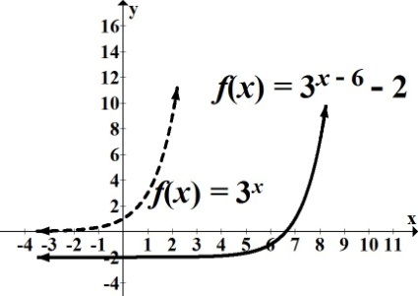

7. For each function, find the initial value and the growth or decay factor.

a. $P(t)$ = $2.4{(5.6)}^{t}$ $P_{0}$**= 2.4 growth factor = 5.6**

b. $N\left(x\right)$ = $21.3{(0.8)}^{x}$ $N_{0}$**= 21.3 decay factor = 0.8**

8. The number of Facebook active users in millions can be modeled by the function

*P*(*t*) *= $1.53(2.82)^{t}$* , where *t* is the number of years after 2004.

a. Identify and interpret $P_{0}$.

$P_{0}$**= initial value, that is, population at time = 0.**

$P_{0}$**= 1.53 Facebook had ≈ 1.53 million active users in 2004.**

b. Identify the growth or decay factor.

**Growth factor = 2.82**

c. Without graphing, determine whether the function is increasing or decreasing. Explain your

decision.

$b =$**2.82 Since 2.82 > 1 increasing**

d. Approximate the number of Facebook active users in 2008.

**We know *t* represents the number of years after 2004.**

**In 2008, $t$ ≈ 4. Therefore, $P(4)=$ $1.53(2.82)^{4}$ ≈ 96.756 ≈ 97 million active user**

End Extra Problems.

**2.5 Logarithmic Function**

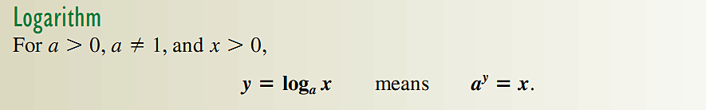

1) Rewrite in exponential form.

a. $\log_{2}16$ = $4$ b. $\log_{m}n$ = ½ Ans: a. **=**  b. **=**

2) Rewrite in logarithmic form.

a. $5^{3}$ = 125 b. $t^{r}$ = $s$ Ans: a.  **=**  b.  **= *r***

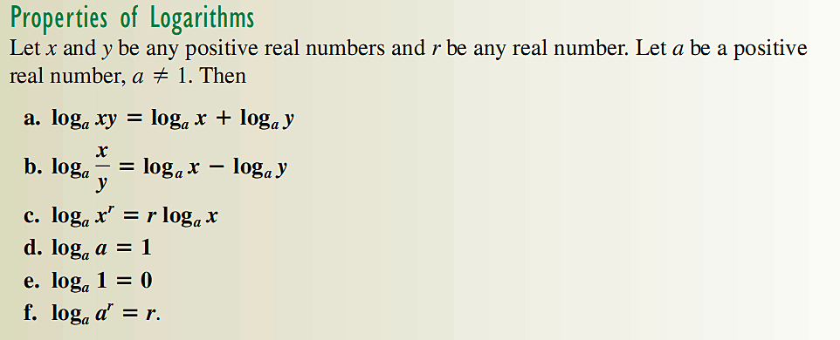

3) Evaluate:

a. $\log_{4}1$ b. $\log_{17}\sqrt{17}$ [recall $x^{1/2}$ = $\sqrt{x}$] c. $log(-1)$ [recall log definition]

Ans: a. 1; b. ½ ; c. undefined

4) Write the expression $\log_{4}\frac{\sqrt{x}y^{2}}{z^{3}}$ as a sum difference or product of simple logarithm.

Logarithmic Function

The Inverse function of Exponential function is the Logarithmic function:

Let $f(x$) = $b^{x}$

$y$ = $b^{x}$

$x$ = $b^{y}$ $x$ = $b^{y}$ if and only $\log_{b}x$ = $y$

Logarithmic function: $f(x$) = $\log_{b}x$ for > 0, > 0, ≠ 1

5) Graph the inverse of $f\left(x\right)=2^{x}$.

Ans: $f^{-1}\left(x\right)=\log_{2}x$.

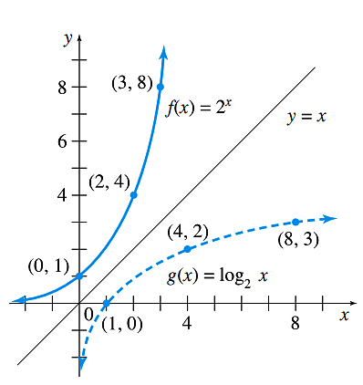

Evaluating Logarithms

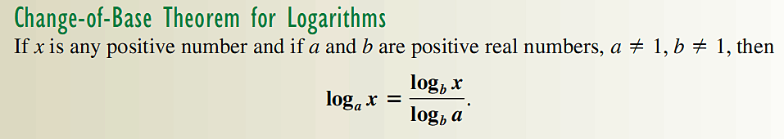



6) Evaluate $\log_{2}3$. Ans: $\frac{ln3}{ln2}=\frac{log3}{log2}$

Solving Logarithmic Equations

To solve logarithmic equations, change your equation to an exponential.

7) Solve for *x*: (a) $\log_{4}x=\frac{3}{2}$; (b) $\log_{2}x+\log_{2}(x+2)=3$ Ans: (a) 8; (b) 2

Solving Exponential Equations

To solve exponential equations whose bases cannot be equate, we use logarithms.

8) Solve for *x*: Ans:



9) Write using base *e* instead of 3. Ans:

10) Approximate $e^{0.025x}$ in the form $a^{x}$. Ans: 1.025*x*

Extra Problems

1. Find the inverse function:

a. ) = **) =**

b. =

2. Complete the table and graph the function. $f(x$) = $\log_{3}x$

|  |  |
| --- | --- |
| ***x*** | ***y*** |
| **1** | $$\log_{3}1=0$$ |
| **3** | $$\log_{3}3=1$$ |
| **9** |  |
| **1/3** | **1** |
| **1/9** |  |

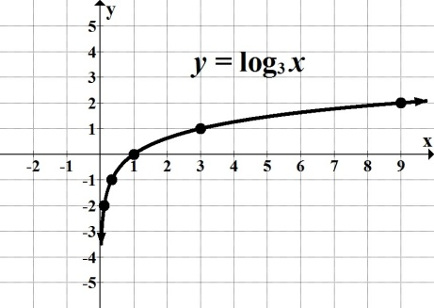

3. Find the domain.

a. $\log_{b}x$ $x >0$**or $(0, ∞)$**

b. $log(x+11)$ $x + 11>0$**, therefore, $x >-11$ or $(-11, ∞)$**

c. $log(-3x+2)$ $-3x+2$ $>0$**, therefore, $x<2/3$ or $(-∞, 2/3)$**

**(Note: On part "*c,*" remember we reverse the inequality symbol when dividing by a negative quantity.)**

4. For each logarithmic function, find the corresponding transformations.

a. $f(x$) = $log(x)+11$**up 11** **units**

b. $f(x$) = $log(x+11)$**left 11** **units**

c. $f(x$) = $log\left(x-7\right)-15$**right 7, down 15**

d. $f(x$) = $-log\left(x\right)+ 2$**reflection about the *x*-axis, up 2**

5. Evaluate and round your answer to 3 decimal places where needed.

a. $e^{4}$**54.598**

b. $5.2e^{0.65}$**9.961**

c. $ln\sqrt{e}$**1/2 or 0.5**

d. **0.901**

6. Find the initial value, the continuous growth or decay rate, and the growth or decay factor.

a. *P*(*t*) *= $43e^{0.064t}$*

$P_{0}$**= 43 $k$ = 0.064, continuous growth rate is 6.4%**

**growth factor is $e^{0.064}$ ≈ 1.0661**

b. *N*(*t*) *= $178e^{-0.075t}$*

${ N}_{0}$**= 178 $k$ = $-$ 0.075, continuous decay rate is $-$ 7.5%**

**decay factor is ≈ 0.9277**

7. Ronald bought a sport utility vehicle in 2009, which unfortunately started losing its

value as soon as he drove off the lot. Ronald's SUV's value can be modeled by the function

*V*(*t*) *=* 21305 $e^{-0.173t}$, where *t* represents years after 2009.

a. Find and interpret *V*(0).

${ V}_{o}$**= 21,305 Ronald's SUV initial value, before it is driven away from the car lot.**

b. Find *V*(5). Round your answer to the nearest dollar. Interpret your answer.

$V(5)$***=* 21305 $e^{-0.173(5)}$ = 8971.**

**After 5 years, Ronald's SUV value will decline to $8,971.**

c. After what year will the SUV's value drop to $5,338?

**Let *Y1=* 21305 $e^{-0.173x}$ and  *Y2 =* 5338 Graph and find intersection.**



8. Use the exponential equality to solve each equation. Round your answers to 4 decimal places as needed.

a. $3^{2x -11}$ = ${27}^{3x+ 1}$

$3^{2x -11}$**= ${\left(3^{3}\right)}^{3x+ 1}$**

$3^{2x -11}$**= $3^{9x+3}$**

**Equate exponents and solve for *x*:**

**2*x $-$* 11 = 9*x $+3$***

**7*x = $-14$***

***x = $-2$***

b. $8^{2x -5}$ = $\sqrt{2}$

${\left(2^{3}\right)}^{2x- 5}$**= $2^{1/2}$**

${ 2}^{6x-15}$**= $2^{1/2}$**

**6*x $-$* 15 = 1/2**

**6*x =***

***x =* or**

9. Solve each exponential equation. Give answers in exact form, then estimate to 4 decimal places.

a. 7(1.2 – ${10}^{0.25x}$) = 0.63

**Steps: (1) Isolate the power (the term containing the variable exponent) on one side of the equation. If necessary, divide both sides of the equation by any coefficient of the power term. (2) Convert the equation to logarithmic form. (3) Solve for the variable.**

**7(1.2 $–$ ${10}^{0.25x}$) = 0.63**

**1.2 $–$ ${10}^{0.25x}$ = 0.09**

$–{10}^{0.25x}$**= $-$ 1.11**

${10}^{0.25x}$**= 1.11**  **Divide both sides by $-$ 1.**

$\log{1.11}$**= 0.25*x***

$\frac{\log{ 1.11}}{0.25}$**= *x* or  *x $≈$* 0.1813**

b. 25 $e^{2x-3}$ = 9

$e^{2x-3}$**= 0.36**

$\log_{e}{0.36}$**= $2x-3$**

$2x-3$**= $\ln{0.36}$**

***x* = 0.9892**

10. Given that $\log_{3}{7}$ = 1.7712 and $\log_{3}{11}$ = 2.1827, use the properties of logarithms to

estimate the value of the following expressions. Round your answers to 4 decimal places as

needed.

a. $\log_{3}{77}$**= $\log_{3}{(7 11)}$ = $\log_{3}{7 }$ + $\log_{3}{11 }$ = 1.7712 + 2.1827 = 3.9539**

b. $\log_{3}\left(\frac{11}{7}\right)$ **= $\log_{3}{11- }\log_{3}{7 }$ = 2.1827 $-$ 1.7712 = 0.4115**

11. Use the properties of logarithms to rewrite ${(log}_{b}{y}+ 4\log_{b}{z)- }\frac{1}{5}\log_{b}{x}$ as a single logarithm.

**=**

**=**

**=**

**=**

12. Expand $\log_{b}{\sqrt[4]{\frac{m^{2}}{n^{3}}}}$ in terms of simpler logarithms. Assume that all variable expressions are positive real numbers.

**=**

**=**

**=**

**=**

**=**

13. Use properties of logarithms to solve the exponential equation. Round your answer to 4 decimal places as needed: 3 $\left(5^{7x}\right)$ = 3081

**Steps: (1) Isolate the power on one side of the equation (2) Take the logarithm of both sides of the equation; may take common (base 10) or natural logarithm (base *e*). (3) Apply the power property of logarithms to simplify ("bring down" the variable exponent to the front). (4) Solve for the variable.**

**3 $\left(5^{7x}\right)$ = 3081**

$5^{7x}$**= 1027**

**ln $5^{7x}$ = ln 1027**

$7x\ln{5}$**= ln 1027**

**7*x* =**

**0.6155**

14. Use properties of logarithms to solve each logarithmic equation. Round your answers to 4 decimal places as needed.

a. $\log_{6}\left(3x+4\right)=\log_{6}{(2x-7)}$ $+ 2$

**Steps: (1) Isolate the logarithmic expressions on one side of the equation; if needed, apply properties of logarithms to combine all logarithms as a single logarithm. (2) Convert the logarithmic equation to an exponential equation. (3) Solve for the variable. (4) Check for possible extraneous solutions.**

$\log_{6}\left(3x+4\right)-\log_{6}{(2x-7)}$ $= 2$

$\log_{6}\left(\frac{3x+ 4}{2x- 7}\right)$ $=2$

$6^{2}$ $=$ $\frac{3x+ 4}{2x- 7}$

$\frac{3x+ 4}{2x- 7}$ $= 36$

$3x+4$ $=(36)(2x-7)$**Multiply both sides by $(2x-7)$.**

$3x+4$ $=72x-252$

$69x$ $=256$

$x$ $≈$ $3.7101$

b. 6 + $\ln{x^{5}}$ = 8

**6 + $5 \ln{x}$ $=$ 8**

$5 \ln{x}$ $=$**2**

$\ln{x}$ $=$**2/5 Equivalent to $\log_{e}x{=2/5}$**

$x$ $=$ $e^{2/5}$

$x$ $≈$ $1.4918$

c. $\ln{x}$ + $\ln{(x+4)}$ = $\ln{(2x+63)}$

$\ln{[x}(x+4)]$ $=$ $\ln{(2x+63)}$

$ln{(x}^{2}+4x)=$ $\ln{(2x+63)}$

$x^{2}+4x$ $=2x+63$**Logarithmic equality**

${ x}^{2}+ 2x$ $- 63=0$

$(x$ $+ 9)(x-7)=0$

$x$ $=- 9$**or $x=7$**

**Verifying both solutions, we must discard $=- 9$, since it is not in the domain.**

15. Solve the literal equation for *T*:

***rs***

***T* *N***

16. According to the Motion Picture Association of America, the number of digital 3D

screens worldwide has increased dramatically during the last years, representing about

half of all digital screens in the world. The function *P*(*t*) = $89.371{\left(3.2\right)}^{t}$ models the

number of digital 3D screens worldwide for *t* number of years after 2005. Using this model,

estimate when the number of digital 3D screens worldwide reached approximately 9,000.

Solve algebraically and answer in a complete sentence. Round your answer to the nearest

whole number. *Source: mpaa.org.*

$89.371{\left(3.2\right)}^{t}$ $=9000$

${\left(3.2\right)}^{t}$ $=$ $100.7038$**Divide both sides by 89.371**

${ln \left(3.2\right)}^{t}=$ $ln 100.7038$

$t ln 3.2=$ $ln 100.7038$

***t* = $\frac{ln 100.7038}{\ln{3.2}}≈ 3.97$ $≈ 4$**

**The number of digital 3D screens worldwide reached approximately 9,000 in 2009.**

17. In 2006, a company sold 2,340 units. The company’s accountant noticed a 4.6% continuous annual increase in the number of units sold between 2006 and 2012.

a. Write an exponential function *N*(*t*) that models the number of units sold by the company,

where *t* is the number of years after 2006.

***N*(*t*) *= $2340e^{0.046t}$***

b. Find and interpret *N*(4). Round your answer to the nearest whole number. Answer in a

complete sentence.

***N*(4) $=$ $2340e^{0.046(4)}≈2812.71≈2813$**

**In the year 2010, the company sold approximately 2813 units.**

c. If this growth rate continues, use your model to estimate when the company will sell

approximately 6,000 units. Solve algebraically and round your answer to the nearest whole

number.

$2340e^{0.046t}$ $=6000$

$e^{0.046t}$ $=2.5641$

${ln e}^{0.046t}$ $=ln 2.5641$

$0.046t ln e$ $=ln 2.5641$

$0.046t(1)$ $=ln 2.5641$**Recall that ln *e* = $\log_{e}{e}$ = 1**

$0.046t=ln 2.5641$

$t=$ $\frac{ln 2.5641}{0.046}≈ 20.47≈ 20$

**20 years or 2026**

End Extra Problems.

**2.6. Applications: Growth and Decay; Mathematics of Finance**

Consider $1M, at a rate of 8% compounded, once a year, quarterly, monthly, daily, and continuously for one year. Use the Compound interest formula $A = P{\left.\left(1 + \frac{r}{m}\right.\right)}^{mt}$ where *m* is the number of times compounded per year, we obtain the following table:

|  |  |
| --- | --- |
| *m* | A |
| 1 | 1.08 |
| 4 | 1.0824 |
| 12 | 1.083 |
| 365  ∞ | 1.083278  1.083287 |

Effective Rate:

The Effective Rate is the rate due to compounding of the nominal (stated) rate.

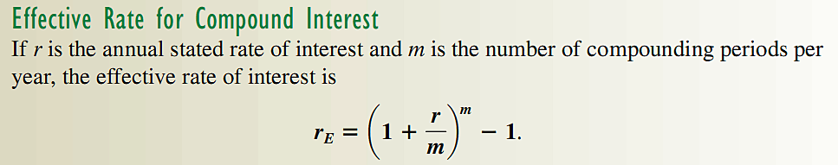

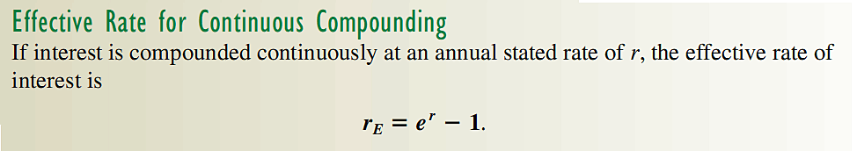

11) Find the Effective Rate corresponding to 8% compounded quarterly, monthly, daily, and continuously.

12) Find the time needed for $50K to grow to 75K when invested in an account that pays 5% compounded quarterly,

12) Find the interest rate that will cause $3,500 to grow to $5,200 in 5 years is the money is compounded continuously.

13) Suppose you want to invest $5,000 in an account for *t* years.

a. Find the accumulated amount (future value) if you invest this money at 3.5% interest

compounded quarterly for 20 years. Round your answer to the hundredth.

**The accumulated amount, *A*, after *t* years in an account with principal *P* invested at an annual interest rate, *r*, (expressed as a decimal value) compounded *n* times per year is given by *A* = $P{\left(1+ \frac{r}{n}\right)}^{nt}$.**

***P* = 5000, *r* = 0.035, *n* = 4, *t* = 20**

***A* = $5000{\left(1+ \frac{0.035}{4}\right)}^{(420)}$ $≈$ $10,038.15**

b. Compare this return with the same principal compounded weekly for 20 years.

Answer in a complete sentence.

***P* = 5000, *r* = 0.035, *n* = 52, *t* = 20**

***A* = $5000{\left(1+ \frac{0.035}{52}\right)}^{(5220)}$ $≈$ $10,066.39.**

**Compounding weekly will yield a higher future value.**

c. How much money would you have in your account after the 20 years if you invested your

$5,000 at 3.75% compounded continuously? Round your answer to the nearest dollar.

**The accumulated amount, *A*, after *t* years in an account with principal *P* invested at an annual interest rate, *r*, compounded continuously is given by *A* = $Pe^{rt}$.**

***P* = 5000, *r* = 0.0375, *t* = 20**

***A* = $10,585**

14) How much money must you invest today if you want to see your money grow to $500,000 in

30 years at 5% annual interest compounded monthly? Round to the nearest dollar.

**The present value, *P*, of an investment that will produce a future value in an account with annual interest rate, *r*, compounded *n* times per year is given by *P = A ${\left(1+ \frac{r}{n}\right)}^{-nt}$*where *A* = accumulated amount or future value, and *t* = time in years.**

***A* = 500000, *r* = 0.05, *n* = 12, *t* = 30**

***P =* 500000 ${ \left(1+ \frac{0.05}{12}\right)}^{-(1230)}$ $≈$ $111,913**