Differentiating Functions of Several Variables

- Use the following table of values of g(x, y) to estimate (a) g_{x} (2, 5) and (b) g_{y} (2, 5).
 | x = 1 | x = 1.5 | x = 2 | x = 2.5 | x = 3
y = 5.2 | 150 | 160 | 172 | 184 | 195
y = 5.0 | 187 | 200 | 212 | 223 | 235
y = 4.8 | 231 | 242 | 253 | 266 | 278
y = 4.6 | 273 | 283 | 293 | 305 | 316

Ans: Centered {23, -202.5}

- Level curves of G (x, y) are shown in the figure below. Find its approximate x- and y-derivatives at (3, 3).
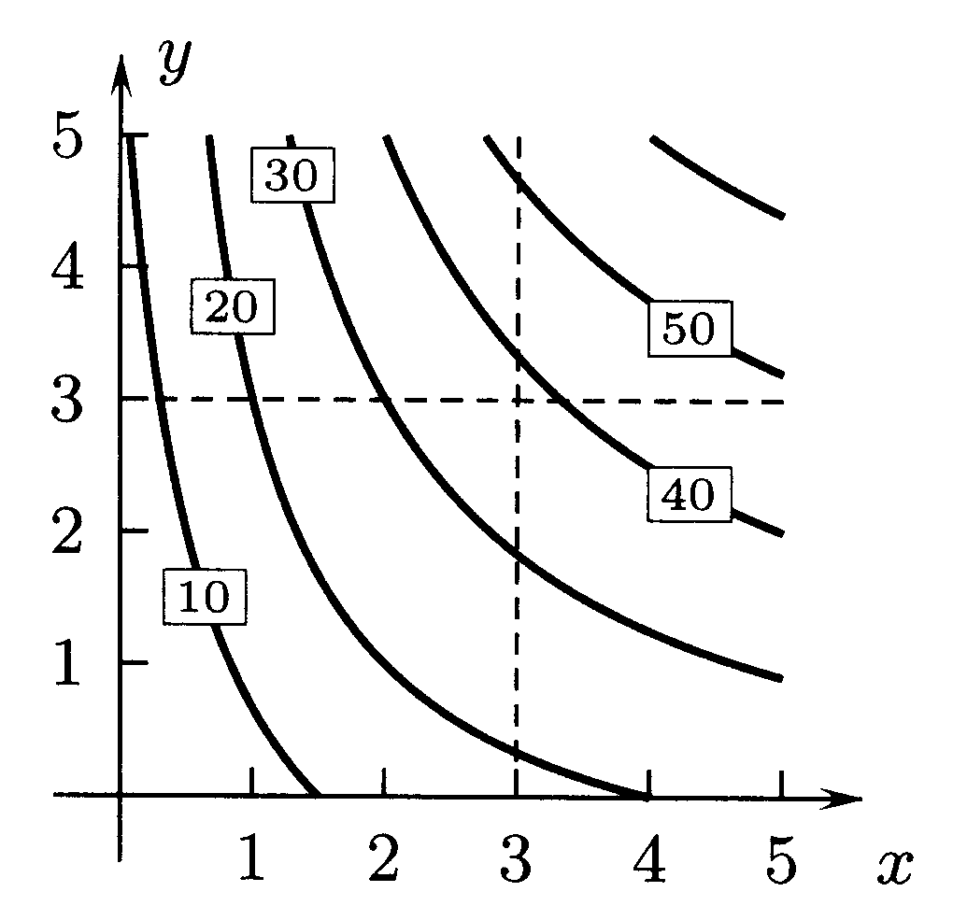
Ans: {10/1.3, 10/1.4}

- Figure 11 shows the graph of the function P(x, 2) of x that is obtained from P(x, y) by setting
y = 2, and figure 12 shows the graph of the function P(3, y) of y that is obtained from P(x, y) by setting x = 3. Use the graphs to find the approximate values of 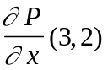 and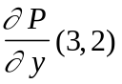.

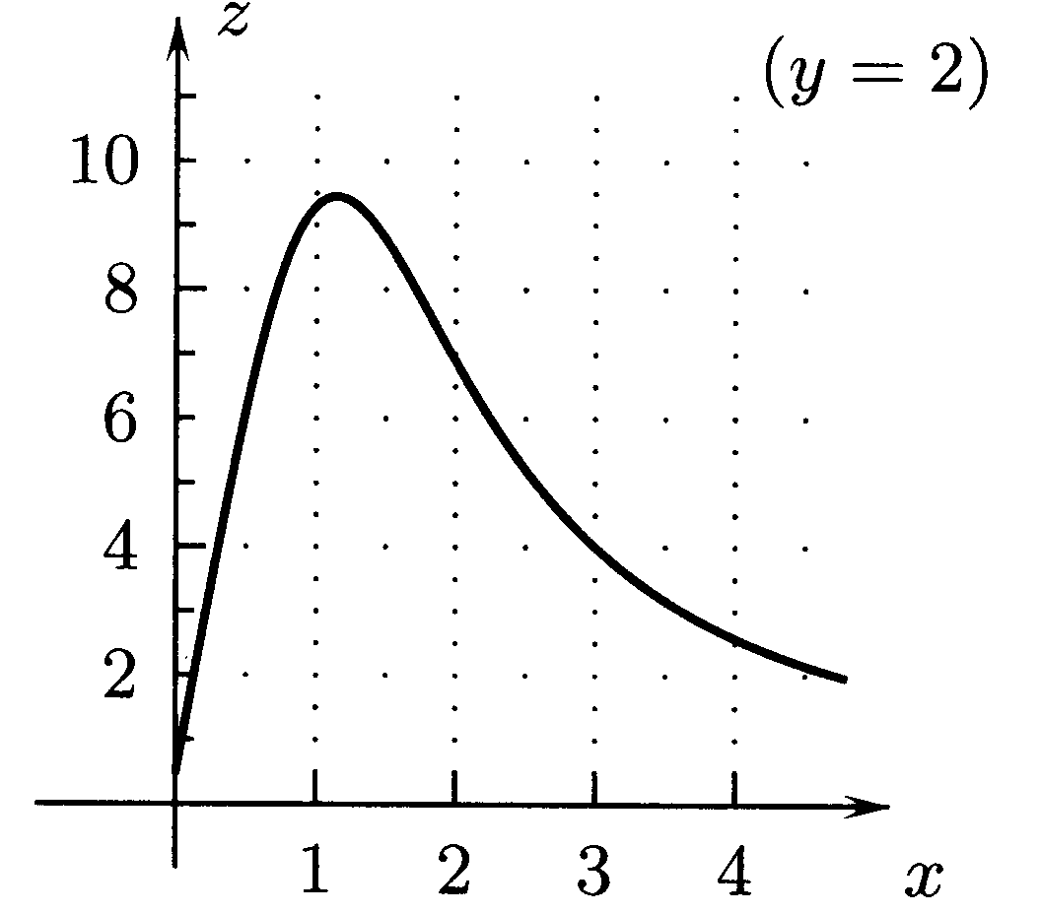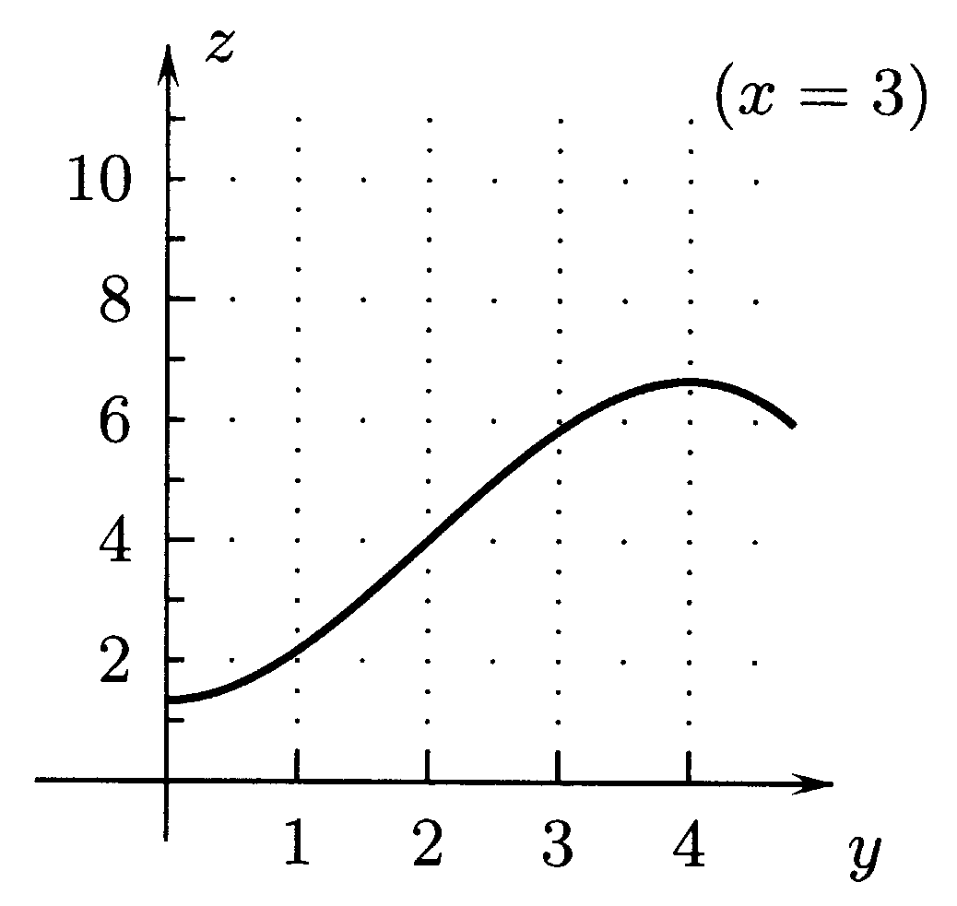

FIGURE 11 FIGURE 12
Ans: {-2, 2}

- The volume of a right circular cone of height h meters and with a base of radius r meters is
V = 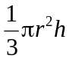 cubic meters. What is the rate of change of the volume with respect to the radius?
Ans: 2/3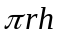 m³/m

- If a constant current of I amperes flows through a circuit with a resistance of 100 ohms for t seconds, it will produce H(I, t) = 23.9I2t calories. Is H(I, t) a linear function of I for fixed t or a linear function of t for fixed I? (b) What is the rate of change of the heat production with respect to I at t = 5, I = 10? Give the units. Ans: 2390 cal/amp.

- If a gas has density 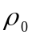 grams per cubic centimeter at 0˚C and pressure of one atmosphere, then its density at T˚C and pressure P atmospheres is (T, P) = 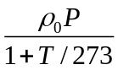 gm/cm³. Find formulas for 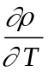 and 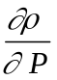 in terms of T, P, and the parameter. Give their units. (b) One of the derivatives in part (a) is positive and the other negative for T > –273 and positive P. Explain in terms of gasses why this could be expected. Ans {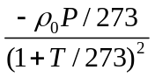,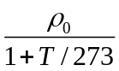}; as temperature increases, density decreases, as pressure increases density increases.

- The table below gives the volume V (p, t) (cubic feet) of a pound of a p-percent solution of sulfuric acid in water that is at a temperature of T˚C. (a) Does the volume of a pound of a solution increase or decrease as the temperature increases? (b) Suppose that two solutions are at the same temperature but one contains a greater concentration of sulfuric acid. Which has the greater volume? (c) What rate of change is represented by 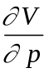(15, 80) and what is its approximate value? (d) What is the approximate value of 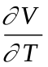(p, T) for 10≤ p ≤ 20 and
60 ≤ T ≤ 100?

 | p = 10% | p = 15% | p = 20% | p = 25%
T = 100˚C | 0.0157 | 0.0152 | 0.0147 | 0.0143
T = 80˚C | 0.0155 | 0.0150 | 0.0145 | 0.0141
T = 60˚C | 0.0153 | 0.0148 | 0.0143 | 0.0139
T = 40˚ | 0.0151 | 0.0146 | 0.0142 | 0.0138
Ans: Centered {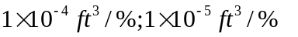}

- The next table gives the wind chill (perceived temperature) W(T, v) in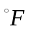 as a function of temperature T and velocity of the wind v, measured in mph for five temperatures and four wind speeds. (a) Is W(T, v) an increasing or a decreasing function of T for fixed v and why is this plausible? (b) What is the approximate rate of change of W(T, v) with respect to T if the temperature is 0°F and the wind velocity is 20 miles per hour? (c) Is wind chill W(T, v) an increasing or a decreasing function of v for fixed T, and why? (d) What is the approximate rate of change of the wind chill with respect to the velocity of the wind when the temperature is 0°F and the wind velocity is 20 miles per hour? Ans: inc, 1.45/, dec, -1.34/mph. centered.

 | T = –20 | T = –100 | T = 0 | T = 10 | T = 20
v = 30 | –79 | –64 | –49 | –33 | –18
v = 20 | –67 | –53 | –39 | –24 | –10
v= 10 | –46 | –34 | –22 | –9 | 3
v = 0 | –20 | –10 | 0 | 10 | 20

- The next table gives the amount of food F(w, t) (pounds) required each day by a horse that weighs w pounds and is ridden t hours a day. (a) Give approximate values of 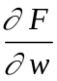(1000, 4) and 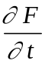(1000,4). Why, in terms of horses, is F(w, t) an increasing function of w for fixed t and an increasing function of t for fixed w?

 | w = 800 | w = 900 | w = 1000 | w = 1100 | w = 1200
t = 6 | 18.7 | 20.5 | 22.2 | 23.8 | 25.4
t = 4 | 17.9 | 19.6 | 21.2 | 22.8 | 24.3
t = 2 | 16.9 | 18.5 | 20.1 | 21.5 | 23.0
t = 0 | 12.9 | 14.1 | 15.3 | 16.4 | 17.5
Ans: {0.016 lb-food/lb, 0.525 lb-food/hr} centered

- Use the level curves of K(x, y) in the figure below to give its approximate x- and y-derivatives at (6, 2). Ans: {-2/2=-1, -2/0.5=-4}
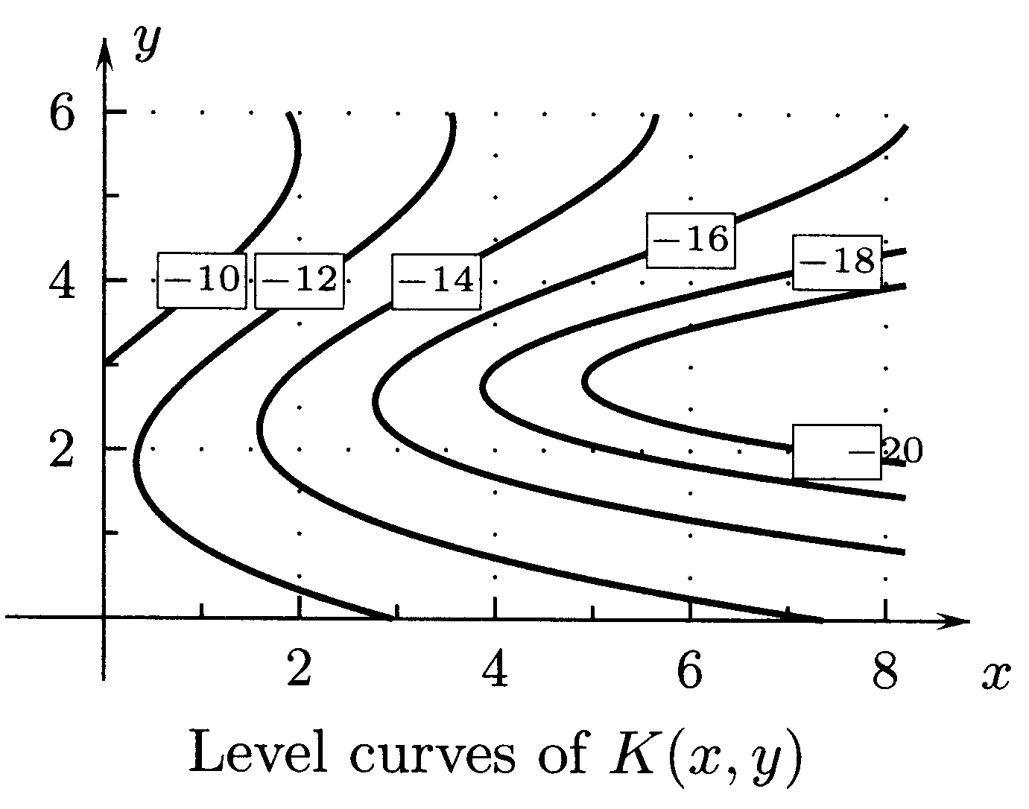

- What are the approximate values of the x- and y-derivatives of the function h(x, y) of the figure below? Find a linear equation for the level curves below. Ans: {2, 3}, 2x+3y = 20
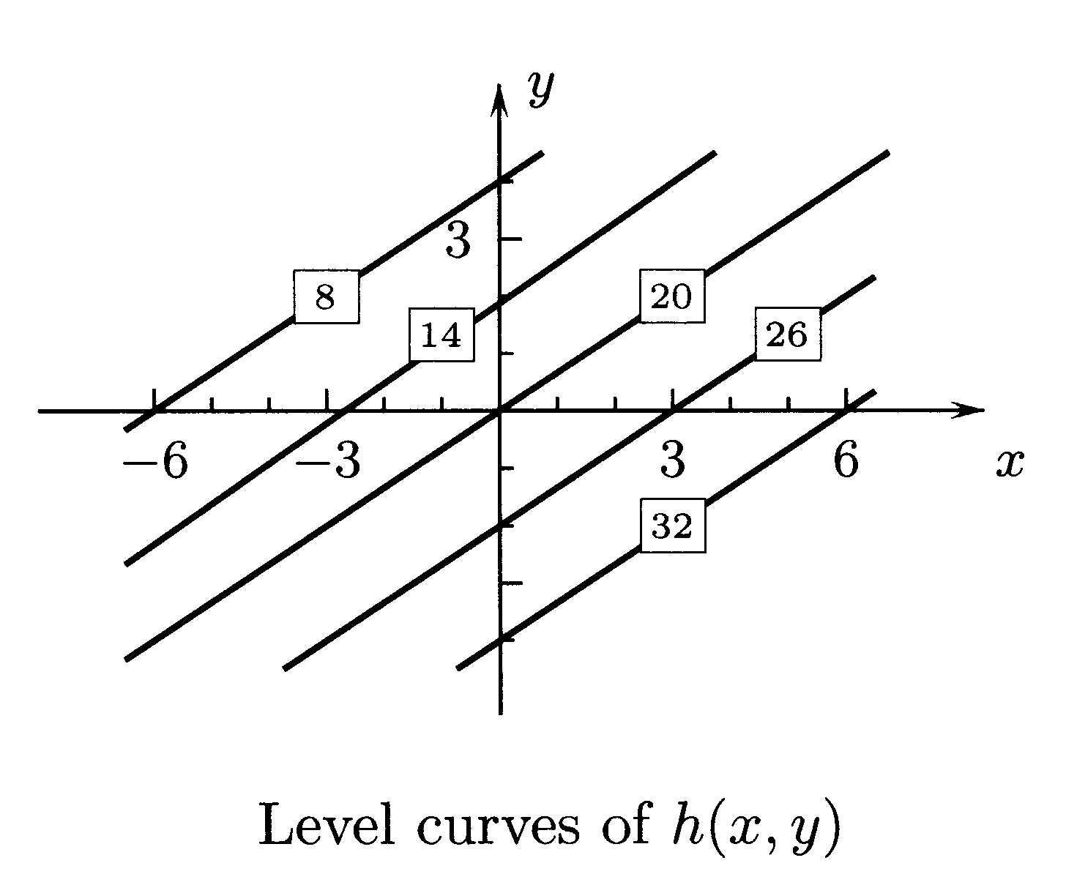
- The figure below gives level curves of the compressive strength S(g, t) (pounds per square inch) of Portland concrete that is made with g gallons of water per sack of cement and that has cured t days. What are the approximate values of 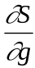(6, 14) and 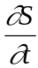(6, 14)?

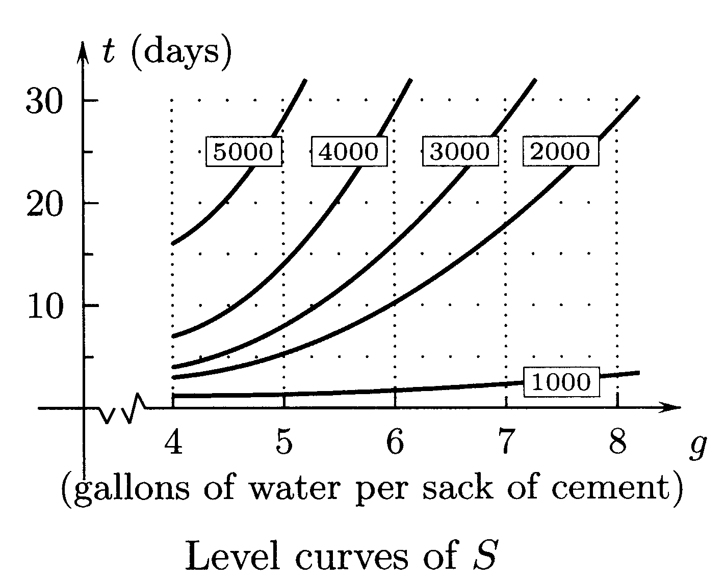
Ans:{-1000/0.75 lb/in²/gal, 1000/6 lb/in²/day}

- The FETCH of the wind at a point on a body of water is the distance that the wind has blown over water before it reaches the point. The next table gives the height h(v, f) (feet) of waves as a function of the wind velocity v (knots) and of the fetch f (nautical miles). (Knots are nautical miles per hour). (a) Based on the table, what is 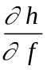(10, f) for all f? What does this say about the waves? (b) Based on the table, is 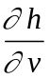(40, f) an increasing or a decreasing function of f? What does this say about the waves? (c) What do you think would happen to h (v, f) as f for each fixed v?

 | v = 10 | v = 20 | v = 30 | v = 40
f = 1000 | 3 | 8 | 18 | 50
f = 500 | 3 | 8 | 18 | 47.5
f = 200 | 3 | 7.5 | 17 | 39.5
f = 100 | 3 | 7 | 14.5 | 31
f = 50 | 3 | 6 | 12 | 22.5
Ans: 0. At10mph the height does not change, increasing, h
- Find the approximate maximum and minimum values of 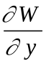(x, y) for 0 ≤ x ≤ 5, 1 ≤ y ≤ 4, where W (x, y) is the function whose level curves are shown the figure below.
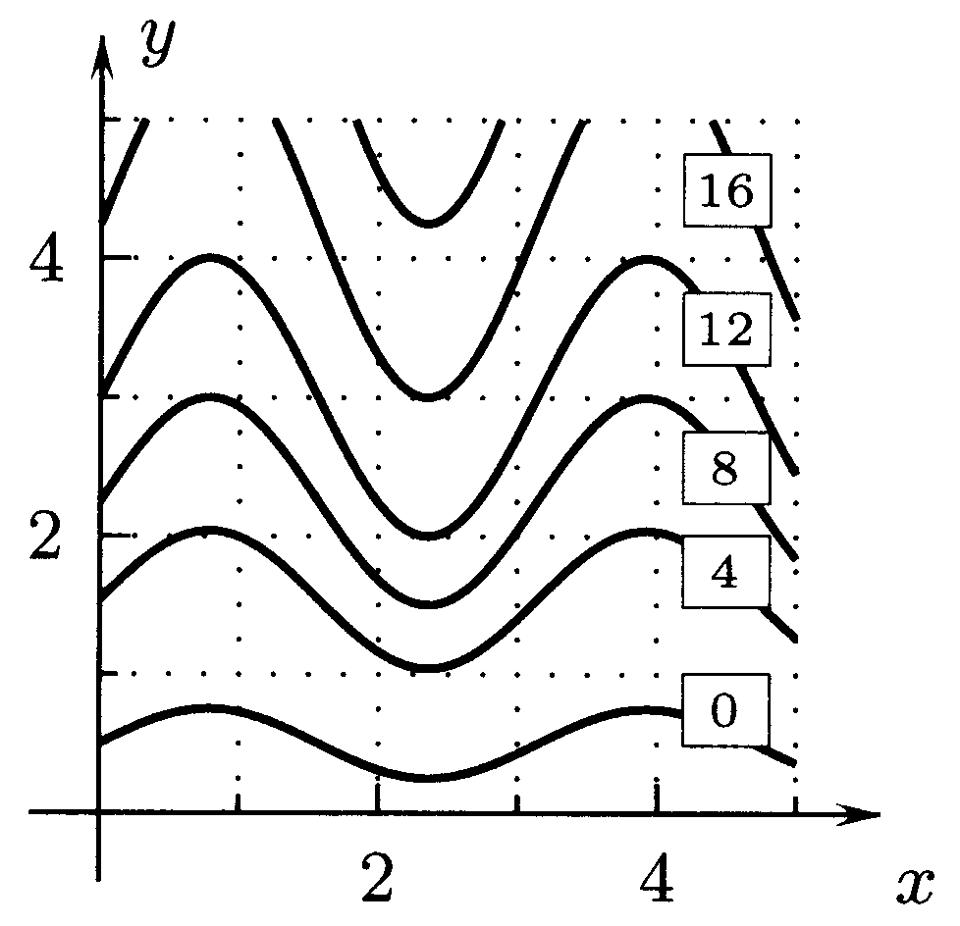
Ans: closer curves W_{y (max)} (2.5,1.5)= 8/1=8; further apart W_{y (min)} (1,1.5)= 4/1.25=3.2

- The figure below shows the graph of p(x, y) =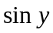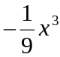. (a) Draw the intersection of the surface with the plane x = 0 and its tangent line whose slope is 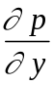(0, π). (b) Draw the intersection of the surface with the plane y = π and its tangent line whose slope is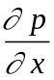(0, π).

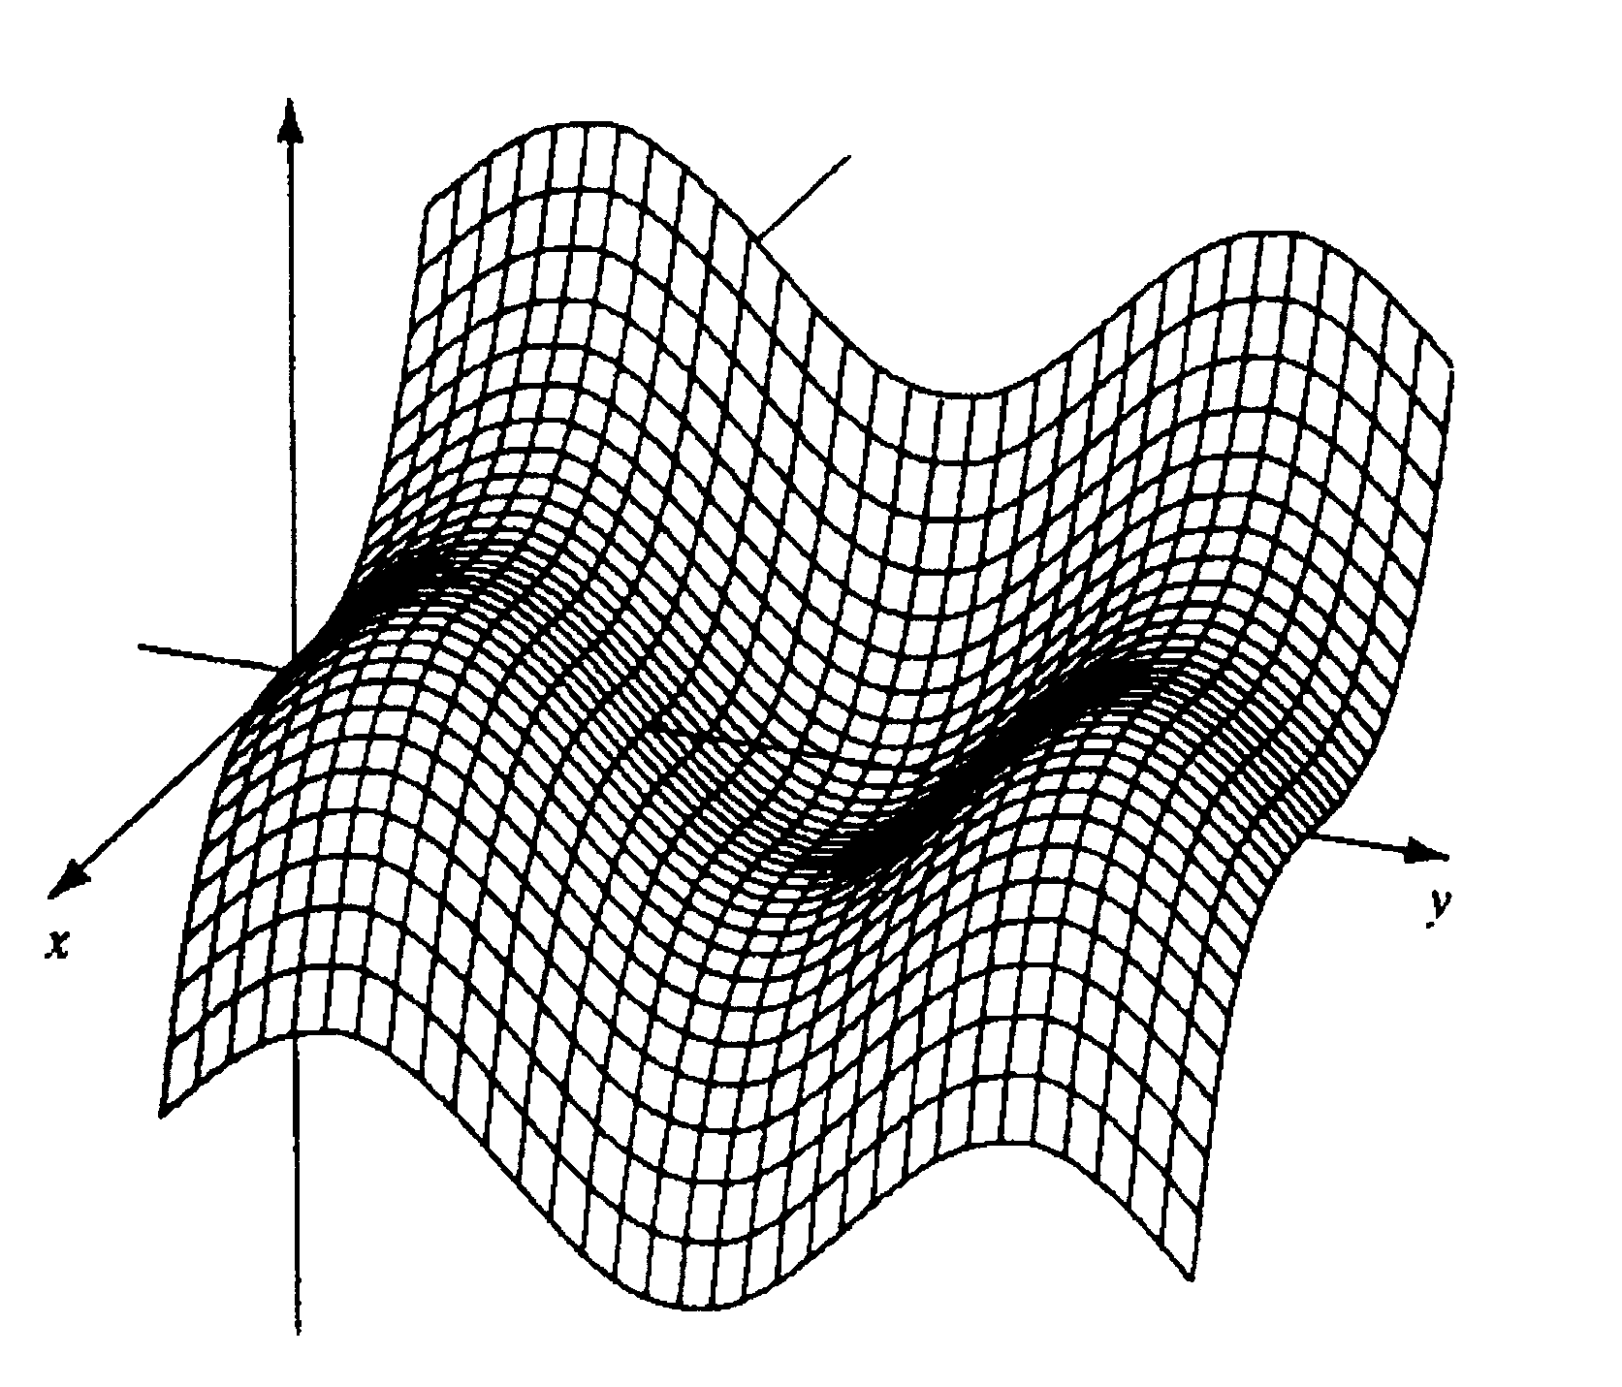

Ans: tangents {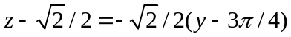; 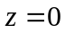}

- Draw the intersection of the graph of 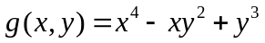 with the plane y = –1 and the tangent line whose slope is 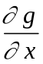(1, –1). (b) Draw the intersection of the graph of g(x, y) with the plane x = 1 with the tangent line whose slope is 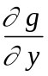(1, –1).
Ans: tangents {

- The volume of water (liters) in the body of a person who weighs w kilograms and is h centimeters high can be predicted with the formula V (w, h) = 0.135w2/3h1/2. Suppose that a man is 169 centimeters high and that at his current weight, the volume of water V in his body would increase by approximately 0.3∆w if his weight increased by a small amount ∆w. Based on the formula, how much does he weigh? Ans: Since ∆V/∆w≈ .3, w≈ 59kg..

- A company sells two products, A and B. When it has sold 2000 units of product A and 3000 units of product B, it earns $3 per unit profit on the sale of item A and $4.50 per unit profit on the sale of item B. At what rate is its total profit from the two items increasing at a time when it has sold 2000 units of product A and 3000 units of product B and it is selling item A at the rate of 200 units per month and item B at the rate of 250 units per month? Ans: 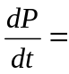$1725/mo.
- Express the x- and y-derivatives of W(x3y5) in terms of x, y, and 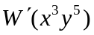.
Ans: 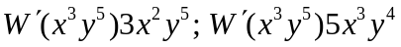

- What is 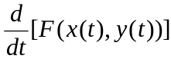 at t = 0 if x(0) = 3, y(0) = 7, 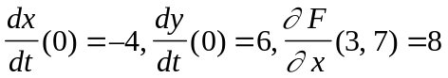, and 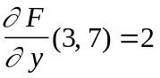? Ans: -20

- Find the u- and v-derivatives of f(x(u, v), y(u,v)) with f(x, y) = 3x – 4y + 7, x = 2u – 5v, and y = 3u + 8v (a) by using the Chain Rule 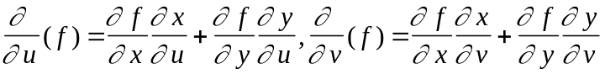 and (b) by first writing f(x(u, v), y(u, v)) in terms of u, and v. Ans: {-6, -47}

- What is 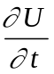(2, 6) if U(s, t) = V(x(s, t), y(s, t)), x(2,6) = 5, y(2, 6) = –7, 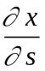 (2,6) = 4,
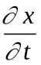(2, 6) = 8, 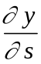(2, 6) = –1, 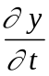(2, 6) = 10, 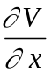(5, –7) = 11, and 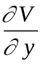 (5, –7) = 12? Ans: 208
- What are (a) 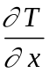(1, 2) and (b) 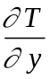(1, 2) for T (x, y) = U (v(x, y)) if v(1, 2) = 3, vx(1, 2) = 5,
vy(1, 2) = 7 and (3) = 9 Ans: {45,63}

- Give the values of (a) F (0, 2), (b) Fu(0, 2) and (c) Fv(0, 2) where F (u, v) = f(v sin u, u sin v) with f(0, 0) = 4, fx(0, 0) = 10, and fy(0, 0) = 2. Ans: {4, 20+2sin2,0}

- Find (a) 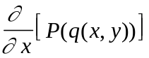 and (b) 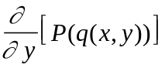 at x = 3, y = 7 where q(3, 7) = 9, qx(3, 7) = 6, qy(3, 7) = 10, and (9) = –11. Ans: {-66,-110}

- What are (a) P(3, 2), (b) Pu(3, 2), and (c) Pv(3, 2) for P(u, v) = R(x(u, v), y(u, v)) where
x(3, 2) = 1, y(3, 2) = 0, xu(3, 2) = 5, xv(3, 2) = 6, yu(3, 2) = 7, yv(3, 2) = 4, R(1, 0) = 8,
Rx(1, 0) = 9 and Ry(1, 0) = 10? Ans: {8, 115, 94}

- The temperature T (x, y)°F at the point (x, y) on a metal plate does not change with time, and an ant crossing the plate is at x = t2, y = 4t + 1 feet at time t minutes. What is the temperature at the ant’s position at t = 3 and what is the rate of change of the temperature at the ant’s position with respect to time at t = 3 if T (9, 13) = 50 degrees, Tx(9, 13) = 5 degrees per foot, and
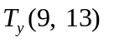 = –1 degree per foot. Ans: 50 degrees, 26 degree/min.
- Find the derivative of g(x, y) = x²y³ at (1, –1) in the direction toward the point (2, 2). Ans: 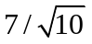
- Level curves of a function K(x, y) are shown in the figure below. Find the approximate derivative of K at (10, 10) in the direction toward the origin. Ans: 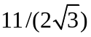
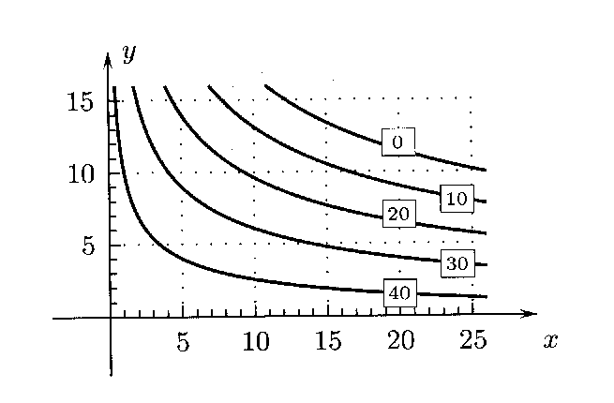

Level curves of K (x, y)

- Give an equation of the tangent plane and normal line to the graph of 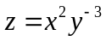 at (2, 1). Ans: 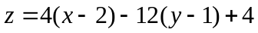, <2,1,4> + t <4,-12,-1>

- Give a formula for the linear function P(x, y) whose values are given in the following table.
 | x = 10 | x = –5 | x = 0 | x = 5 | x = 10
y = 10 | –105 | –95 | –85 | –75 | –65
y = 5 | –55 | –45 | –35 | –25 | –15
y = 0 | –5 | 5 | 15 | 25 | 35
y = –5 | 145 | 55 | 65 | 75 | 85
Ans: 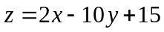

- Draw the approximate gradient vector 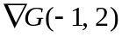 and estimate its components, where G is the function whose level curves are in figure below.
Ans:
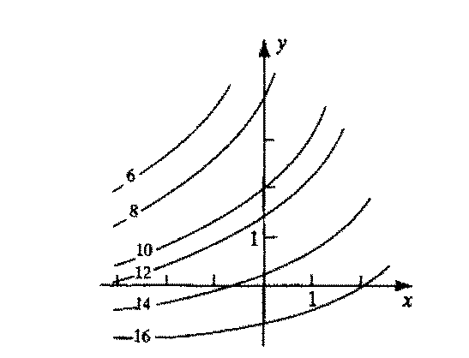

- The figure below shows level curves of g(x, y). Find the approximate derivative of g(x, y) at (–1, 1) in the direction toward (0, –2). Ans: -10/2 = -5
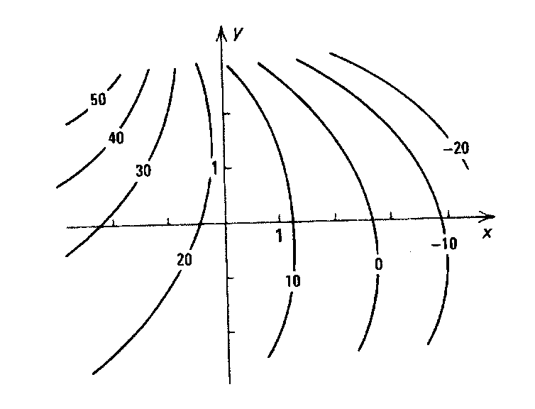

- Give a formula for the linear function L(x, y) such that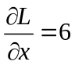, 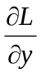= –3, and L(0, 0) = 7. Ans: L=6x-3y+7
- (a) Give an equation of the tangent plane to the graph of f(x, y) = xy at x = 3, y = 5. (b) Let
L (x, y) be the linear function whose graph is the tangent plane from part (a). How closely does L (3.01, 5.01) approximate f (3.01, 5.01)? (c) How closely does L(3.001, 5.001) approximate f (3.001, 5.001)? Ans: a) z =5x-6y-15 b) |15.0801-15.08|=10 ⁻⁴ c) |15.008001-15.008|=10 ^{– 6}.

- (a) Give a formula for the linear function L(x, y) whose graph is the tangent plane to the graph of g(x, y) = sin() + 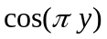at x = 1, y = 1. (b) How closely does L (1.02, 1.03) approximate g (1.02, 1.03)? Ans: a) 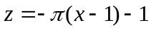, b) 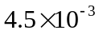

- Find the approximate x- and y-components of 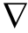f(2, 1) for the function f(x, y) whose level curves are shown in the figure below. Ans: 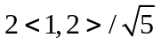

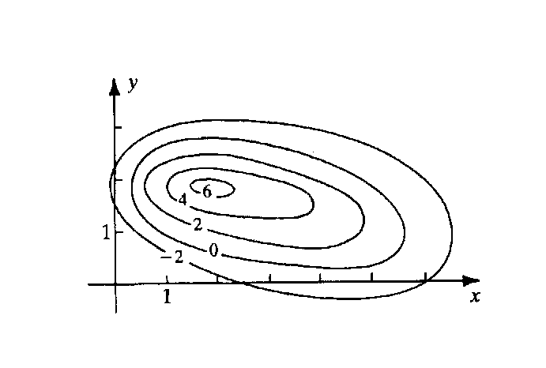

- Find the approximate x- and y-components of 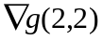for the function g (x, y) whose level curves are shown in figure below. Ans: 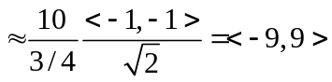

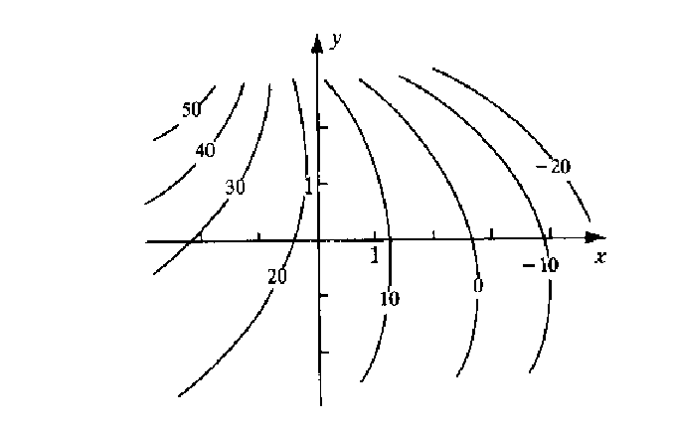

- An ant is on a metal plate whose temperature at (x, y) is 3x²y–y³ degrees Celsius. When he is at the point (5, 1), he is anxious to move in the direction in which the temperature drops the most rapidly. Give the unit vector in that direction. Ans: 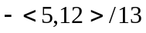

- (a) Give the two unit vectors normal to the curve xy³ + 6x²y = –7 at (1, –1). (b)Give the two unit vectors normal to the curve x – y² = 0 at (4, 2). (c) Give the two unit vectors normal to the curve e^{x-y2} = 1 at (4, 2). Ans: a) 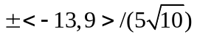; b) 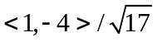; c) .
- If D_{u}W (5, 10) = –17 for u = 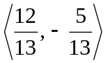 and D_{u}W (5, 10) = 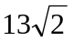for u =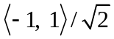. What are the x- and y-derivatives of W (x, y) at (5, 10)? Ans: W_{x}=-13, W_{y}= 13

- Find the unit vectors u such that D_{u}f (x_{o}, y_{o}) =1 if 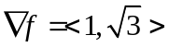. Ans: u={<1,0>,<-1/2,/2>}

- T1. (a) What is the domain of f(x, y, z) =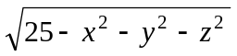? (b) Describe the level surface
f = 4. Ans: a) inside (including) the sphere of radius 5, b) a sphere of radius 3

- 1-For a yacht to be in the R-5.5 class at the Olympic Games, its rating R(L, V, A)
= 0.9 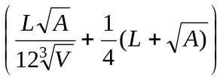 must be less than 5.5 where L (meters) is the length of the yacht, A (square meters) is the surface area of its sails, and V (cubic meters) is the volume of water it displaces. Would your yacht qualify for the R-5.5 class if it is 10 meters long, has 36 square meters of sail, and displaces 8 cubic meters of water?

- The maximum rate r (liters per minute) at which men 55 years old or older can take in oxygen under strenuous exercise can be predicted with the formula r = 3 – 0.05A + 0.003m + 0.01h where A is the man’s age, m is his weight in kilograms, and h is his height in meters. Based on this formula, how much weight would a man have to gain every year to maintain the same maximum rate of oxygen intake? Ans: 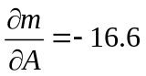, 16.6kg

- (a) A silo has the shape of a right circular cylinder of radius r and height H with a right circular cone of radius r and height h on top of it. Give a formula for the volume V of the silo. (b) What are the rates of change of V with respect to r, H, and h? (c) The exterior surface area of the silo is A = 2rH + r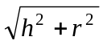. What are the rates of change of A with respect to r, H, and h? Ans: a) 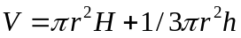 b) c)

- If the sides of lengths a an b in a triangle form an angle, use the Law of Cosines to find the third side c of the triangle. What are the rates of change of c with respect to a, b, and θ?
Ans: 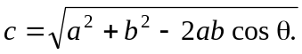, 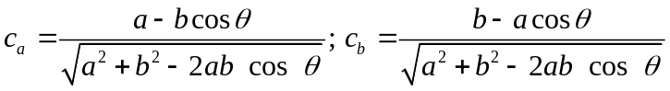;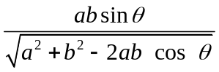

- Give the values of P (2) where 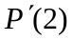where P(t) = f (t, t², t³) and f (x, y, z) satisfies f(2, 4, 8) = 3, f_{x} (2, 4, 8) = 4, f_{y}(2, 4, 8) = 5, and f_{z} (2, 4, 8) = -6. Ans: P (2) = 3, P’ (2) = - 48

- What are the first-order derivatives of G(x, y, z) = H(L(x, y, z)) at (–5, 0, 5) if L(–5, 0, 5) = 0,
L_{x} (–5, 0, 5) = 4, L_{y} (–5, 0, 5) = 8, L_{z} (–5, 0, 5) = 10,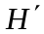(0) = 10,(4) = 16, and (8) = 12?
Ans: G_{x} =40, G_{y}= 80, G_{x}= 100.
- What is B_{x}(3, 2, 1) if B(x, y, z) = sin[(x, y, z)], (3, 2, 1) = 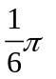, 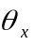(3, 2, 1) = 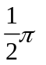, 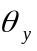(3, 2, 1) =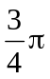, and 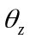(3, 2, 1) = 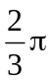? Ans: 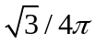

- In a mathematical model of a vibrating drum head, we suppose that the drum has the shape of the surface z = f(x, y, t) at each fixed time t and the function f(x, y, t) satisfies the WAVE EQUATION f_{xx} + f_{yy} = k⁻²f_{tt}. Show that f(x, y, t) = sin x sin y cos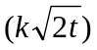 satisfies this differential equation.

- Suppose that a sound is emitted at frequency f (cycles per second) from a source that is moving with velocity v meters per second in the positive direction on an x-axis; that the wind is blowing parallel to the x-axis with velocity w meters per second; and that an observer is moving on the s-axis with velocity V meters per second. In this case the observer hears the sound as if it had frequency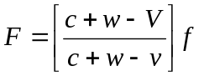. (This change in the frequency is called the DOPPLER EFFECT.) Here the constant c is the speed of sound. Find the derivatives of F with respect to v, w, V, and f and give their units.

- Find the set of points in xyz-space where 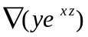 = (0, 1, 2). Ans: 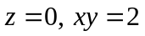.

- The work done by a constant force of magnitude F on an object that moves a distance s along a straight line at an angle with the direction of the force is 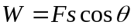. The force F is measured to be 10lb with an error no greater that 0.1 lb; the distance s is measure to be 100ft. with an error no greater than one inch; and the angle is measured to be 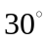 with an error no greater that one degree. Use differentials to estimate the maximum possible error in the work if the measured values are used to calculate it. Ans: 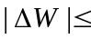18.1 ft-lb

- The height h of the frustum a right circular cone is measured to be 3in with an error no greater than 0.01in. The radius R of the base and the radius r of the top are measured to be 10in. and 5in with error no greater that 0.03in in each measurement. . Use differentials to estimate the maximum possible error in the computed volume 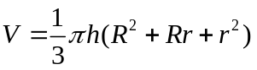of the frustum. Ans 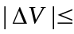6.07 in³.

