Functions of Several Variables

- (a) Is g (x, y) = x³y an increasing or decreasing function of x for y = 10? (b) Is g (x, y) from part (a) an increasing or decreasing function of y for x = –2. Ans: a) inc. b) dec.

- What is the global minimum of h (x, y) = (x–y) ² + 10 and at what values of x and y does it occur? Ans: 10; (0,0)
- What is the global maximum of k (x, y) = 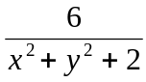 and at what point (x, y) does it occur?
Ans: 3; (0,0)

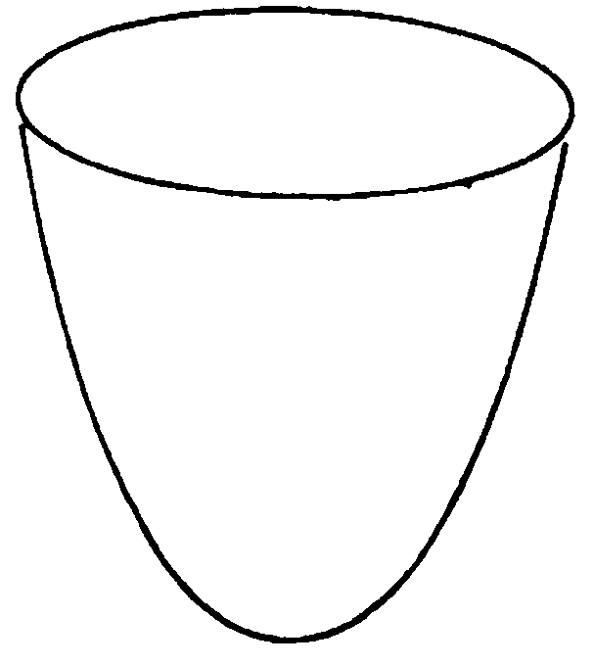
- (a) Describe the intersections of the graph z = x² + y² + 6 with the planes x = c, y = c, and z = c for constants c. (b) Add axes to the surface in the figure below so it represents the graph of z = x² + y² + 6

Ans: x = c and y = c are parabolas that open to the z-axis, z=c is a circle for z > 6.

- (a) Describe the intersections of the graph of the function f(x, y) = y² with the planes x = c, y = c, and z = c for constants c. (b) Copy the surface in the figure below and add axes and label them so the drawing represents the graph of f(x, y) = y².

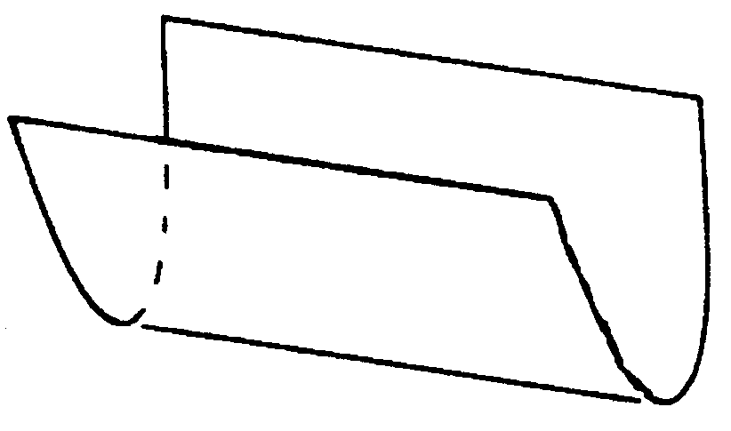

Ans: x = c parabola s, y = c lines, z = c parallel lines if c>0.

- Draw the graph of the function L (x, y) = –3.

- (a) What is the domain of z(x, y) =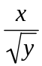? (b) For what values of x and y is the function positive? For what values of x and y is z negative? For what values of x and y is z zero?

Ans: y 0; half plane b) x>0, x<0, x=0.

- Draw the level curves x² + y = c of M (x, y) = x² + y for c = –2, 0 and 2.

- What are the values of P (x, y) = x² + 4y² on its three level curves in the figure below?
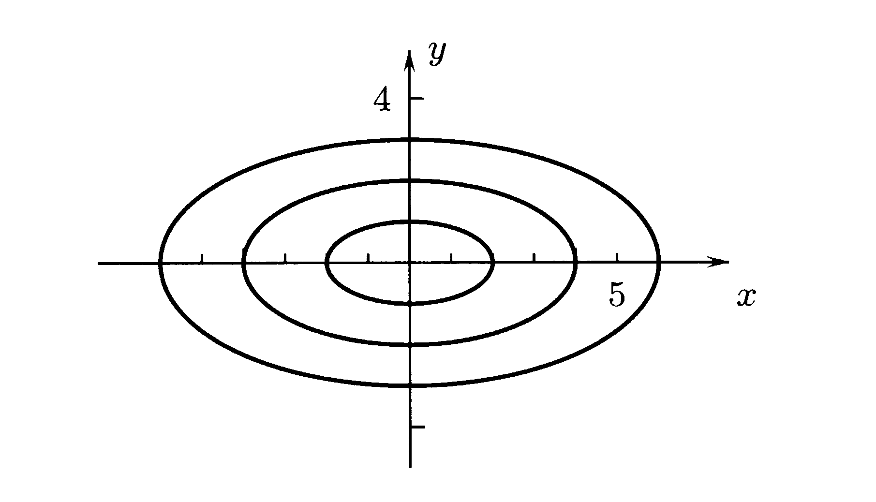

Ans: P_{in} = 4; P_{mid} = 16; P_{out} = 36

- Without using a calculator, which is the greatest and which is the least of the numbers M(1, 2), M(2, 1), M(2, 2) if M(x, y) =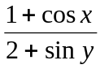? Ans: greatest M (1, 2); least M (2, 2).

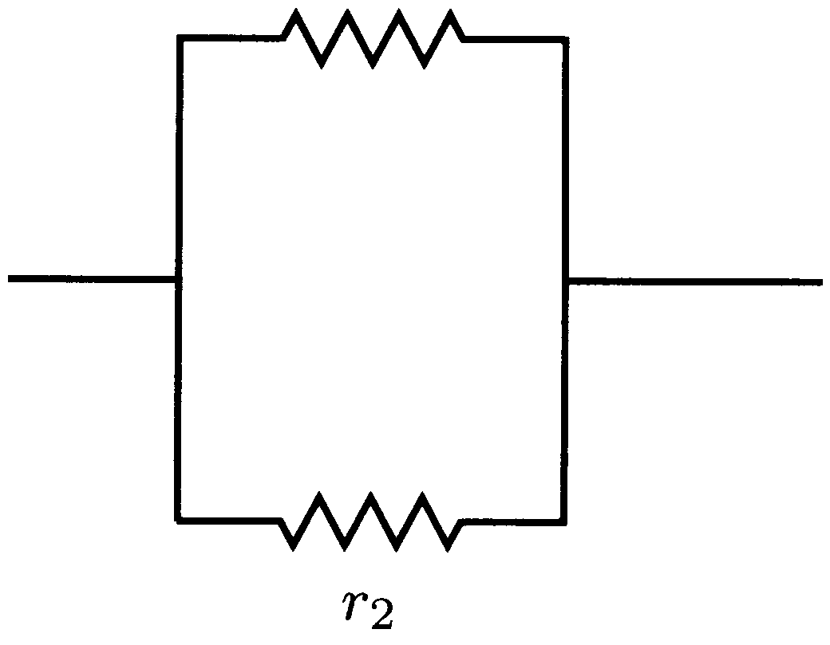
- The total resistance R = R(r₁, r₂) of an electrical circuit consisting of resistances, in parallel of r₁ and r₂ ohms (figure below) is determined by the equation 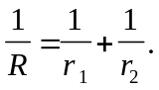 Show that

R(r₁, r₂) = 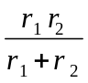

- When a very small spherical pebble falls under the force of gravity in a deep body of still water, it quickly approaches a constant speed called its TERMINAL SPEED. By STOKES’ LAW the terminal speed is v(r, p) = 21800(p – 1) r² centimeters per second if the radius of the pebble is r centimeters and its density is p ≥ 1 grams per cubic centimeter if its radius is 0.01 centimeters? (a) What is the terminal speed of a quartz pebble of density 2.6 grams per cubic centimeter if its radius is 0.01 centimeters? (b) Which of two pebbles has the greater terminal speed if they have the same density and one is larger than the other? (c) What happens to the pebble if its density is 1 gram per centimeter, the density of water? Ans: 3.488cm/s increases/ floats.

- The table below gives the equivalent human age A(t, w) of a dog that is t years old and weighs w pounds. (a) What does A(11,50) represent and, based on the table, what is its approximate value? (b) What does A(14, 70) represent and what is its approximate value? Ans: {64.5,83}

A(t, w) = EQUIVALENT HUMAN AGE

 | t = 6 | t = 8 | t = 10 | t = 12 | t = 14 | t = 16
w = 20 | 40 | 48 | 56 | 64 | 72 | 80
w = 50 | 42 | 51 | 60 | 69 | 78 | 87
w = 90 | 45 | 55 | 66 | 77 | 88 | 99

- Describe the level curve N (x, y) = 1 of N (x, y) =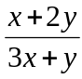. Ans: line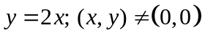.

- What are the values of L (x, y) = 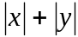 on its three level curves in the figure below?

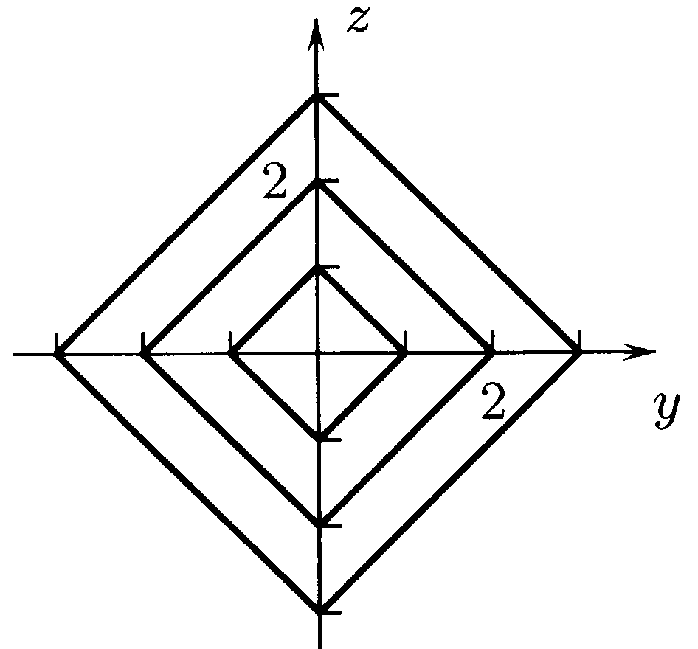

Ans: L_{in} = 1; L_{mid} = 2; L_{out} = 3

- What are the values of K (x, y) = 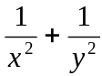 on its eight level curves in the figure below?
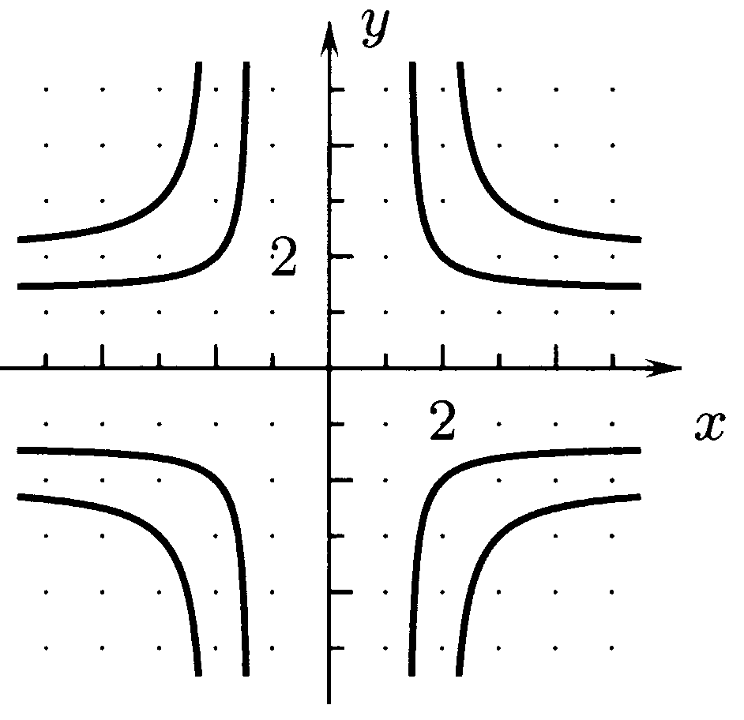

Ans: all K_{in} = 1/2; all K_{out} = 2/9

- In the figure below shows level curves of the function F (x, y) = Ax + By + C. What are the values of the constants A, B, C? Ans: -2,1,0

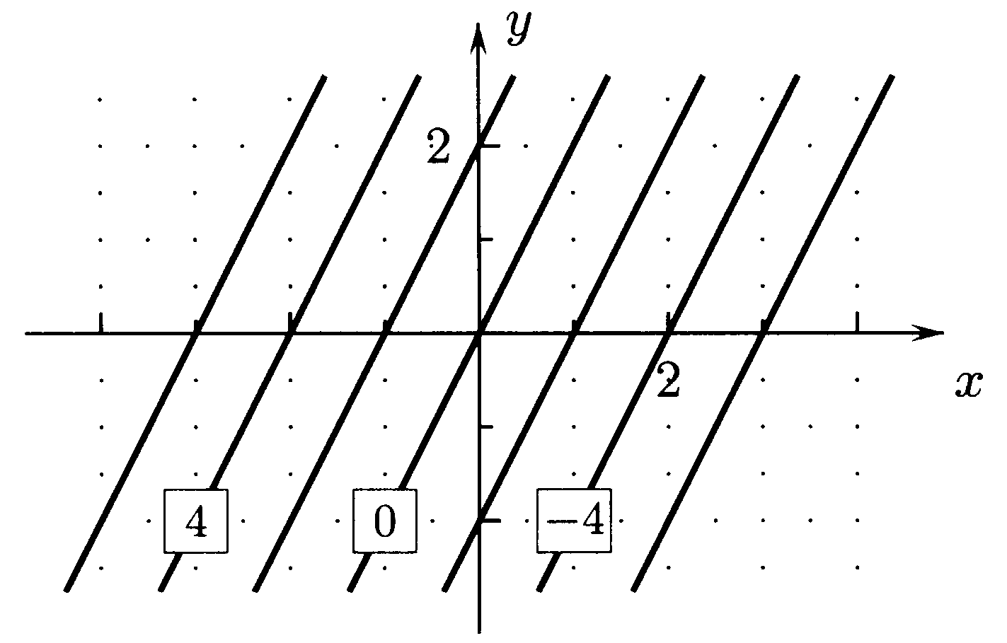

- Level curves of G (x, y) = Ay³ – cos (Bx) are shown in the figure below. What are the constants A and B? Ans: 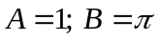
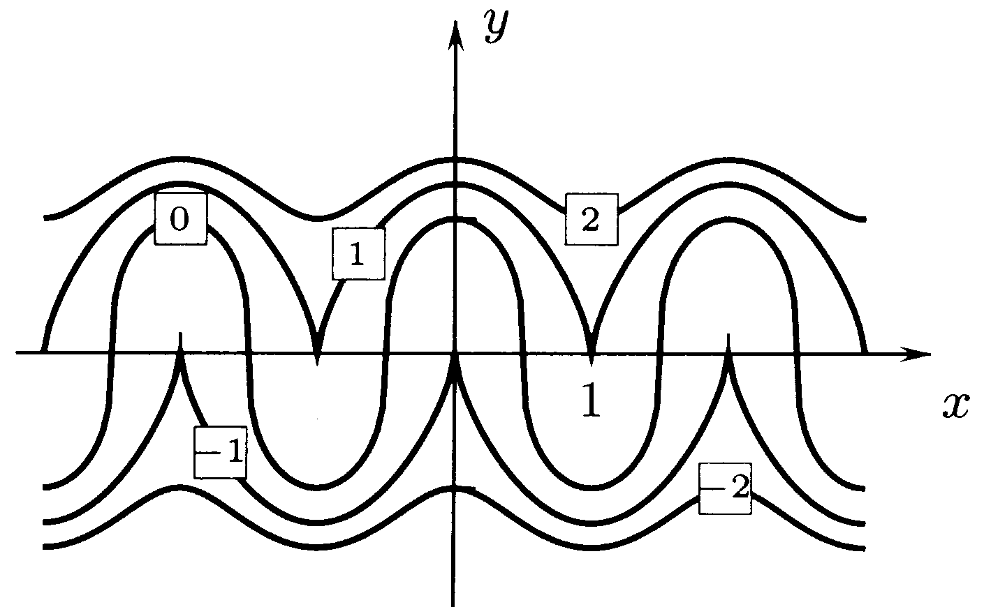

- The figures below show the surfaces z² = 2x² + 2y², z² = 2x² + 2y² – 1, and z² = 2x² + 2y² + Use these drawings to sketch the graphs of f (x, y) = 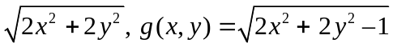 and 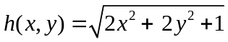 (b) what are the domains and ranges of f, g, and h from part (a)?

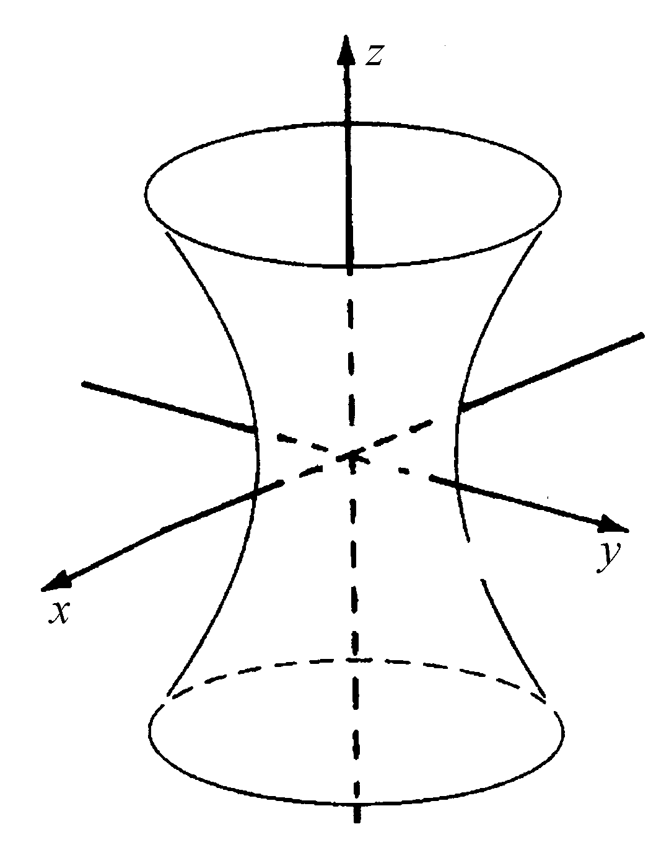
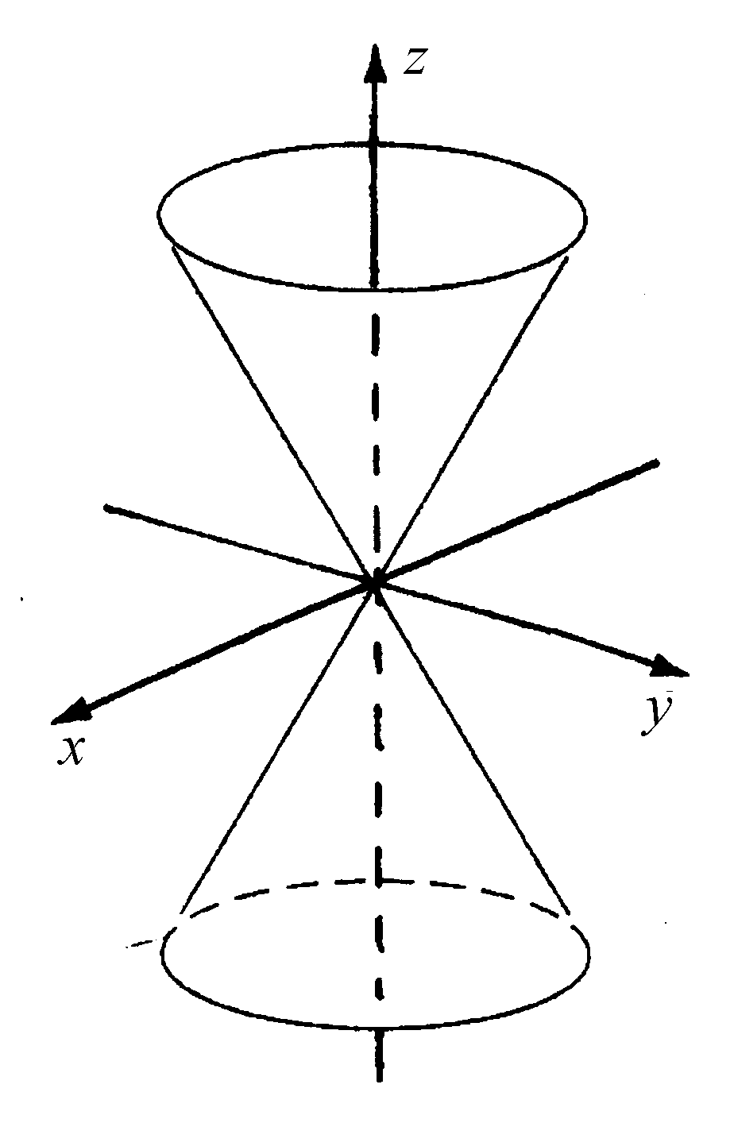
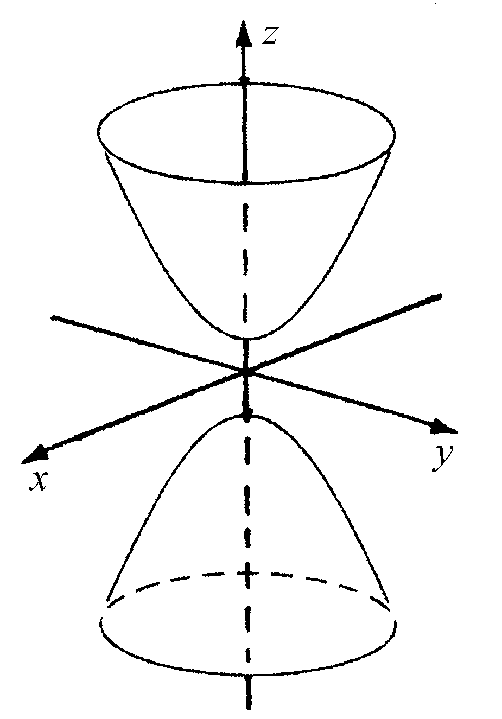

- Label positive ends of the x- and y-axes in Figure 1 so that the surface has the equation
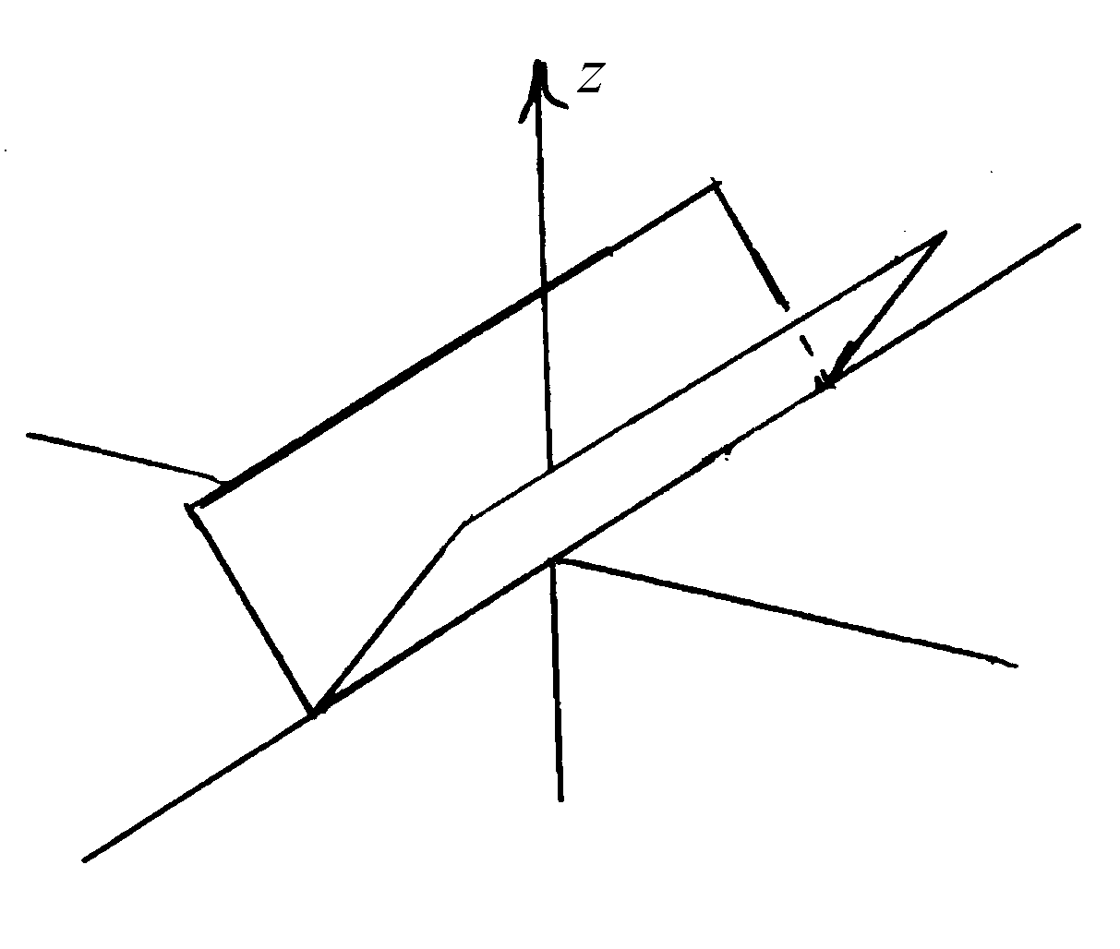
z =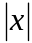.
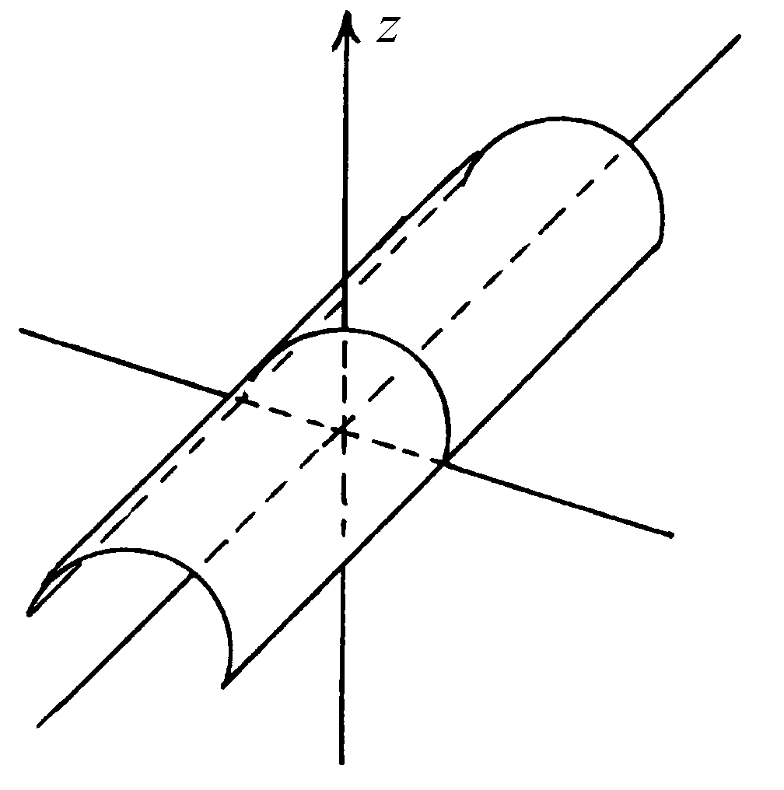

Figure 1
Figure 2

- Select positive ends of the x- and y-axes in Figure 2 so that the surface is the graph of
Q (x, y) = 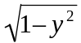

- Identify the positive ends of the x– and y- axes in the figure below (a) so that the surface is
z = y² – x² (b) so that the surface is z = x² – y².
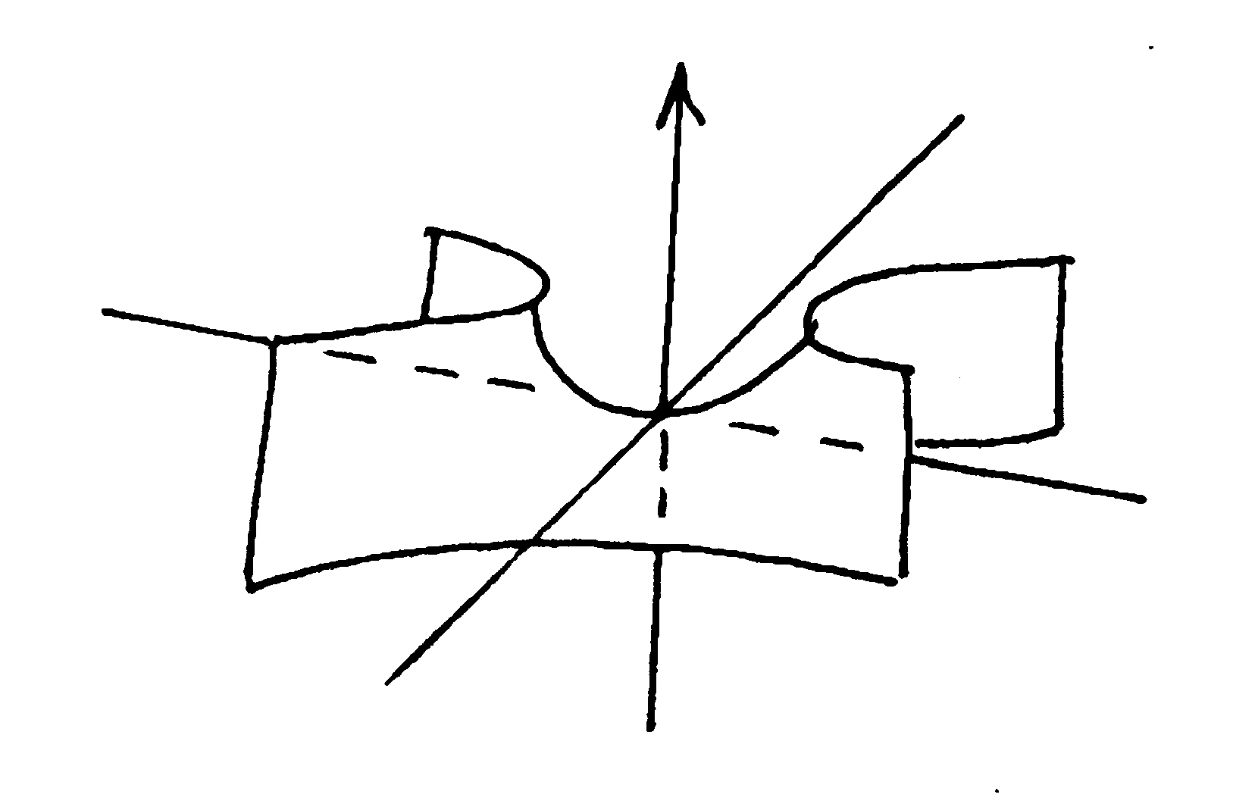

- Draw (a) the graph of R (x,y) = 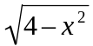. (b) Describe the level curves where the function of part (a) has the value 0, 1, and 2.

- Draw the surface z = x² in xyz-space.

- The graphs of (a) sin y –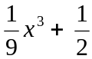, (b) sin y, (c) – sin x sin y, (d) sin² y + x² (e) –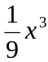 sin y and (f) 3e^{-x/5}sin y are shown in the figures below. Match the functions to their graphs and explain how the shapes of the surface are determined by their equations.
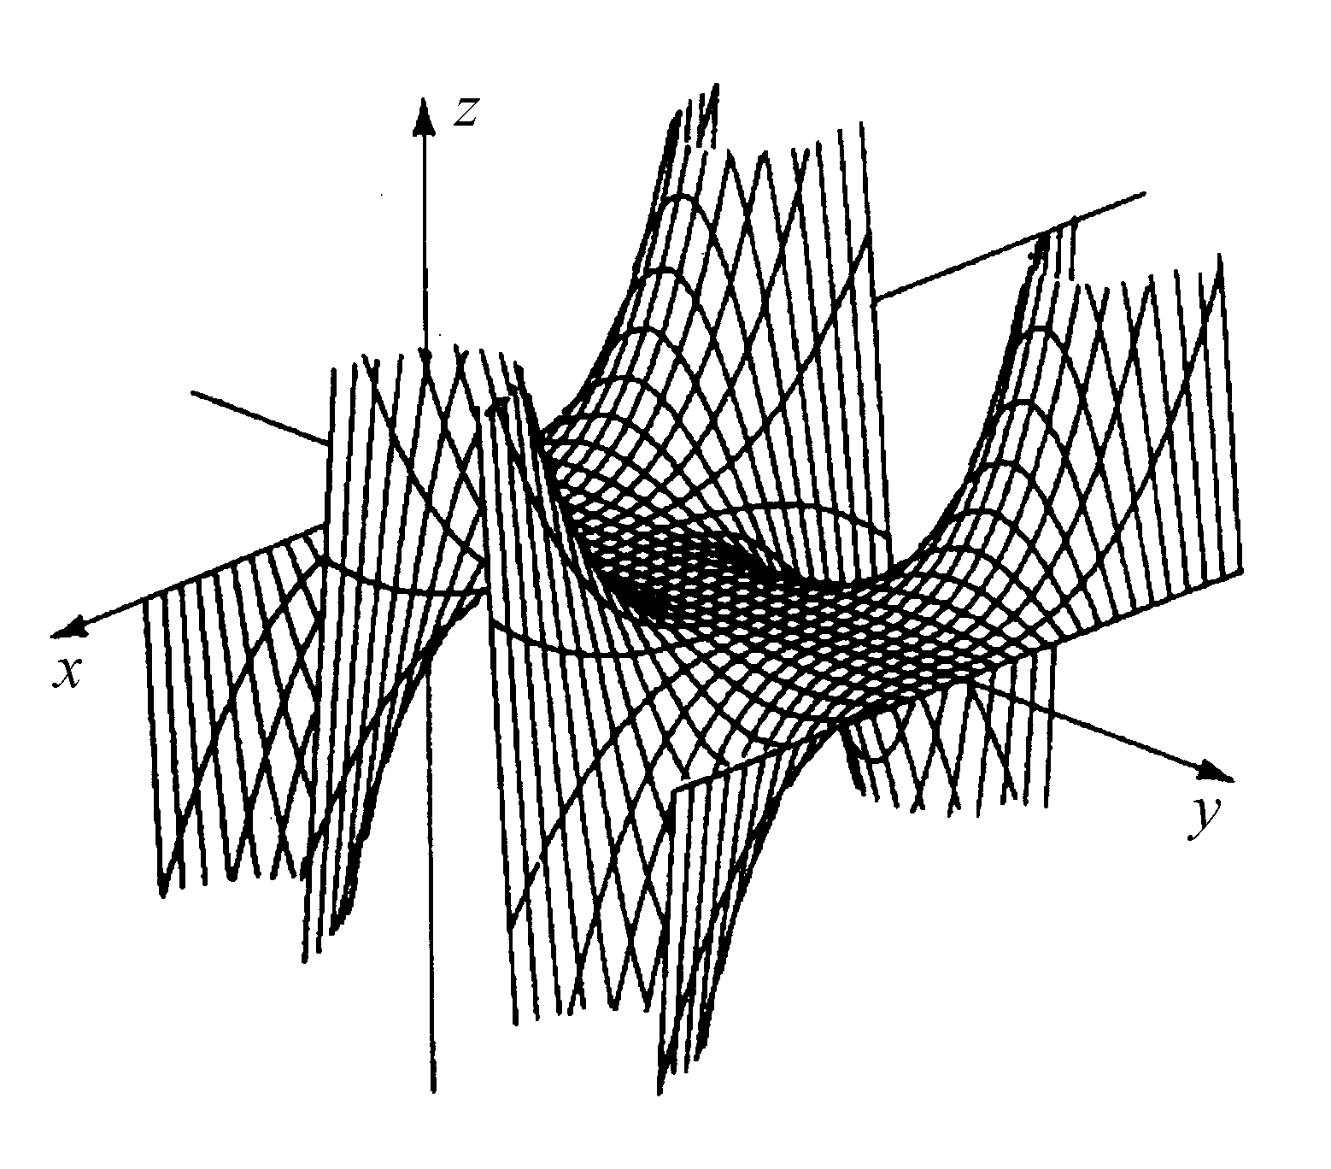
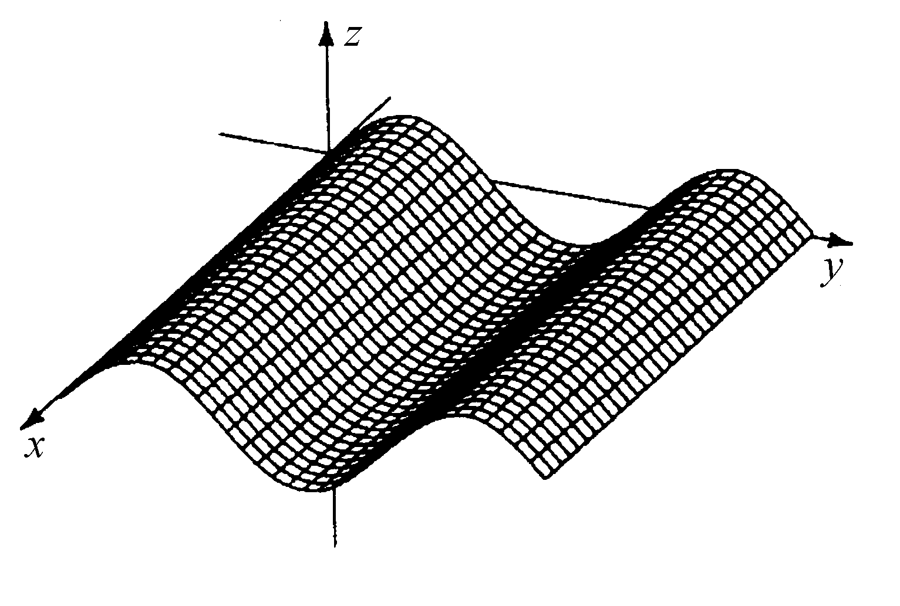
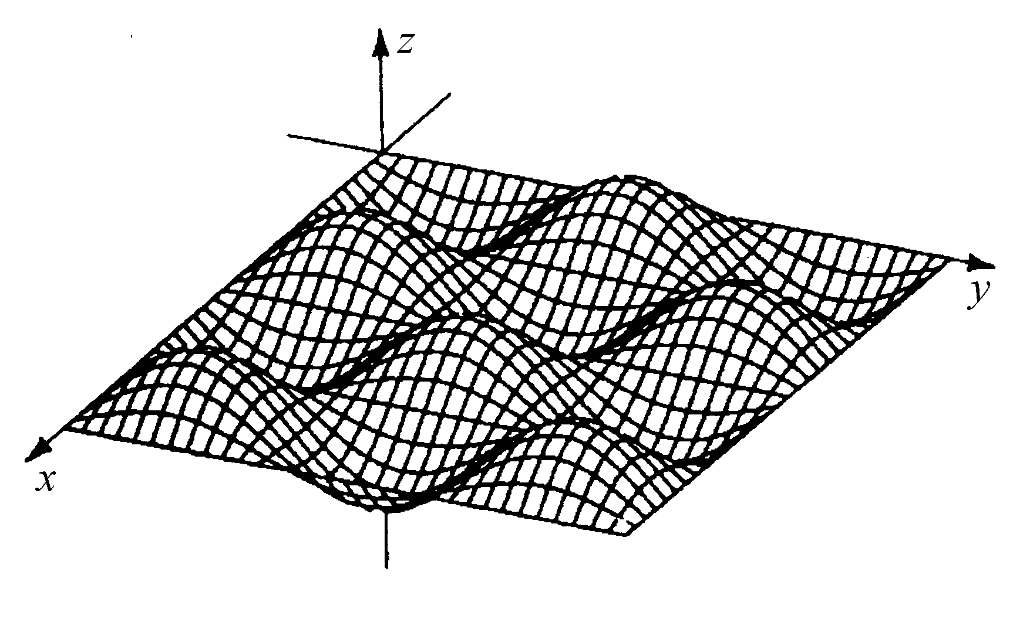

Figure 3 Figure 4 Figure 5

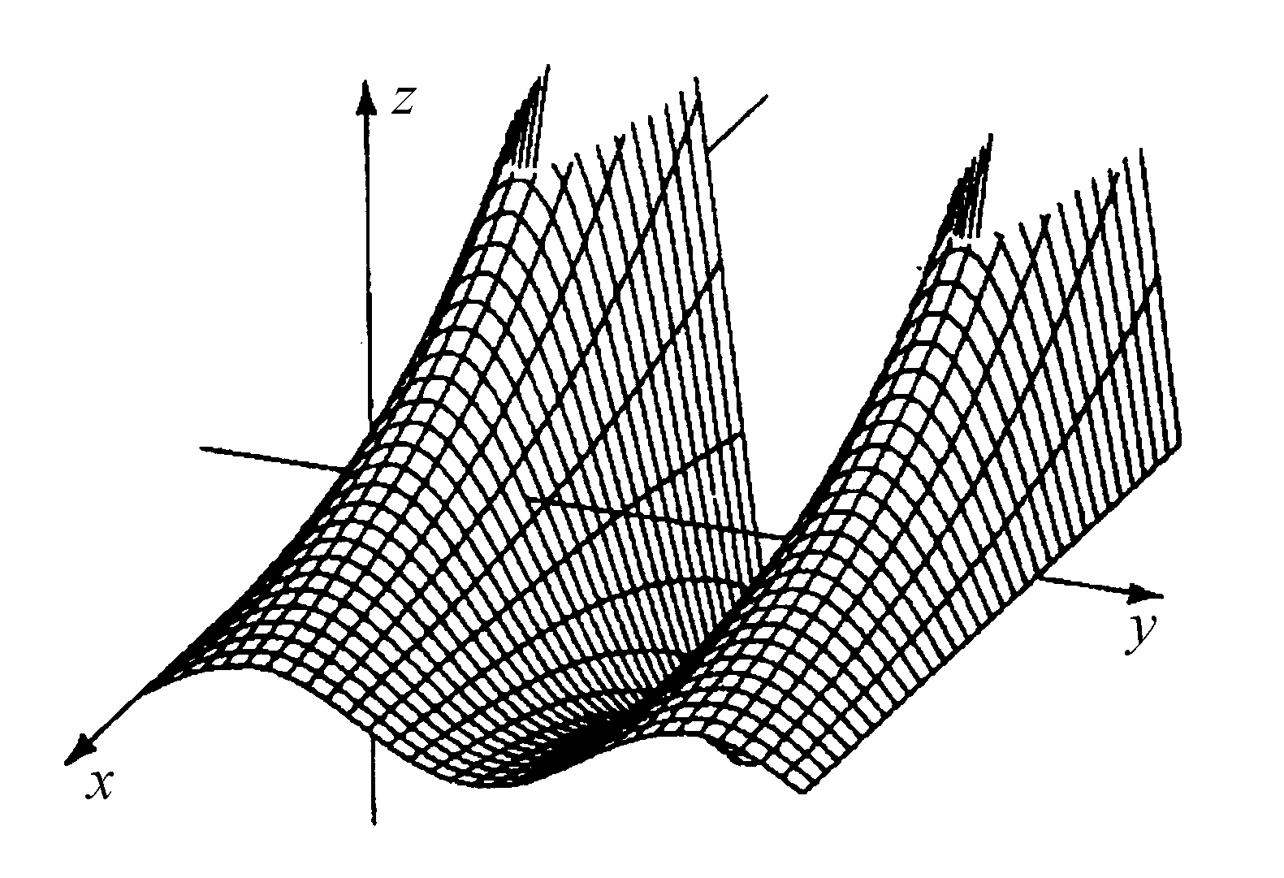
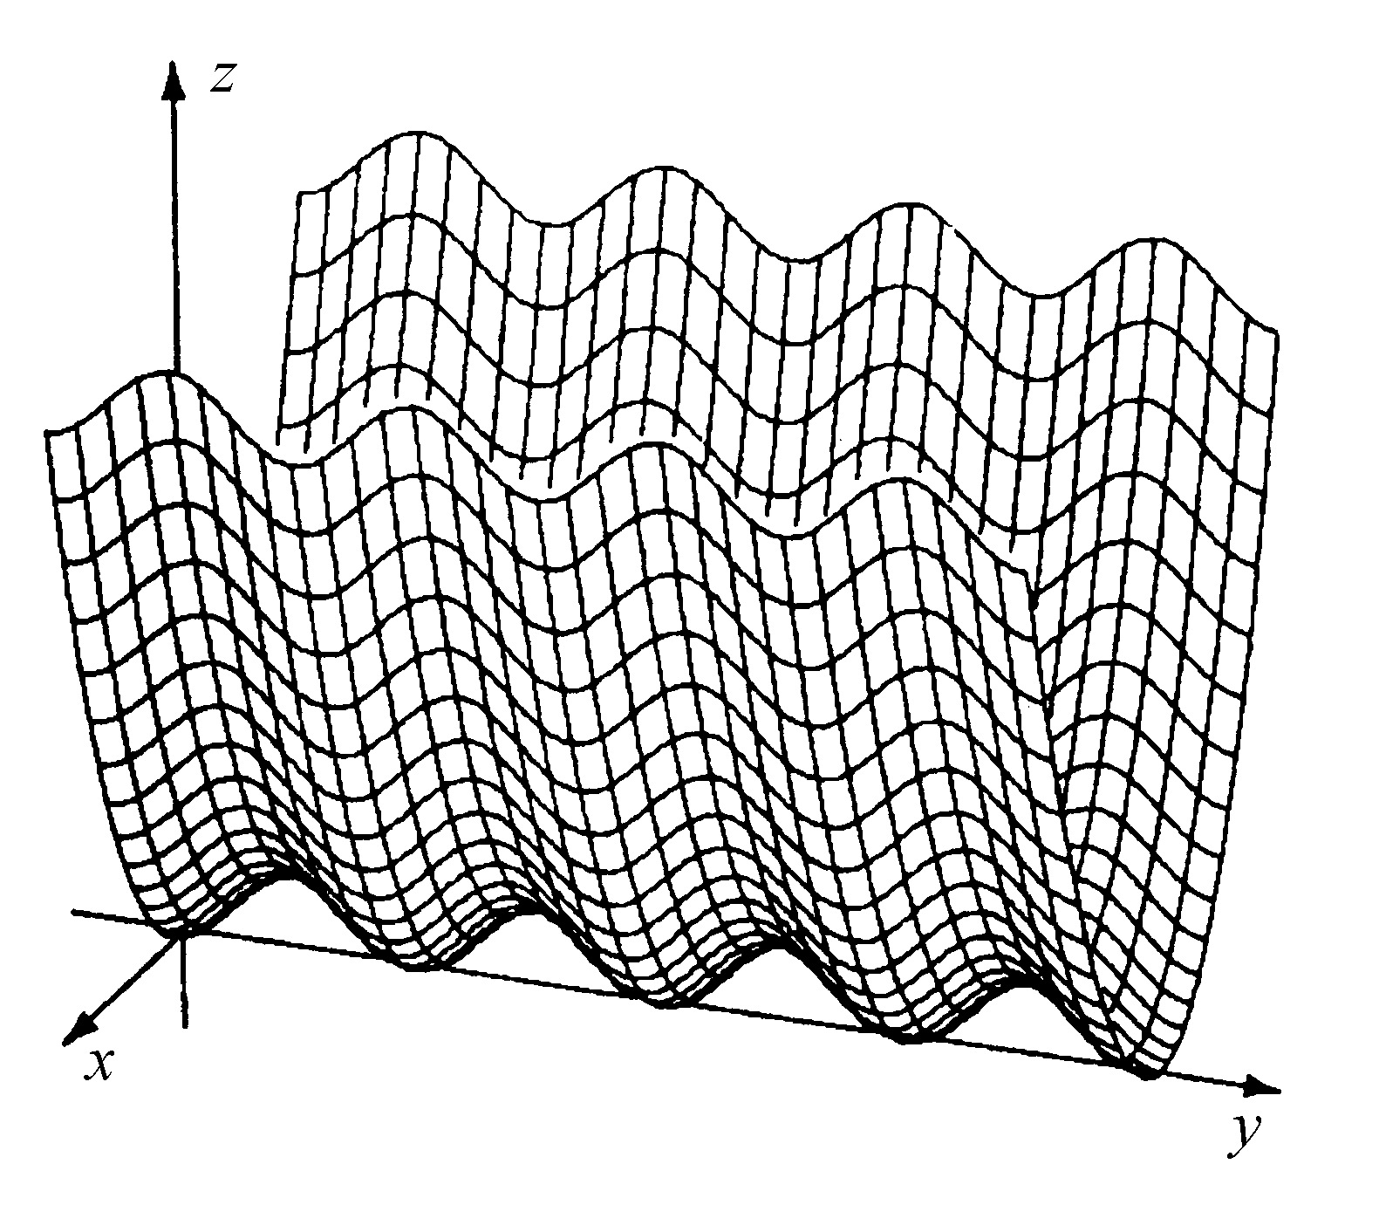
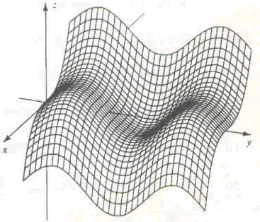
Figure 6 Figure 7 Figures 8

Ans: 3e, 4b, 5c, 6a, 7f, 8d

- Level curves of (a) sin y –, (b) sin y, (c) – sin x sin y, (d) sin² y + x²,
(e) 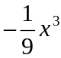 sin y, and (f) 3e^{–x/5} sin y from Problem 25 are shown in Figures 9 through 14. Match the functions to their level curves by comparing the level curves with the graphs in Figures 3 through 8.
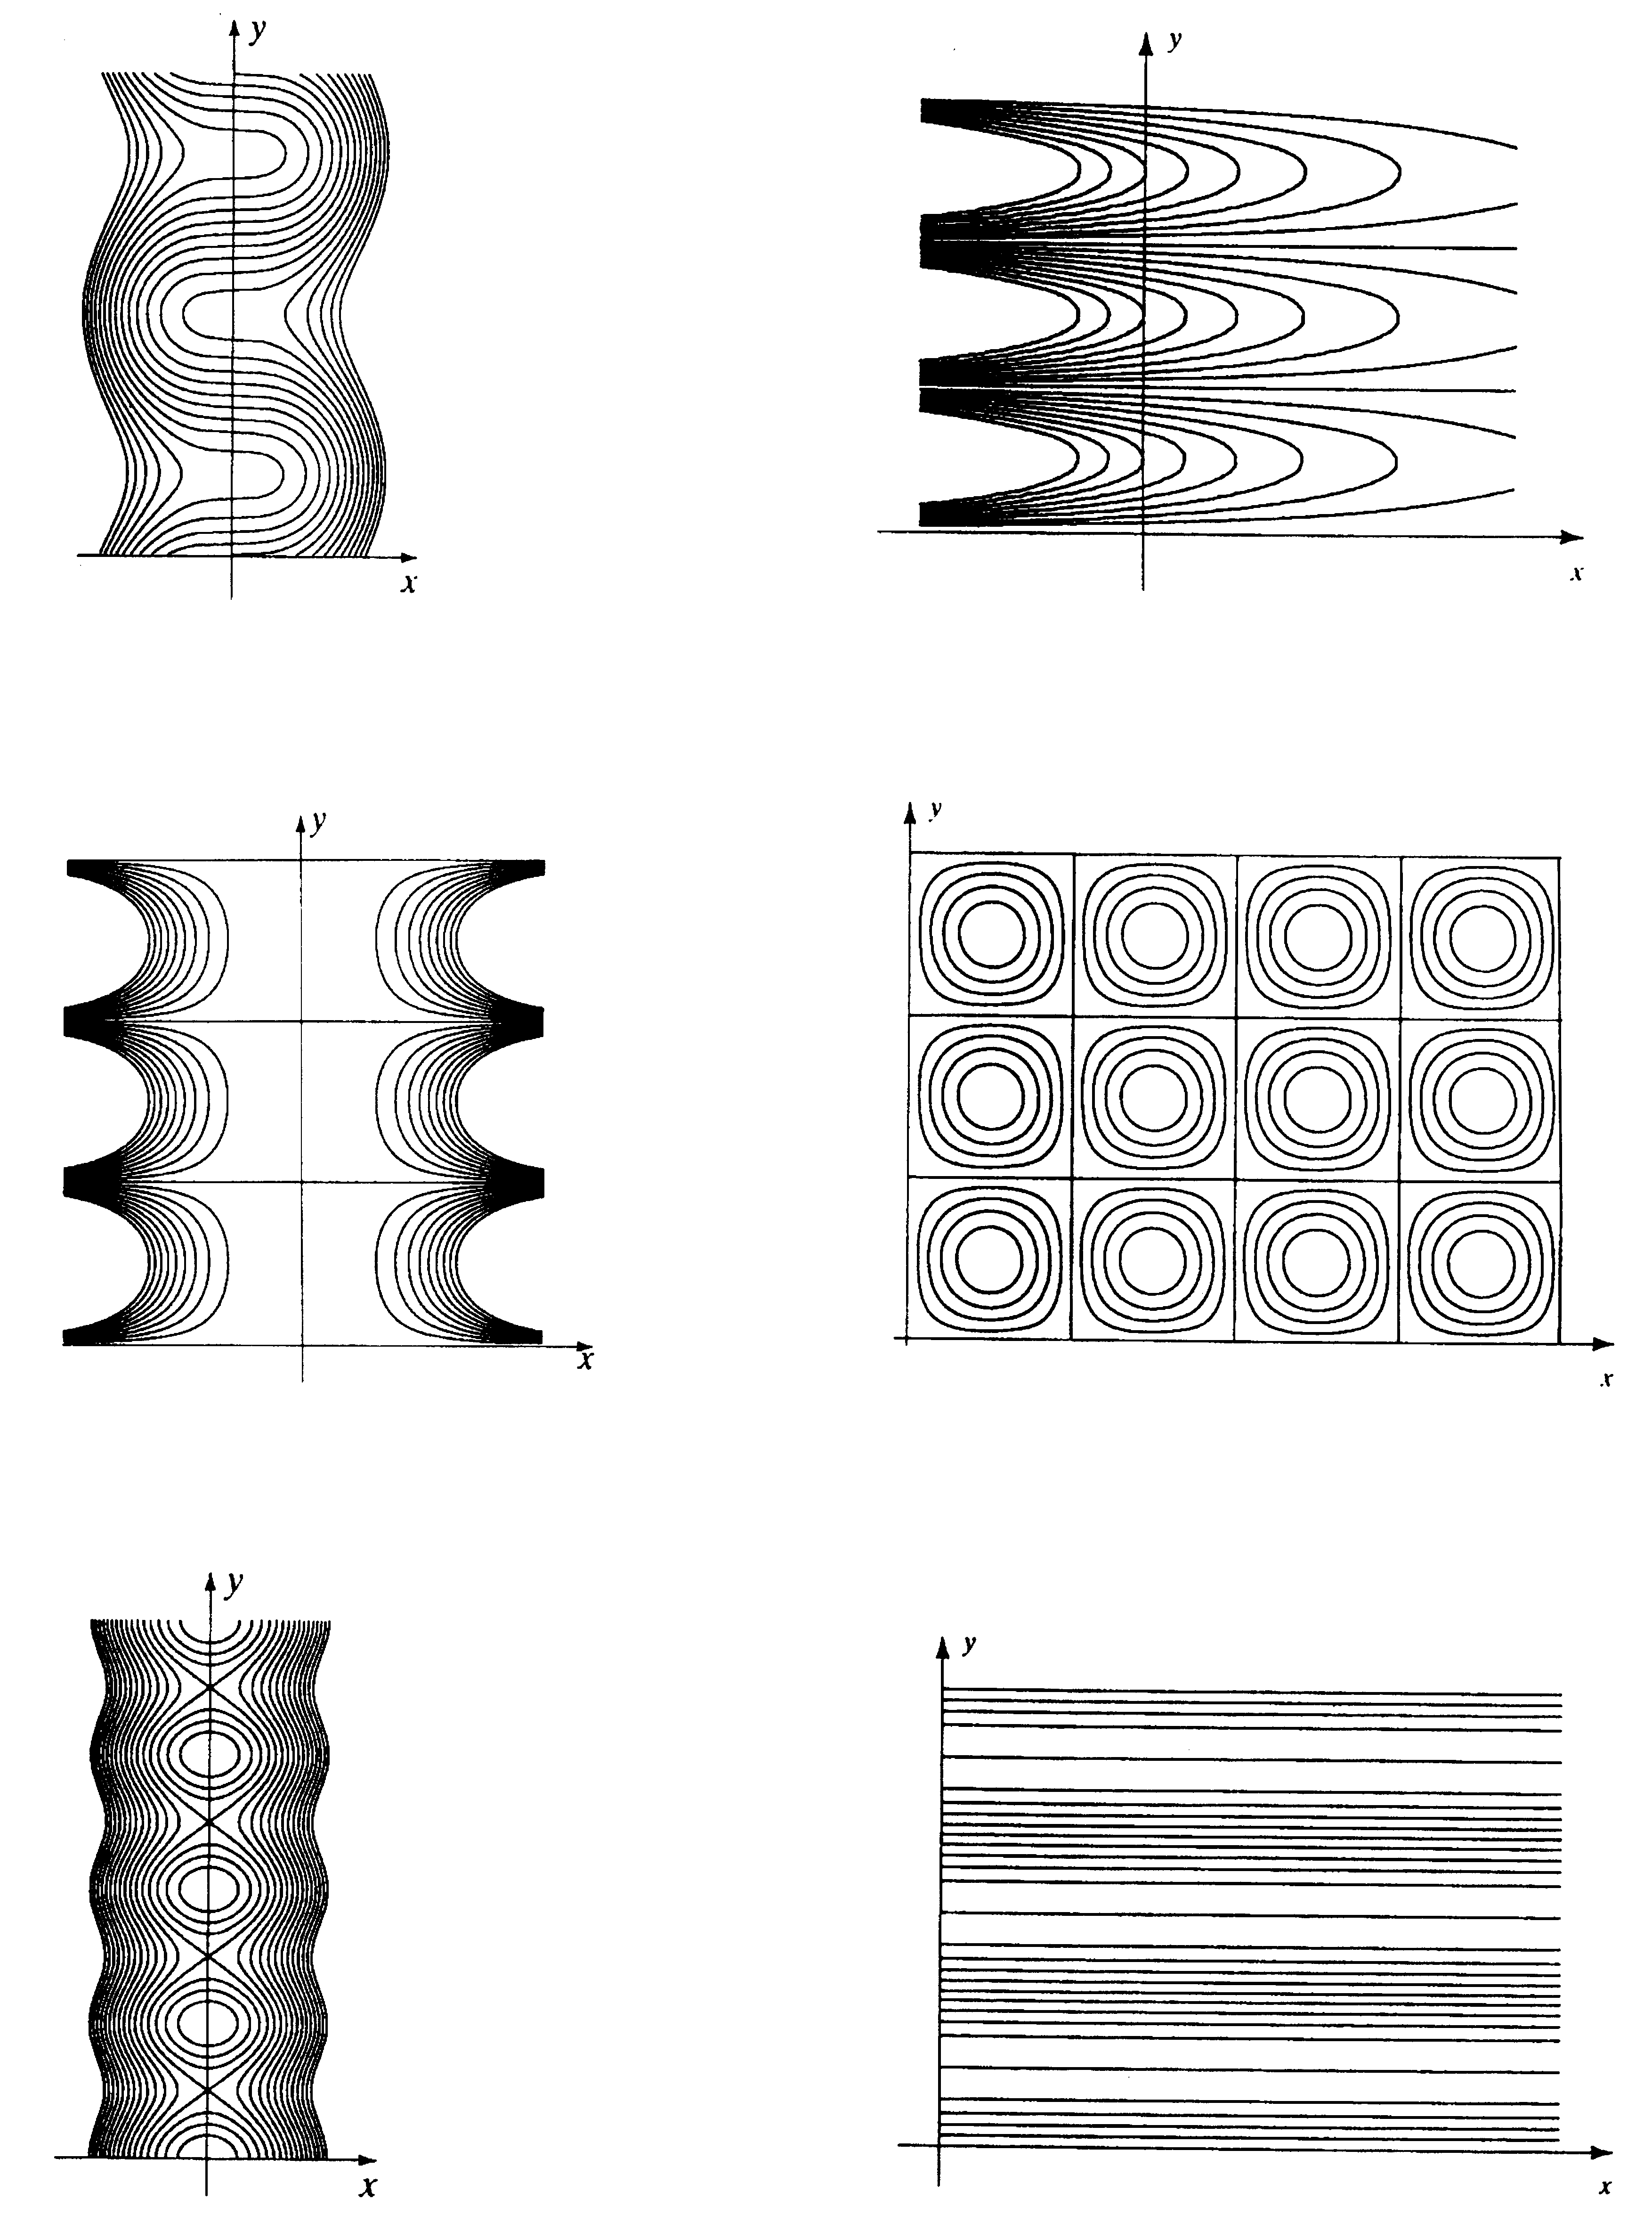

Figure 9
Figure 10

Figure 11

Figure 12

Figure 13
Figure 14

Ans: 9a, 10f, 11e, 12c, 13d, 14b

- (a) Explain why the horizontal cross sections of z = ln(x² + y²) and of z = 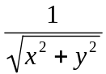 are circles. (b) Match the surfaces in the figure below to their equations in part (a). Explain your choices.

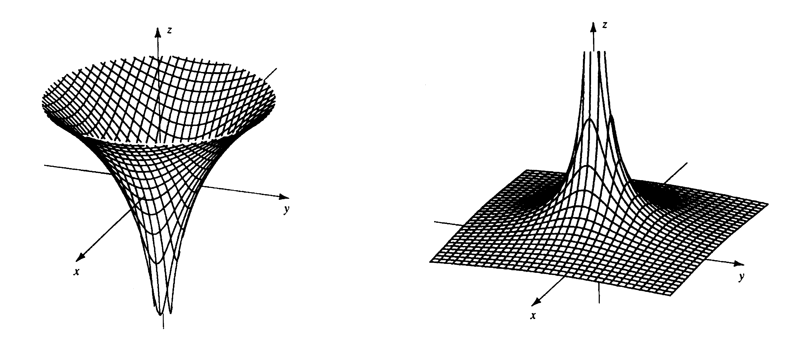

- A person’s BODY-MASS INDEX is the number I (w, h) = 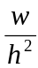 where w is his or her weight, measured in kilograms, and h is his or her height, measured in meters. (a) What is your body-mass index? (A kilogram is 2.2 pounds and a meter is 39.37 inches.) (b) A study of middle-aged women found that those with a body-mass index of over 29 had twice the risk of death than those whose body-mass index was less than 19. Suppose a woman is 1.5 meters tall and has a body-mass index of 29. How much weight would she have to lose to reduce her body-mass index to 19? Ans: 22.5kg or 49.5lb

- (a) What is the domain of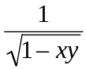? (b) What is its global maximum value and at what points does it occur? Ans: The region of the hyperbola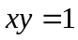that includes the origin; none

- What is the domain of ln(xy)? Ans: The first and third quadrants without the axis

- Use polar coordinates to find the following limits or show that they do not exist:

(a) 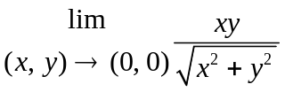; (b) 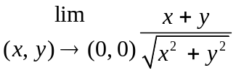; (c)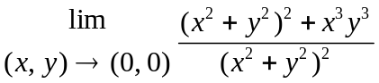
Ans: 0, DNE, 1

- Use polar coordinates to find the value of 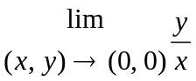 or show that the limit does not exist.

- Show that 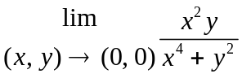 does not exist by considering (x, y) that approach (0, 0) along different parabolas.

- The figure below shows the graph of g(x, y) =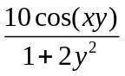. Find the global maximum of g(x, y) and the values of (x, y) where it occurs. Ans: g(x,0) =10
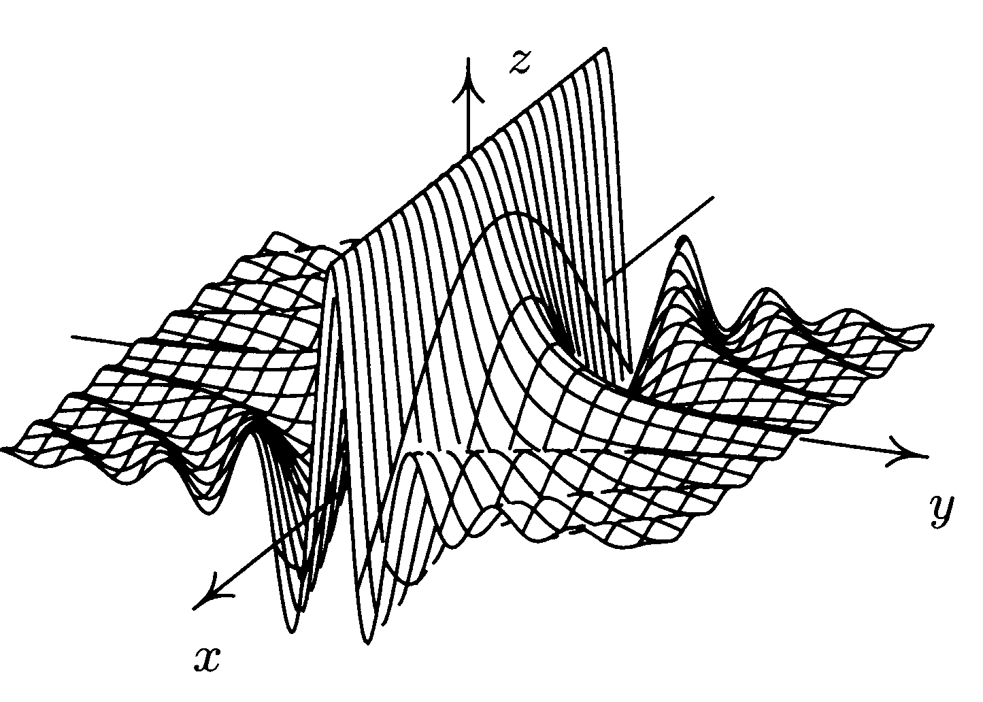

- Find, without using derivatives, the global maximum of h(x, y) = 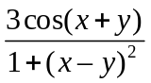 and the values of (x, y) where they occur. The graph of h(x, y) is in below.
Ans: Max: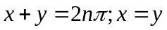, ( 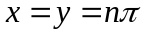); Min: 



