Viewing Scores and Grades
On your My Assignments page, you see all of your scores for your assignments within WebAssign. You might also see scores for assignments that you took outside of WebAssign.
Note: You cannot view scores or grades for a course in WebAssign after the last available date set by your instructor. Often, this date is shortly after the last day of classes.
In addition, your instructor can turn off display of scores and grades in WebAssign or choose to display only certain information.
On the Grades page, you see all of your raw scores and grades that your instructor posts.
The page might also include the class average, minimum and maximum scores, the standard deviation, and a histogram of scores for each category of assignment and for individual assignments. It might have your average for each category of assignments as well as the scores for individual assignments. Your instructor will let you know which scores and grades will be posted for your course.

To see your scores and grades:
- From the menu bar, click Grades.
- If your instructor enabled all of the options, your Grades page might look like this:
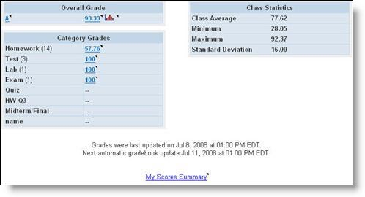
The Overall Grade gives information about your grade in the class as calculated from the various categories of assignments, such as Homework, Test, In Class, Quiz, Lab, and Exam. Your instructor might have different categories. You can click the Histogram icon next to the Overall Grade to view a histogram of the grades in the class.
The Category Grades show the contribution to your overall grade from each of the categories. Class Statistics shows you how the rest of the class is doing.
- To see how a number was calculated, click a grade that is a link.

