MAC 2311 Hybrid Calculus I (B)

3.7-3.8
1. Find the differential of $y=tan\sqrt{x}$.

2 Find the linearization of $f\left(x\right)=sin⁡(x)$ at x=π/3.

3. Find the derivative of $f\left(x\right)=\cosh\left(\sqrt{x}\right)+e^{\sqrt{x}}$

4. A balloon is inflated and its volume increases at a rate of 2 cm³/min. At what rate is the radius of the balloon changing when the radius is 5 cm?

5. Gravel is being dumped from a conveyor belt and accumulates in a conical pile with radius that is always 3 times its height. If gravel falls from the belt at a rate of 100ft³/min, how fast is the height of the gravel pile changing when the pile is 10 ft. high? The volume of a cone is$V=\frac{1}{3}πr^{2}h$. Your answer should be exact (No decimals). Show units.
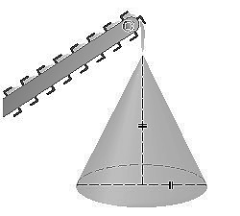

6. A 13-ft ladder is leaning against a vertical wall. If the foot of the ladder is pulled away at a rate of ½ ft/s, how fast is the top of the ladder sliding when the lower end of the ladder is 5 ft. from the wall?

7. A boat is pulled into a dock by a rope attached to the bow of the boat and passing through a pulley on the dock that is 3 m higher than the bow of the boat. If the rope is pulled in at a rate of 2 m/s how fast is the boat approaching the dock when 5 m of rope are left to pull in? Your answer should be exact (No decimals).

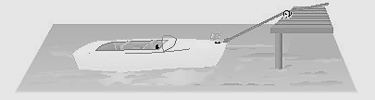

8. Use the definition of cosh(x) to simplify cosh(ln2).

