MAC 2311 Hybrid Calculus I (S)

Name Quiz # 3 (2.8) Take Home. Show all work.
1. Use the limit definition of the derivative (only) to find the equation of the tangent line to $f\left(x\right)=\frac{1}{\sqrt{x}}$ at $x=1$.

Answer: _______________

2. Given the graph of $f\left(x\right)$on the left, sketch the graph of$f'\left(x\right)$ on the right. Each tic mark is one unit.

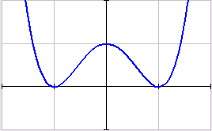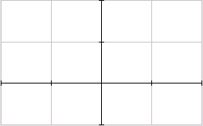

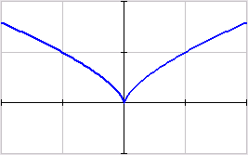

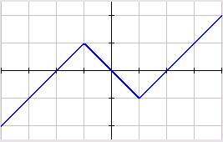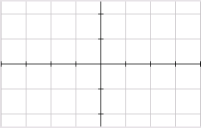

3. Give an example of a case where a function fails to be differentiable. Write the function, and show the graph of the function.

Answer: _______________

