Enrolling Yourself in a Class Using a Class Key
You will enroll in a WebAssign class using Self-Enrollment. You can find a WebAssign class key at the beginning of the syllabus. With your WebAssign class key, you can enroll yourself in the WebAssign class roster. If you do not already have a WebAssign account, you can create one after verifying the class key.
Important: An access code is not the same as a class key. You need a class key to enroll. You need your access code to access the course.

To self-enroll for a class:
- Go to the WebAssign login page (www.webassign.net), and click I have a Class Key.
- Enter the class key your instructor gave you, and click Submit.
- On the verification page, check the class information and determine whether or not the correct class and section is displayed.
  - If the correct class and section is listed, click Yes, this is my class and go to step 4.
  - If the listed class or section is not correct, click No this is not my class. Try entering your class key again, in case you might have mistyped a character. If the correct class is still not displayed, contact your instructor.
- If you have an existing WebAssign account, select I already have a WebAssign account, type the Username, Institution, and Password for your account, and click Continue. You are enrolled in the class and logged in to WebAssign using your existing account.
- If you do not have an existing WebAssign account, you can create one now.
  - Select I need to create a WebAssign account, and then click Continue.
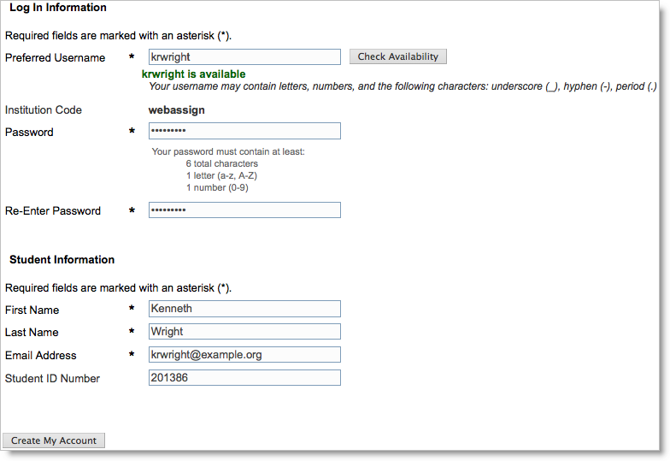
  - Type the username that you would like to use for your WebAssign account in the Preferred Username field, and click Check Availability to see if the username that you want is available. Usernames are not case-sensitive, so BobSmith, bobSmith, and bobsmith are all the same username.
  - After confirming the availability of your new username, type a password in both the Choose a password and Confirm password fields. Ensure that your password meets the displayed requirements, which might be different than those shown above. Passwords are case-sensitive, so IAmCa3sar is not the same as iamca3sar.
  - Enter your First Name, Last Name, and Email Address, and optionally your Student ID Number.
  - Click Create My Account. WebAssign confirms that your account has been created.
You should only enroll in the class once. After enrolling, you might also need to provide an access code to verify payment for the class.
You can click Log in now to log in to the new user account and go to your home page. Remember your username and password, because you will need them each time you log in.
Tip: If you forget your password, you can click the Reset Password link on the login page. If you forget your username, your instructor can look up your username for you.

