MAC 2311 Hybrid Calculus I (B)

Section 3.1
1. Use the limit definition of the derivative (only) to find the slope of the tangent line to
$f\left(x\right)=\sqrt{x+3}$ at the point (1, 2)

2. Use the limit definition of the derivative (only) to find a function that gives the slope of the tangent line to $g\left(x\right)=\frac{1}{x+1}$.

3. Use the limit definition of the derivative (only) to find the equation of the tangent line to $h\left(x\right)=x^{2}+1$ at $x=1.$

4. Given the graph of $f\left(x\right)$sketch the graph of$f'\left(x\right)$.

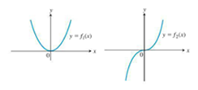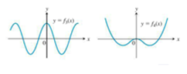

5. If the line tangent to the curve y = f (x) at (5, 18) is $y$ = 4x – 2, then $\lim_{h→0}\frac{f\left(5+h\right)-f(5)}{h}=$

6. If the line tangent to the curve y = g (x) at (5, 18) is $y$ = 4x – 2, then $\lim_{x→5}\frac{g\left(x\right)-g(5)}{x-5}=$

7. True/False: if a function is continuous, it is differentiable; and if a function is differentiable it is continuous. Explain with examples.

8. Give 3 different cases, with examples, when a function is not differentiable.

