Review 7.1-7.2

1. Given the graph below, do the following.
a. State the number of turning points.
b. Find the zeros. Write your answer(s) in ordered pair form.
c. Determine whether the graph represents an even or odd degree function. Justify your decision.
d. State whether the leading coefficient is positive or negative. Justify your decision.
e. Write the equation of the function in factored form.
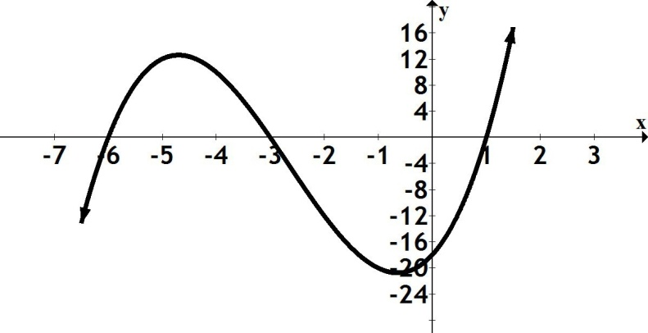
2. Given $f\left(x\right)=7x{\left(x-9\right)}^{2}{\left(x+8\right)}^{3 }$
a. Find the degree (without multiplying through).
b. Find the zeros and state the multiplicity for each.
3. Determine if $(x+2)$ is a factor of f$\left(x\right)=$ ${x^{3}+4x}^{2}+ 5x+2$.
4. Use your calculator to find all the real zeros of the function $f(x)=$ ${5x}^{3}-{12x}^{2}- 2x+$3.
Approximate your answers to 4 decimal places.
5. Find a polynomial that could be represented by the given graph.
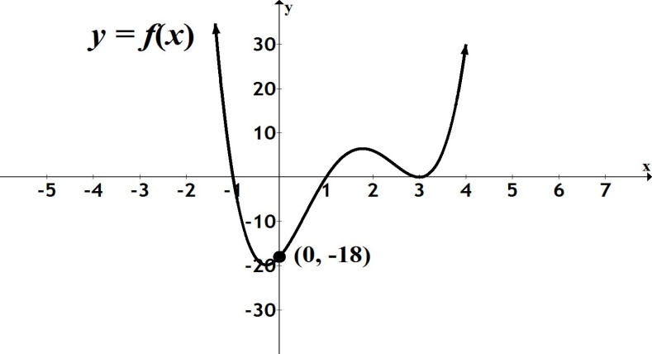

6. Given$f\left(x\right)=$ $\frac{7x + 2}{3x + 5}$
a. Determine the domain. Write your answer using interval notation.
b. Find the vertical asymptote(s), if any.
c. Find the horizontal asymptote, if it exists.

7. Given$f\left(x\right)=$ $\frac{x - 18}{x^{2} - 9}$
a. Find the vertical asymptote(s), if any.
b. Find the horizontal asymptote, if it exists.
c. Find the x-intercept.
8. Abdul has a business designing and selling sports memorabilia. The average cost per item (in
dollars) for producing x number of items is given by the function $A(x)$ = $\frac{400 + 2.25x }{x }$ .
a. Find and interpret $A$(150). Round to the nearest dollar and answer in a complete sentence.
b. If the average cost per unit is $3.05, how many items can Abdul produce? Round your answer to
the nearest whole number.
c. What is the domain in terms of this problem? Answer in a complete sentence.

