Review 6.2-6.3
1. Logarithm: $\log_{b}x$ = $y$ if and only if $b^{y}$= $x$; b > 0, b ≠ 1, x > 0
Example: $\log_{3}9$ = $2$ is equivalent to $3^{2}$= $9$
Log reading hint: "start at base and read counterclockwise" $\log_{3}9$ = $2$
Rewrite in exponential form.
a. $\log_{2}16$ = $4$ b. $\log_{m}n$ = 1/2

2. Rewrite in logarithmic form.
a. $5^{3}$= 125 b. $t^{r}$= $s$

3. Evaluate.
a. $\log_{4}1$ b. $\log_{17}\sqrt{17}$ [recall $x^{1/2}$= $\sqrt{x}$ ] c. $log(-1)$ [recall log definition]

4. Inverse function of Exponential function is the Logarithmic function:
Let $f(x$) = $b^{x}$
$y$ = $b^{x}$
$x$ = $b^{y}$ $x$ = $b^{y}$ if and only $\log_{b}x$ = $y$
Logarithmic function: $f(x$) = $\log_{b}x$ for $x$ > 0, $b$ > 0, $b$ ≠ 1
For each function, find its inverse.
a. $f(x$) = $3^{x}$ b. $f(x$) = ${10}^{x}$
5. Graphs of logarithmic functions: if b > 1, graph increasing; if 0 < $b$ < 1, graph decreasing
For each function, complete the table and graph the function.
a. $f(x$) = $\log_{3}x$
x | y
1
3
9
1/3
1/9
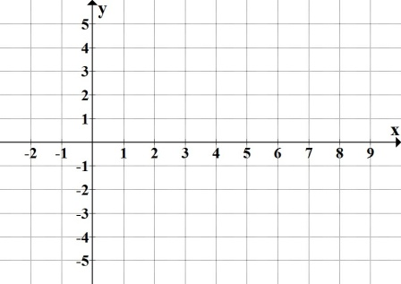

b. $f(x$) = $\log_{1/3}x$
x | y
1
3
$$9$$
1/3
1/9
6. Find the domain.
a. $y=\log_{b}x$ b. $y=log(x+11)$ c. $y=log(-3x+2)$

7. For each logarithmic function, find the corresponding transformations.
a. $f(x$) = $log(x)+11$ b. $f(x$) = $log(x+11)$
c. $f(x$) = $log\left(x-7\right)- 15$ d. $f(x$) = $-log\left(x\right)+ 2$
8. Evaluate and round your answer to 3 decimal places where needed. Hint: Use the © key.
a. $e^{4}$ b. $5.2e^{0.65}$ c. $ln\sqrt{e}$ d. $ln\left(\frac{3}{e^{2}}\right)$

9. Exponential growth and decay: $P(t)$ = $P_{0}e^{kt}$ Note: $e^{k}$ is equivalent to "$b$" on$P(t)$ = $P_{0}b^{t}$
$P_{0}$ = initial value (that is, population at time = 0); $P>0$
$k$ = continuous growth or decay rate (expressed as decimal)
$e^{k}$ = growth or decay factor
$t$ = time
Find the initial value, the continuous growth or decay rate, and the growth or decay factor.
a. P(t) = $43e^{0.064t}$ b. N(t) = $17e^{-0.075t}$

10. Ronald bought a sport utility vehicle in 2009, which unfortunately started losing its value as soon as he drove off the lot. Ronald's SUV's value can be modeled by the function V(t) = 21305$e^{-0.173t}$, where t represents years after 2009.
a. Find and interpret V(0).
b. Find V(5). Round your answer to the nearest dollar. Interpret your answer.
c. After what year will the SUV's value drop to $5,338? Solve graphically.

