*Review 6.2-6.3 (****Key****)*

1. Rewrite in exponential form.

a. = **=**

b. = 1/2 **=**

2. Rewrite in logarithmic form.

a. = 125  **=**

b. =  **= *r***

3. Evaluate.

a. $\log_{4}1$ ${{let log}_{4}1=y, so 4}^{y}$**= $1$; thus, $y=0$**  **because $4^{0}=1$**

b. $\log_{17}\sqrt{17}$ ${{let log}_{17}\sqrt{17}=y, so 17}^{y}=\sqrt{17};$**thus, $y=1/2$**  **because**

c.

4. Find the inverse function:

a. ) = **) =**

b. =

5. For each function, complete the table and graph the function.

a. $f(x$) = $\log_{3}x$

|  |  |
| --- | --- |
| ***x*** | ***y*** |
| **1** | $$\log_{3}1=0$$ |
| **3** | $$\log_{3}3=1$$ |
| **9** | $$\log_{3}9=2$$ |
| **1/3** | $\log_{3}1/3=-$**1** |
| **1/9** | $$\log_{3}1/9=-2$$ |

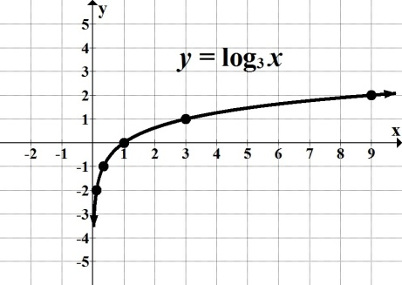

b. $f(x$) = $\log_{1/3}x$

|  |  |
| --- | --- |
| ***x*** | ***y*** |
| **1** | $$\log_{1/3}1=0$$ |
| **3** | $$\log_{1/3}3=-1$$ |
| $$9$$ | $$\log_{1/3}9=-2$$ |
| **1/3** | **1** |
| **1/9** | **2** |

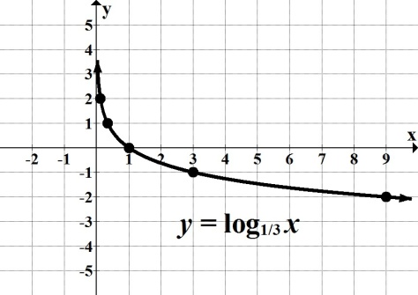

6. Find the domain.

a. $\log_{b}x$ $x >0$**or $(0, ∞)$**

b. $log(x+11)$ $x + 11>0$**, therefore, $x >-11$ or $(-11, ∞)$**

c. $log(-3x+2)$ $-3x+2$ $>0$**, therefore, $x<2/3$ or $(-∞, 2/3)$**

**(Note: On part "*c,*" remember we reverse the inequality symbol when dividing by a negative quantity.)**

7. For each logarithmic function, find the corresponding transformations.

a. $f(x$) = $log(x)+11$**up 11** **units**

b. $f(x$) = $log(x+11)$**left 11** **units**

c. $f(x$) = $log\left(x-7\right)-15$**right 7, down 15**

d. $f(x$) = $-log\left(x\right)+ 2$**reflection about the *x*-axis, up 2**

8. Evaluate and round your answer to 3 decimal places where needed.

a. $e^{4}$**54.598**

b. $5.2e^{0.65}$**9.961**

c. $ln\sqrt{e}$**1/2 or 0.5**

d. **0.901**

9. Find the initial value, the continuous growth or decay rate, and the growth or decay factor.

a. *P*(*t*) *= $43e^{0.064t}$*

$P_{0}$**= 43 $k$ = 0.064, continuous growth rate is 6.4%**

**growth factor is $e^{0.064}$ ≈ 1.0661**

b. *N*(*t*) *= $178e^{-0.075t}$*

${ N}_{0}$**= 178 $k$ = $-$ 0.075, continuous decay rate is $-$ 7.5%**

**decay factor is ≈ 0.9277**

10. Ronald bought a sport utility vehicle in 2009, which unfortunately started losing its

value as soon as he drove off the lot. Ronald's SUV's value can be modeled by the function

*V*(*t*) *=* 21305 $e^{-0.173t}$, where *t* represents years after 2009.

a. Find and interpret *V*(0).

${ V}_{o}$**= 21,305 Ronald's SUV initial value, before it is driven away from the car lot.**

b. Find *V*(5). Round your answer to the nearest dollar. Interpret your answer.

$V(5)$***=* 21305 $e^{-0.173(5)}$ = 8971.**

**After 5 years, Ronald's SUV value will decline to $8,971.**

c. After what year will the SUV's value drop to $5,338?

**Let *Y1=* 21305 $e^{-0.173x}$ and  *Y2 =* 5338 Graph and find intersection.**



**Under normal circumstances, this SUV's value will drop to $5,338 after 2017.**