*Review 6.1 (****Key****)*

1. Identify the exponential function(s).

a. $f(x$) = $3^{x}$**Yes**  b. $f(x$) = $x^{3}$**No** c. $f(x$) = ${(-7)}^{x}$**No**  d. $f(x$) = ${-7}^{x}$**Yes**

**Note: $f(x$) = ${-7}^{x}$ is not the same as $f(x$) = ${(-7)}^{x}$. The exponential function $f(x$) = ${-7}^{x}$ is equivalent to multiplying $f(x$) = $7^{x}$ by $-1$, whereas $f(x$) = ${(-7)}^{x}$ would not be an exponential function because it would have a negative base, *b* = .**

2. Graphs of exponential functions:

a.

|  |  |
| --- | --- |
| ***x*** | ***y*** |
| **0** | $$3^{0}=1$$ |
| **1** | $$3^{1}=3$$ |
| **2** | $$3^{2}=9$$ |
| $-$**1** | $3^{-1}=$**1/3** |
| $-$**2** | $3^{-2}=$**1/9** |

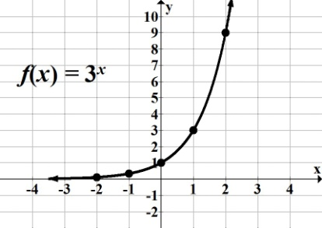

b.

|  |  |
| --- | --- |
| ***x*** | ***y*** |
| **0** | ${(1/3)}^{0}$**= 1** |
| **1** | ${(1/3)}^{1}$**= 1/3** |
| **2** | ${(1/3)}^{2}$**= 1/9** |
| **1** | **= 3** |
| **2** | **= 9** |

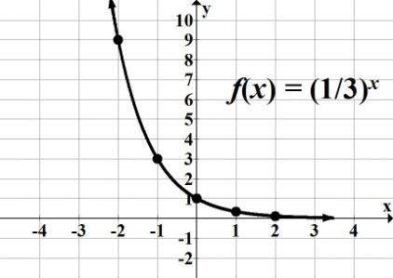

3. Does ) = have an inverse function?

**Yes, it is one-to-one; passes the horizontal line test**

4. Use the calculator to graph $f(x$) = $5{(3)}^{x}$ and $f(x$) = $\frac{1}{5}{(3)}^{x}$; compare each graph with that of $f(x$) = $3^{x}$. Find the vertical intercept for each graph.

 

**[-5, 5, 1] by [-2, 8, 1] [-5, 5, 1] by [-2, 8, 1]**

**Note: On each screen shot, dotted graph is the graph of $f(x$) = $3^{x}$; vertical intercept (0, 1)**

$f(x$**) = $5{(3)}^{x}$: graph is stretched by a factor of 5; vertical intercept (0, 5)**

$f(x$**) = $\frac{1}{5}{(3)}^{x}$: graph is compressed by a factor of 1/5; vertical intercept (0, 1/5) or (0, 0.2)**

5. Compare graphs of $f(x$) = $2^{x}$ and $f(x$) = $-2^{x}$.

$f(x$**) = $-2^{x}$ is equivalent to $f(x$) = $-1{(2)}^{x}$; reflection about the $x$-axis.**

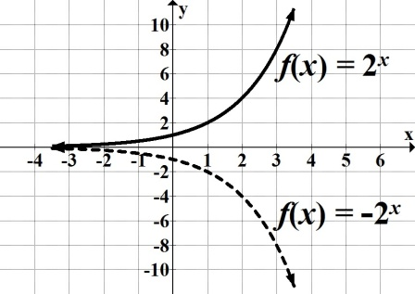

***Reminder*: $f(x$) = $-2^{x}$ ≠ $f(x$) = $(-{2)}^{x}$**

$f(x$**) = $(-{2)}^{x}$ would not be an exponential function, since it has a negative base.**

6. For each function, do the following without graphing: Find the vertical intercept and state whether it is an increasing or decreasing function.

a. $f(x)$ = $5{(3.2)}^{x}$

**Vertical intercept: (0, 5) $b =$ 3.2 Since 3.2 > 1 increasing**

b. $f(t)$ = $\frac{1}{4}{\left(\frac{8}{3}\right)}^{t}$

**Vertical intercept: (0, 1/4) $b =$ 8/3 Since 8/3 > 1 increasing**

c. $y$ = $0.8{(0.7)}^{x}$

**Vertical intercept: (0, 0.8) $b =$ 0.7 Since 0.7 < 1 decreasing**

d. $f(x)$ = $8^{x}$ = $1({8)}^{x}$

**Vertical intercept: (0, 1) $b =$ 8 Since 8 > 1 increasing**

e. $f(x)$ = ${\left(\frac{4}{3}\right)}^{-x}$ = ${\left(\frac{3}{4}\right)}^{x}$ = ${1\left(\frac{3}{4}\right)}^{x}$

**Vertical intercept: (0, 1) $b =$ 3/4 Since 3/4 < 1 decreasing**

7. State any transformations on each exponential function.

a. $f(x$) = $3^{x}+ 5$**Graph of $f(x$) = $3^{x}$ has been shifted 5 units up**

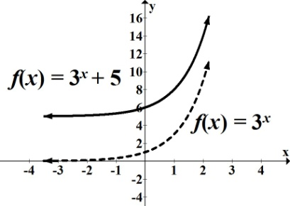

b. $f(x$) = $3^{x + 5}$ **Graph of $f(x$) = $3^{x}$ has been shifted 5 units left**

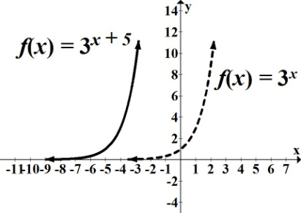

c. $f(x$) = $3^{x- 6}-2$ **Graph of $f(x$) = $3^{x}$ has been shifted 6 units right, 2 units down**

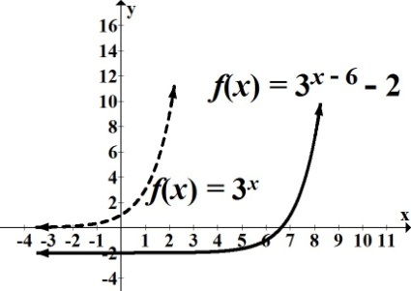

8. For each function, find the initial value and the growth or decay factor.

a. $P(t)$ = $2.4{(5.6)}^{t}$ $P_{0}$**= 2.4 growth factor = 5.6**

b. $N\left(x\right)$ = $21.3{(0.8)}^{x}$ $N_{0}$**= 21.3 decay factor = 0.8**

9. The number of Facebook active users in millions can be modeled by the function

*P*(*t*) *= $1.53(2.82)^{t}$* , where *t* is the number of years after 2004.

a. Identify and interpret $P_{0}$.

$P_{0}$**= initial value, that is, population at time = 0.**

$P_{0}$**= 1.53 Facebook had ≈ 1.53 million active users in 2004.**

b. Identify the growth or decay factor.

**Growth factor = 2.82**

c. Without graphing, determine whether the function is increasing or decreasing. Explain your

decision.

$b =$**2.82 Since 2.82 > 1 increasing**

d. Approximate the number of Facebook active users in 2008.

**We know *t* represents the number of years after 2004.**

**In 2008, $t$ ≈ 4. Therefore, $P(4)=$ $1.53(2.82)^{4}$ ≈ 96.756 ≈ 97 million active users**

e. Find the average rate of change in the number of Facebook active users between 2004-2008.

Round your answer to the nearest whole number.

**For 2004, $t$ = 0, and for 2008, $t$ = 4.**

$P(0)=$ $1.53(2.82)^{0}$ $=1.53 \left(1\right)= 1.53$**and $P(4)=$ $1.53(2.82)^{4}$ ≈ 97**

**So, we have the points $(0, 1.53)$ and $(4, 97)$.**

$\frac{∆y}{∆x}= \frac{97-1.53}{4 - 0}$**≈ 24 million active users**

10. For each of the following, identify the growth or decay factor; state the percent increase or decrease.

a. *P*(*t*) *= $5(1.25)^{t}$*

**Growth factor 1.25 ⇒ 1 + .25 ⇒ increase of 25%**

b. *N*(*t*) *= $210,000(1.015)^{t}$*

**Growth factor 1.015 ⇒ 1 + .015 ⇒ increase of 1.5%**

c. *P*(*t*) *= $8,700(0.98)^{t}$*

**Decay factor 0.98 ⇒ 1 $-$.98 ⇒ decrease of 2%**

d. *V*(*t*) *= $35,000(0.655)^{t}$*

**Decay factor 0.655 ⇒ 1 $-$.655 ⇒ decrease of 34.5%**