Review 5.1-5.3 (Key)

1. Determine if the graph represents a one-to-one function.
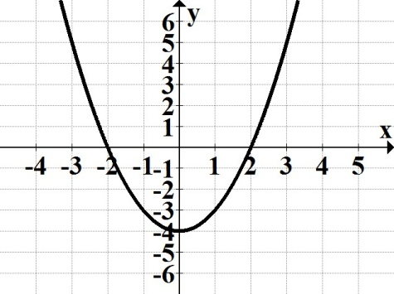

2. Determine if the graph represents a function that has an inverse; explain your decision.
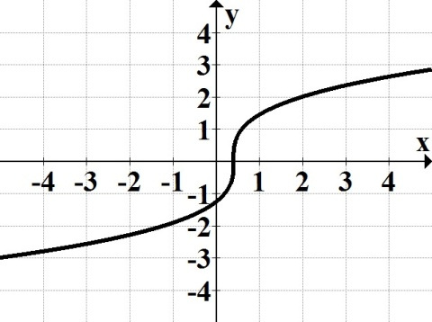

3. Given $\{(-2, 15), (-1, 7), (0, 5), (8, 12)\}$, find the domain of the inverse.

4. Find the inverse function for $f\left(x\right)$= $\frac{7x - 5}{9}$ .

5. Given the graph of $f(x)$, graph its inverse along with y = x; label the inverse $g(x)$.
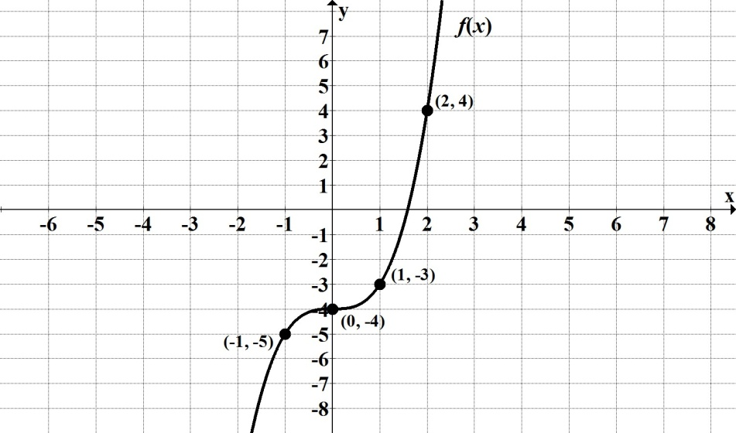

6. Luis bought a new car and the total loan (all charges included) is $$20,256$over a 48 month period. His monthly payment will be $422, with the outstanding amount denoted by
$f(x)$ = $20256 422x$, where $x$ is the number of months paid towards the loan.
a. Find $f(26)$ and interpret its meaning.
b. Find the inverse of the given function.
c. Find $f^{-1}(1266)$ and interpret its meaning.

7. Let $f\left(x\right)= x^{2}+5$ and $g\left(x\right)=6x-1$. Find the following. State any restrictions for $x$, when
applicable.
a. $(f-g)\left(x\right)$ b. $(fg)\left(x\right)$ c. $\left(\frac{f}{g}\right)(x)$
d. $(f+g)\left(-2\right)$ e. $(f g)\left(x\right)$ f. $(f g)\left(3\right)$

8. Let $f\left(x\right)=$ $\sqrt{x+3}$ and $g\left(x\right)=-x^{2}$. Find the following.
a. $(g f)\left(x\right)$ b. $(g f)\left(1\right)$
9. Use the graph below to evaluate ($g$◦ $f$)$(0)$.
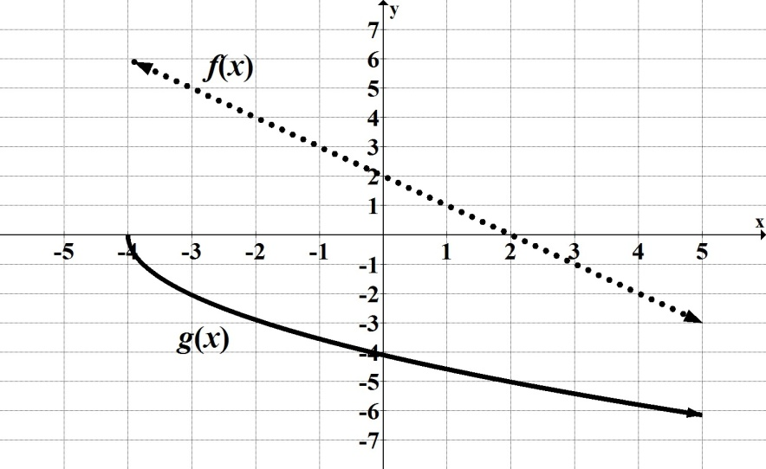

10. Determine if $f\left(x\right)= -4x+3$ and $g\left(x\right)=\frac{-x + 3}{4}$ are inverses of each other.

