Review 5.1-5.3 (Key)

1. Determine if the graph represents a one-to-one function.
The given graph does not represent a one-to-one function; it does not pass the horizontal line test. For example, if we examine the coordinates $x=3$ and $x=-3$, both x-values have
y-coordinate 5 (see graph below). In a one-to-one function, any two different inputs will produce two different outputs. So, a horizontal line cannot intersect the graph more than once, which is not the case here.
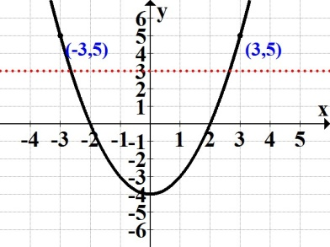

2. Determine if the graph represents a function that has an inverse; explain your decision.
The given graph represents a function that has an inverse; no horizontal line will intersect the graph more than once.
3. Given $\{(-2, 15), (-1, 7), (0, 5), (8, 12)\}$, find the domain of the inverse.
The inverse of the given function is found by interchanging the x-and y-coordinates:
$\{(15, -2), (7, -1,), (5, 0), (12, 8)\}$. The domain, D, of the inverse is D = {15, 7, 5, 12}

4. Find the inverse function for $f\left(x\right)$= $\frac{7x - 5}{9}$ .
Replace $f(x)$ with "y," interchange the x and the y, then solve the new equation for y; assign name $f^{-1}\left(x\right)$ to the resulting inverse function:
$y=$ $\frac{7x - 5}{9}$
$x=$ $\frac{7y - 5}{9}$
(9)$x=$ $\frac{7y - 5}{9}$(9)
$9x=7y-5$
$7y = 9x+5$
$y=\frac{9x + 5}{7}$
$f^{-1}\left(x\right)=\frac{9x + 5}{7}$
5. Given the graph of $f(x)$, graph its inverse along with y = x; label the inverse $g(x)$.
The graphs of a function and its inverse are symmetric about the line y = x. Therefore, since the points $\left(2, 4\right), \left(1, -3\right), \left(0, -4,\right), (-1, -5)$ lie on the graph of $f(x)$, we know that the points $\left(4, 2\right), \left(-3, 1\right), \left(-4, 0\right), (-5, -1)$ will lie on the graph of the inverse, $g(x)$.
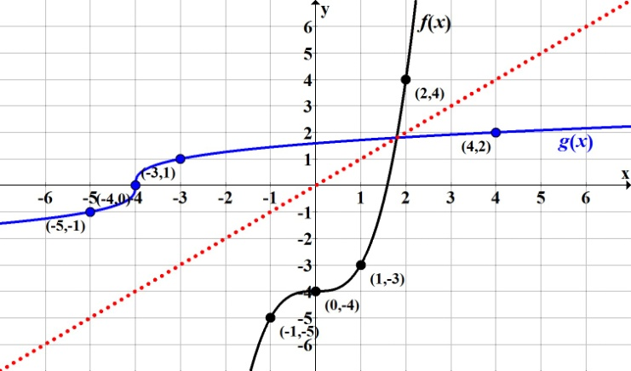

6. Luis bought a new car and the total loan (all charges included) is $$20,256$over a 48 month period. His monthly payment will be $422, with the outstanding amount denoted by
$f(x)$ = $20256 422x$, where $x$ is the number of months paid towards the loan.
a. Find $f(26)$ and interpret its meaning.
b. Find the inverse of the given function.
c. Find $f^{-1}(1266)$ and interpret its meaning.
a. $f(26)$ = $20256 422(26)$ = $9284$
After the 26th payment, the outstanding car loan amount is $\$9,284.$

b. $y$ $=$ $20256 422x$
$x$ $= 20256 422y$
$422y= 20256-x$
$y$ $=$ $\frac{ 20256 - x}{422}$
$f^{-1}(x)$ $=$ $\frac{ 20256 - x}{422}$
c. $f^{-1}(1266)$ = $\frac{ 20256 - 1266}{422}$ $=$ $45$
If the outstanding amount is $\$1266$, Luis has paid the loan for 45 months.
or
After the 45th monthly payment, the outstanding car loan amount is $\$1266.$

7. Let $f\left(x\right)= x^{2}+5$ and $g\left(x\right)=6x-1$. Find the following. State any restrictions for $x$, when
applicable.
a. $(f-g)\left(x\right)$ b. $(fg)\left(x\right)$ c. $\left(\frac{f}{g}\right)(x)$
d. $(f+g)\left(-2\right)$ e. $(f g)\left(x\right)$ f. $(f g)\left(3\right)$
a. ($f -$ $g$)($x$) $=(x^{2}+5$) $- (6x -1)=$ $x^{2}-6x+6$
b. ($f$ • $g$)($x$) $= (x^{2}+5$) $(6x -1)=$ ${6x}^{3}-x^{2}+30x-5$
c. $\left(\frac{f}{g}\right)(x)=$ $\frac{x^{2} + 5}{6x - 1}$ , $x≠1/6$
Note: If $x=1/6$, then $6(1/6) -1$ $=0$, and we know division by zero is undefined.
d. $f\left(-2\right)= {(-2)}^{2}+5=9$ and $g\left(-2\right)=6\left(-2\right)-1= -13$
Therefore, ($f+$ $g$)($-2$) $=\left(9\right)+ \left(-13\right)= -4$
Note: Another option is to first find $(f+g)\left(x\right)$, then evaluate the resulting function at $x=-2$.

e. $(f g)\left(x\right)=f(g\left(x\right))$. This means function $g(x)$ will be the input for function $f(x)$.
$(f g)\left(x\right)=$ $f(6x-1$) = ${(6x-1)}^{2}+5$ = $3{6x}^{2}-12x+1+5$ = ${ 36x}^{2}-12x+6$
f. To find $(f g)\left(3\right)$, first evaluate the inside function "$g$" when $x=3$:
$g\left(3\right)=6(3)-1$ = 17
Now substitute the resulting value, 17, into "$f$" and evaluate:
$f\left(17\right)= {(17)}^{2}+5=294$
Note: Another option is to first find the composite function$(f g)\left(x\right)$, then evaluate the
resulting function at $x=3$.

8. Let $f\left(x\right)=$ $\sqrt{x+3}$ and$g\left(x\right)=$ $-x^{2}$. Find the following.
a. $(g f)\left(x\right)$ b. $(g f)\left(1\right)$
a. $(g f)\left(x\right)$ $=g\left(f\left(x\right)\right)=$ $g\left(\sqrt{x+3}\right)= -{(\sqrt{x+3} )}^{2}= -\left(x+3\right)= -x-3$
b. $f\left(1\right)=\sqrt{1+3}=\sqrt{4}=2$
$g\left(2\right)=-{(2)}^{2}=-\left(4\right)=-4$

9. Use the graph below to evaluate ($g$◦ $f$)$(0)$.
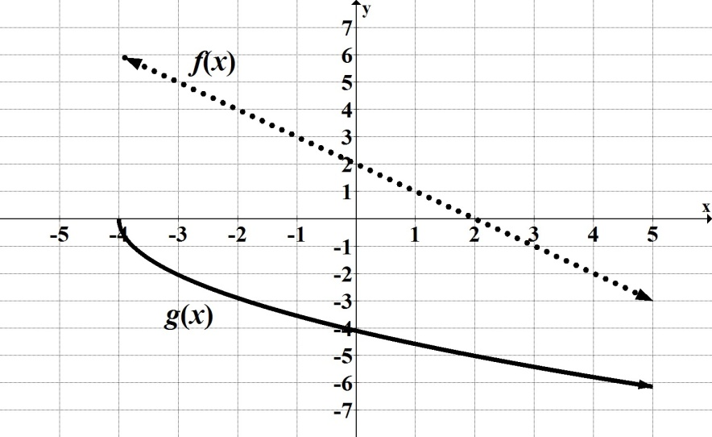

First, find $f(0)$ from the graph: $f\left(0\right)=2$
Now, evaluate function "$g$" at $x=2$, that is, find $g(2)$ from the graph: $g\left(2\right)=-5$
Therefore, ($g$◦ $f$)$\left(0\right)= -5$.

10. Determine if $f\left(x\right)= -4x+3$ and $g\left(x\right)=\frac{-x + 3}{4}$ are inverses of each other.
The functions are inverses of each other if and only if $\left(f g\right)\left(x\right)=x$and $\left(g f\right)\left(x\right)=x$.

($f$◦ $g$)$\left(x\right)=f(g\left(x\right))$
$f\left(\frac{-x + 3}{4}\right)=$ $-4\left(\frac{-x + 3}{4}\right)$ $+ 3 =-1\left(-x+3\right)+ 3=x-3+3=x$

and

($g$◦ $f$)$\left(x\right)=g(f\left(x\right))$
$\frac{-\left(-4x + 3\right) + 3}{4}$ $= \frac{4x -3 + 3}{4}= \frac{4x}{4}=x$

Therefore, the given functions are inverses of each other.

