Review 4.1-4.3

1. Solve by factoring: ${4x}^{2}=20x$
2. Solve by the square root method: ${(x-1/4)}^{2}$ $-$17 = 0
3. The graph of a quadratic equation is given. Find any possible solution(s).
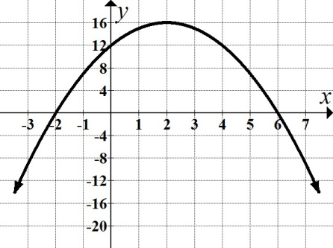
4. Given the equation ${2x}^{2}+5x-2=0$, find the discriminant and state the nature of the solution(s).
5. Do the following for the quadratic function $y =$ $x^{2}+x-6$. Round answer to 2 decimal places
where needed.
a. State the vertex. b. Find the $y$-intercept. c. Find any $x$-intercept(s). d. Graph the parabola.
e. Write the equation of the axis of symmetry f. State the domain and range.
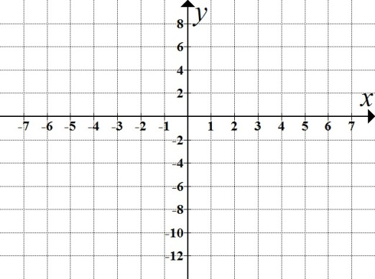
6. The height in feet, h, of a projectile after t seconds is given by $h(t)=-16t^{2}+132t.$
Use your graphing calculator to answer the questions:
a. When did the launched projectile reach ground level? Round answer to 2 decimal places.
b. During what interval(s) did the projectile reach an altitude of more than 182 feet?
Round answer to 2decimal places.

7. Use the graph below to find where $\left(x+3\right)\left(x-6\right)≥0$.
