*Review 4.1-4.3 (****Key****)*

1. Solve by factoring: ${4x}^{2}=20x$

**Set equation $=0$, factor nonzero side, and solve for *x*:**

**or**

**,**

2. Solve by the square root method: ${(x-1/4)}^{2}$ $-$ 17 $=0$

**Isolate squared variable term, apply square root property, simplify to solve for *x*:**

${(x-1/4)}^{2}$ $=17$

$\sqrt{{(x-1/4)}^{2} }=± \sqrt{17}$**Caution: Remember to insert " $±$" to obtain the 2 possible solutions**

**or**

3. The graph of a quadratic equation is given. Find any possible solution(s).

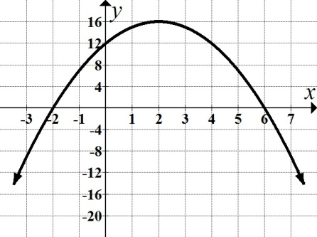

**Look for the *x*-value(s) where the graph intersects the *x*-axis: and**

4. Given the equation ${2x}^{2}+5x-2=0$, find the discriminant **and** state the nature of the solution(s).

**Discriminant is given by: $b^{2}-4ac$**

$b^{2}-4ac$**> 0, two distinct real solutions**

$b^{2}-4ac$**< 0, no real solutions (complex roots)**

$b^{2}-4ac$**= 0, one real solution (double root)**

${2x}^{2}+5x-2=0$ $a = 2, b = 5, c = -2$

$5^{2}-4\left(2\right)\left(-2\right)=41$**Discriminant is positive; two distinct real solutions**

5. Do the following for the quadratic function $y=$ $x^{2}+x-6$. Round answer to 2 decimal places

where needed.

a. State the vertex. b. Find the $y$-intercept. c. Find any $x$-intercept(s). d. Graph the parabola. e. Write the equation of the axis of symmetry f. State the domain and range.

**a. *x*-coordinate: $x=-\frac{b}{2a}$ $x=$ $-\frac{1}{2(1)}$ = $-$ 1/2**

***y*-coordinate: *y $=$ ${(-1/2)}^{2}+\left(-\frac{1}{2}\right)-6=\frac{1}{4}-\frac{1}{2}- 6= -25/4$***

**Vertex: $(-1/2, -25/4 )$ or $(-0.5, -6.25)$**

**b. *y*-intercept: Let *x* = 0 and solve for *y*: *y $=$ ${(0)}^{2}+(0)-6$ $(0, -6)$***

**c. *x-*intercept: Let *y* = 0 and solve for *x*:**

$x^{2}+x-6$**= 0**

$\left(x+3\right)(x-2)$**= 0**

$x=-3$**, $x=2$**

$(-3, 0)$**and $(2, 0)$**

**d. Graph:**

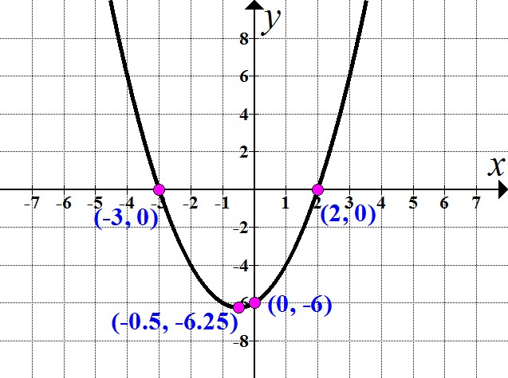

**e. Equation of the axis of symmetry: Vertical line passing through the vertex**

**Vertex is ($-$ 0.5, $-$ 6.25); the equation of the axis of symmetry is $x=$ $-$ 1/2 or $x=-0.5$**

**f. Domain: Possible value of the input (*x*-values) ($-∞,∞)$**

**Range: Possible value of the output (*y*-values) [**

6. The height in feet, *h*, of a projectile after *t* seconds is given by $h(t)=-16t^{2}+132t.$

Use your graphing calculator to answer the questions:

a. When did the launched projectile reach ground level? Round answer to 2 decimal places.

b. During what interval(s) did the projectile reach an altitude of more than 182 feet?

  Round answer to 2decimal places.

**a. Ground level: height = 0**

**Look for value(s) of *t* when $-16t^{2}+132t$ $=0$**

***Solving Algebraically:***

**($-$ 4*t*)(4*t $-$* 33) = 0**

$-$**4*t* = 0 or 4*t $-$* 33 = 0**

***t* = 0 or  *t* = 8.25**

**The projectile reached ground level at 8.25 seconds.**

**(Caution: 0 seconds would imply height of the projectile *before* it was launched!)**

***Solving Graphically:***

**Hint for window: Vertex will give us highest point of the graph**

***t* = $-b/2a$*t* = $-$ ($132)/2$ ($-16$) $t = 4.125$**

$h(t) =$ $-16{(4.125)}^{2}+132(4.125)= 272.25$

**Let Y1 = height equation, and Y2 = ground level; find intersection when launched projectile**

**reached height of zero feet.**

  

 **The projectile reached ground level at 8.25 seconds.**

**b. Altitude more than 182 feet:**

**Let Y1 = height equation, and Y2 = 182**



**There are 2 times when the launched projectile reached a height of 182 (on its way up,**

**and again on its way down):**

 

**Therefore, the projectile reached an altitude of *more than* 182 feet between 1.75 and 6.5**

**seconds, or during the interval (1.75, 6.5).**

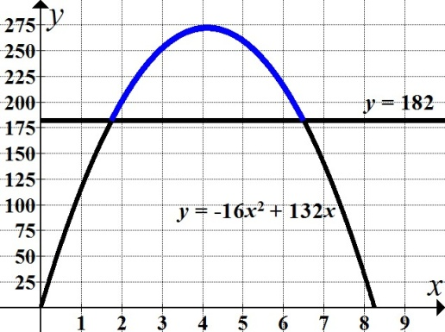

7. Determine where $\left(x+3\right)\left(x-6\right)≥0$.

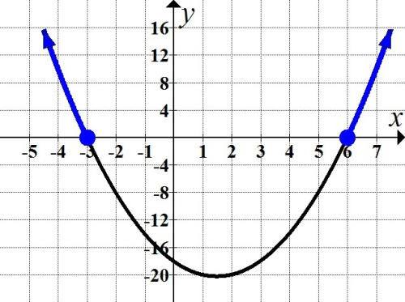

**The graph is above *or* on the *x*-axis at these intervals: $(-∞$, $-3]$ $∪[6,∞)$**