Review 1.4-1.5

1. Given the graph that follows, answer the following:
a. Find f($-$4) b. Find the input(s) when f(x) = 4 c. Find the value(s) of x for which f(x) = 0 d. Estimate the increasing and decreasing intervals.
e. For what x-value(s) is f(x) $>$ 0? f(x) $≤ -$6? Write your answers using interval notation.
f. Estimate the domain and range from the graph. Write your answers using interval notation.
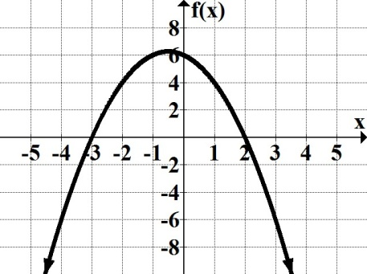

2. The graph below shows the path of a model space rocket launched upward from the ground at
an initial velocity of 128 feet per second. Its height, h, at t seconds, can be modeled by
$h(t)=-16t+128t$.
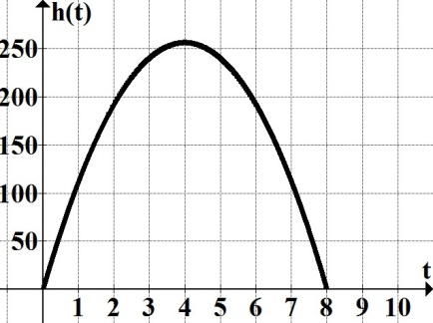
a. Use the graph to evaluate h(6.5) and explain its meaning in the context of the problem.
b. Find the horizontal intercepts and explain the difference between these coordinates in terms of
the problem.
c. State the ordered pair associated with h(4) = 256, locate the corresponding point on the graph and
explain its meaning in the context of the problem.

3. In 2009, Verizon Wireless was offering a $39.99 per month plan which included 450 anytime
minutes. If the customer exceeded 450 minutes, the monthly bill would include a $0.45 per
minute overage charge. As of 2014, new more practical plans were being offered.
a. Suppose that the 2009 cell phone total charge can be modeled by a linear function. Find the
equation of the linear function that models this problem.
b. Find the total charge for 12 minutes after the allowed minutes.
4. Find the equation in slope-intercept form of the line that passes through ($-$1, 4) and has the following properties:
a. Parallel to the line passing through (3, 6) and ($-$4, $-$8).
b. Perpendicular to x + 4y = 8.

5. True or false: y = 3 and y = $-$1/3 represent perpendicular lines. Explain your decision.

