*Review 1.1-1.3*

1. Find the *x*-and *y*-intercepts of the equation $-$ 2*x* +  = 10. Write the answer in ordered pair form.

2. Given that a line has intercepts ($-$ 30, 0) and (0, 125), which of the following viewing windows will be the most appropriate?

a. [$-$ 35, 10, 5] by [$-$ 30, 120, 20] b. [$-$ 40, 40, 10] by [$-$ 30, 130, 20]

3. Find the slope of the line passing through the points (3, $-$ 4) and (5, 7).

4. A jewelry crafter charges a design fee of $25 for fine earrings and sells each pair for $169. The total cost for the earrings, *y*, can be represented by the equation *y* = 169*x* + 25, where *x* represents the number of pairs of earrings.

a.  Find the slope or rate of change of the total cost equation, and explain its meaning in the context

of this problem. Answer in a complete sentence.

b. Find the vertical intercept (*y*-intercept) and explain its meaning.

5. The graph below shows the amount of gasoline, *g*, left in the tank fuel of a 5-gallon portable generator after running for *h* hours.

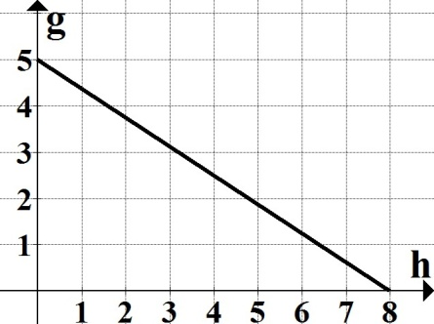

a. Find both intercepts and explain their meaning in the context of this problem

b. Find the slope, to the nearest tenth, and explain its meaning.

c. Write the equation of this line in slope-intercept form. (Use the variables as stated in the problem.)

6. Determine if the following represents a function. Explain why or why not.

|  |  |  |  |  |  |
| --- | --- | --- | --- | --- | --- |
| *Number of questions answered correctly* | 1 | 18 | 10 | 15 | 27 |
| *Score* | 15 | 36 | 22 | 36 | 87 |

7. If , find .

8. Find the domain and range of the functions. Write each answer using interval notation.

a. *y* =  b. *y* =