What is a web page?
- A web page document (usually in hyper text markup language) plus
- Links to a background plus
- Links to pictures plus
- Links to any sounds or movies.

Web page document


b
background
Image 01 file

sound 01 file
<html>
<head>
</head>
<body>
</body>
</html>
Html text



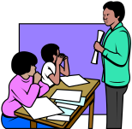


Image 02 file
Image 03 file
Image 04 file
Image 04 file
Creating a Web Page Using MicroSoft FrontPage

Basic Instructions:
- What is a Web Page?
A web page is a hypertext document that includes text and links to other items. The hypertext protocol used is called “html” (hyper text markup language). Without getting into details of html language, it is important to realize two features.
- The text of a web page is saved in a plain text format with special tags that give instructions on how it should be displayed.
- These tags also include the instructions on how to show pictures, movies and sounds. These text files with tags are interpreted by the browser so that you se the finished results.
- The browsers most frequently used are Internet Explorer and Netscape navigator. In addition to interpreting your page visually, the browser gives you the ability to locate web pages by their address or URL. Normally, the URL will start with http://, and will end with the file name “name.html”.
- The web page is the basic building block in a website. They contain multiple web pages linked to each other. One web page becomes the opening or central page. We usually call this the homepage. Its actual file name is usually “default.htm” or “index.htm"”
- In the project three assignment, you are designing a SINGLE PAGE – NOT A SITE!
- Even though this is a single page on the web, it actually takes several files to make it display properly. Each picture, movie or sound must be saved as a separate file. With the html language, you are able to link these files so that they display as a single web page.
- Originally all web pages were created in html language using a simple text editor. They were then viewed in a browser to see how they would be displayed. Obviously, this requires a very technical knowledge of the language and the ability to code the page without seeing what it actually looks like.
- There are a number of visual web creation programs available such as Microsoft FrontPage, Macromedia Dreamweaver and Adobe GoLive. We will be using Microsoft FrontPage. The visual programs like this make it more like using a word processor. Even Microsoft Word can be used to create web pages, but it is not usually advisable.

- Your web page is actually several files. In your projects you should have at least seven files. The basic page is a “html” document, that links to each photo, movie, sound or any other item. That means that with your three photos will add 3 files. With your 2 animated gifs you add two more. And your background image will add one more.

- Open Microsoft FrontPage. Then, Go to the File Menu and select the New command. From options window that opens select, "New Page or Web", then “Blank Page”.

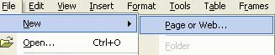

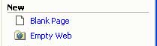

- Once the new untitled page opens, select Format Menu – and the Background command.
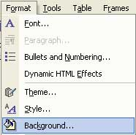
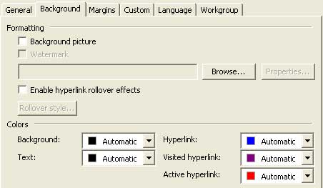
- Next select the "Background Picture" box. Next click on "Browse". Open the Shared Folder/eme2040/university_highschool files and select “backdrop.gif””. When you click

- Next click the Center button on your format toolbar.
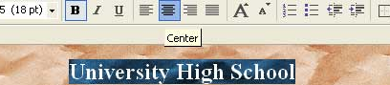
- Type in the name of your page (for Example, University High School). Now select the words you just typed and make the size be 18pt Bold (B).

- Press the "Return Key" several times to move down the page. Insert a picture of the school. Select Insert/Picture/From File. Then in the university_highschool files folder find “uhs_entrance.jpg”

- Press the return key once, then start typing “Meet the Staff”. Make the size about 14pt Bold.

- To insert a picture, first click the mouse at the point you want to start. Then click the "Insert Image" icon on the standard toolbar. A window opens that allows you to find the picture you want to insert.

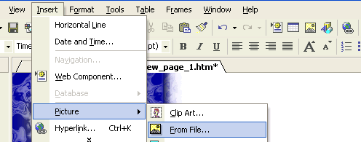

- When you bring in a picture, you can resize it by dragging the handles. In addition, you can create a frame around the picture. A picture can be set on a page so that type wraps around it on either side. Many images will allow you to select a single color in the photo that will be transparent so that you see the page background through it.
- Animated gifs are actually a series of still images saved in a single file that play one after another like a movie. You can insert them just like any still image. The animation will only show when you view the web page in a browser like Netscape Communicator of Microsoft Internet Explorer.

Next, create a table to hold pictures of your Staff. Select Table/Insert/Table

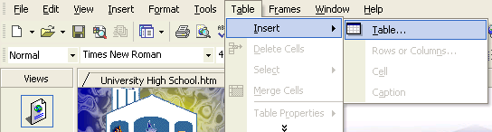
- Make 4 rows, 2 columns, width 65%, alignment Right.

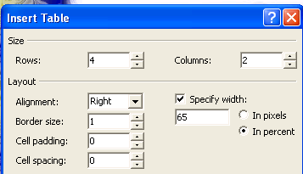

In rows 2 and 4 type: “Principal”, “Vice Principal” “Guidance Counselor” and “Athletic Director”.
(Pic: principal.jpg) | (Pic: viceprincipal.jpg)
Principal | Vice Principal
(Pic: guidance.jpg) | (Pic coach.jpg)
Guidance Counselor | Athletic Director

Resize the pictures to fit as much as possible.

- To create hypertext links (a link to any other site on the web), you first type text that will identify the site to the viewer.You can also use a picture or art image. Then select "hyperlink" icon on the standard toolbar
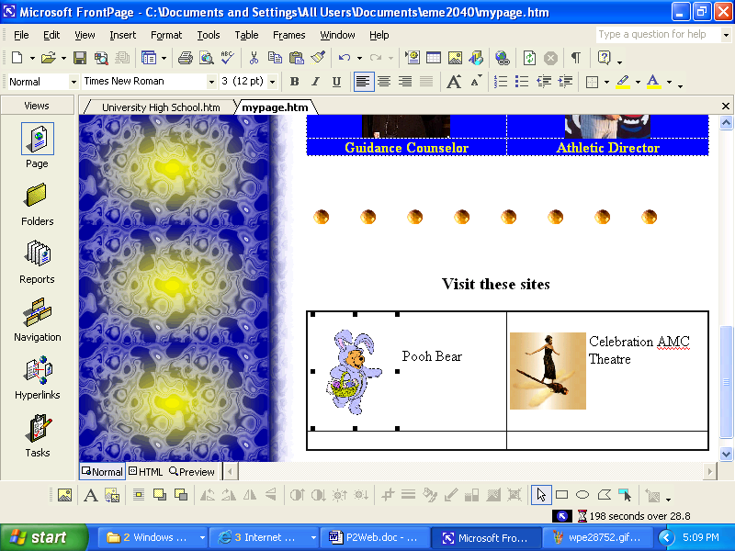

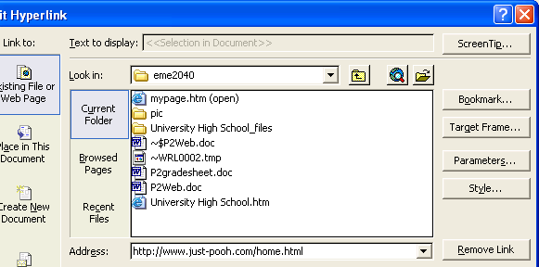
- When you click "OK" you return to the page, and the text is now underlined and color-coded to show that it links to a new location.
- Note: you will need to browse the internet find sites that would be suitable. I have given you a few References at the right. Be sure to use the full URL that starts with the http://www… . This helps to avoid problems later locating your file.

- Hyperlinks can also be created with pictures. In that case you would select an existing image on your page, then go to the linking tool (globe) and click on that image.

- There is even a special kind of hyperlink called an “Image Map” that allows you to make several links on one photo. You have a special tool to draw ovals or polygons in various parts of the image an assign separate links to each part. These shapes become invisible in the browser.

Saving your file
- Select File Menu – Save command. Name the file your first name + your last name, then a dot (.) + htm. For example, my file would be called: “Davidhaskins.htm”.
- Save the file on your 31/2 floppy disk A.
- Remember; put no spaces in the file name. I have created a special folder in our class folder for "web pages". Please save your file in this location.

HTML Guides & References

A Beginner's Guide to HTML
http://www.ncsa.uiuc.edu/General/Internet/WWW/HTMLPrimer.html

Florida Schools
http://www.fldoe.org/schoolmap/flash/regionalmap.asp?bhcp=1

Central Florida Schools
http://www.fldoe.org/schoolmap/flash/centraleastflorida.asp?bhcp=1

University High School
http://www.uhs.ocps.net/

Educational Technology Clearinghouse
The ETC is your starting point for links to educational resources for Florida's teachers.
http://etc.usf.edu/

