Slide 1 | 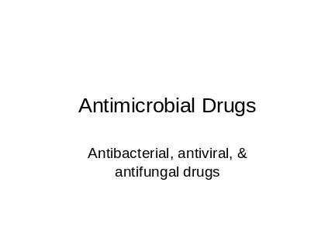
Slide 2 | 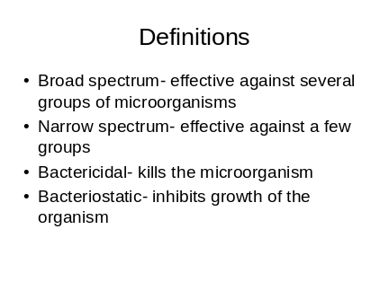 | Bacteriostatic depends on the hosts immune system to eliminate the bacteria and duration of drug therapy. If antibiotic is stopped early…the bacteria may grow and have been exposed to antibiotics
Slide 3 | 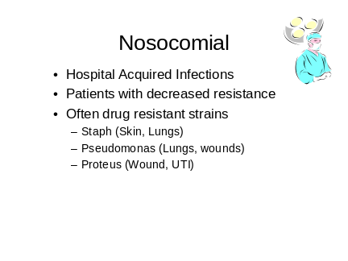
Slide 4 | 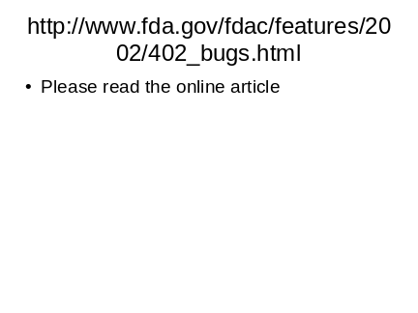
Slide 5 | 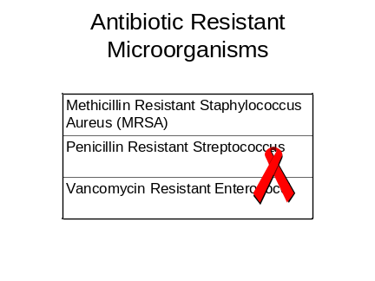
Slide 6 | 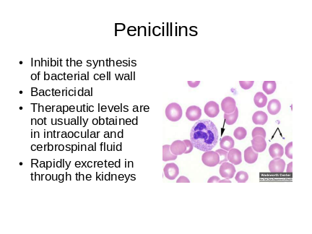 | Synthesis….creation of…what do you think would happen if the cell wall was not strong?  Gram positive streptococci pnuemonia
Slide 7 | 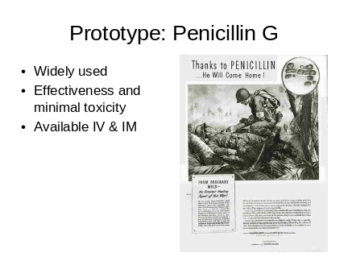 | Effective against strep, staph, gonococi, meningococci, treponema pallidum, & organism  Parenteral??? What does that mean
Slide 8 | 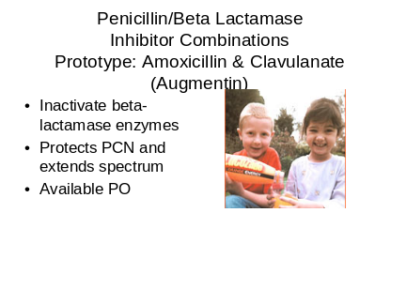 | Resistance to beta lactam antibiotics through penicillinase and cephalosporinase are enzymes that act on pcn
Slide 9 | 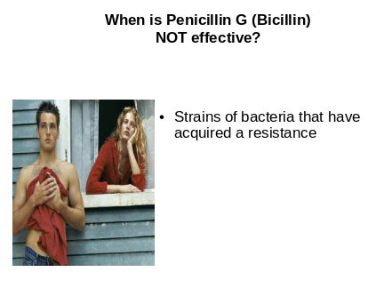
Slide 10 | 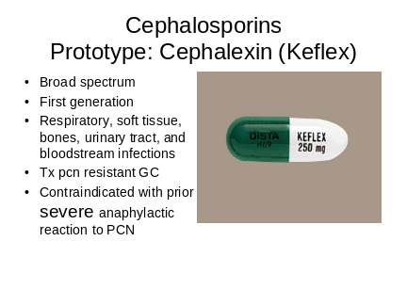 | Clinically important for gram negative infections  Cocci pcn cheaper and more effective  Chemically similar to pcn incidence of cross-sensitivity is low especially with delayed reactions  Pg 519 med error  There are many, many cephalosporins 4 generations, Many sound alike
Slide 11 | 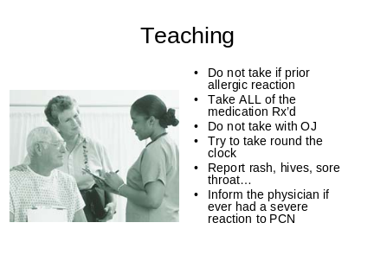
Slide 12 | 
Slide 13 | 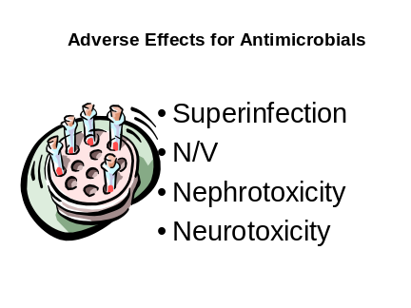
Slide 14 | 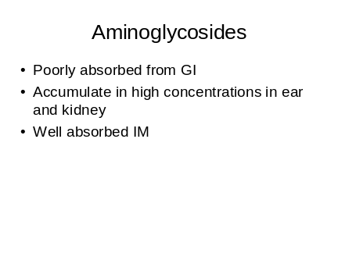 | How do you think we give them?
Slide 15 | 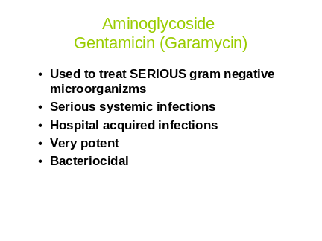
Slide 16 | 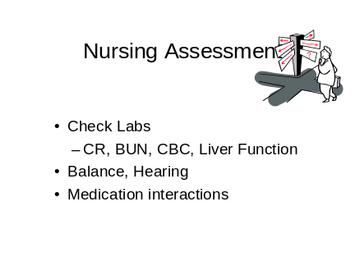
Slide 17 | 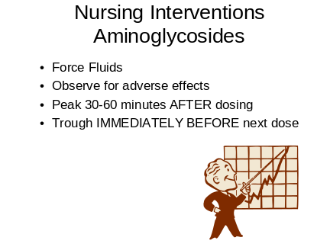
Slide 18 | 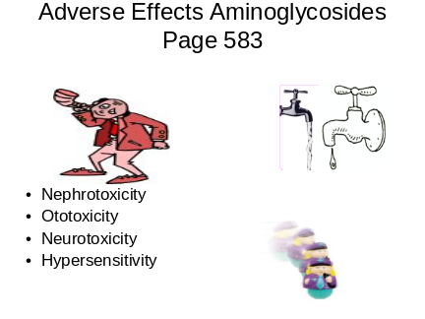
Slide 19 | 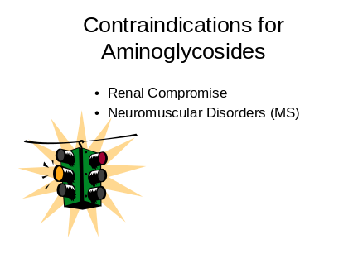
Slide 20 | 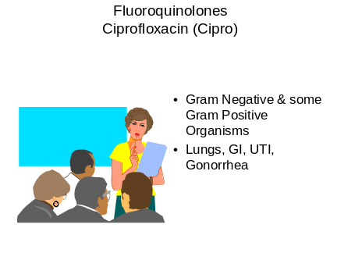
Slide 21 | 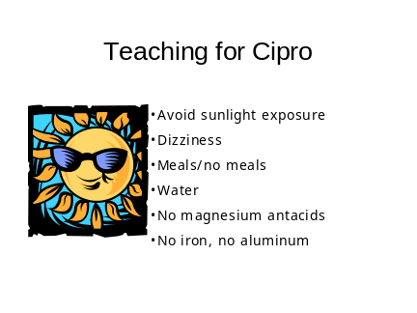
Slide 22 | 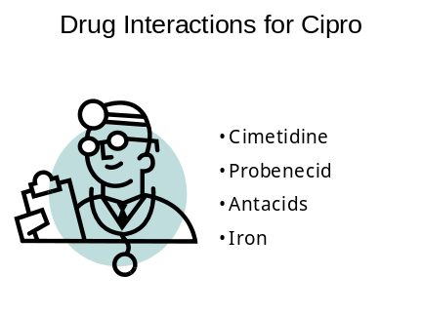
Slide 23 | 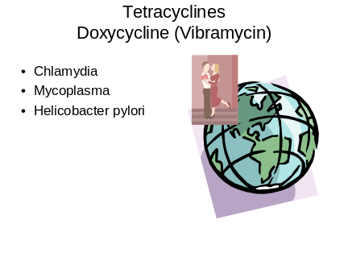
Slide 24 | 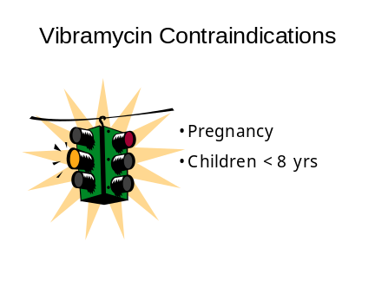
Slide 25 | 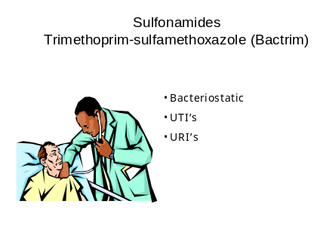
Slide 26 | 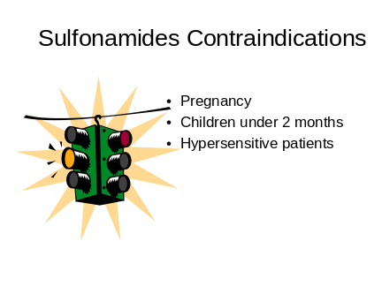
Slide 27 | 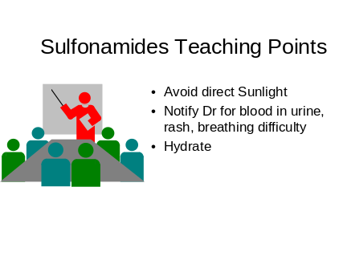 | Since sulfanimides inhibit rather than kill bacteria they MUST be taken as prescribed and for the full duration of therapy  Hydration prevents crytaluria
Slide 28 | 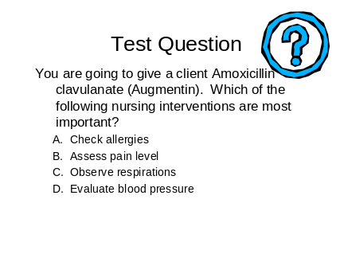
Slide 29 | 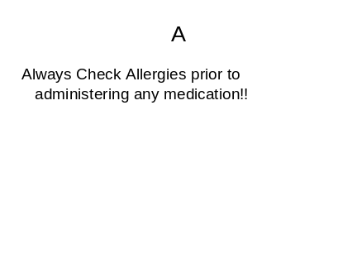
Slide 30 | 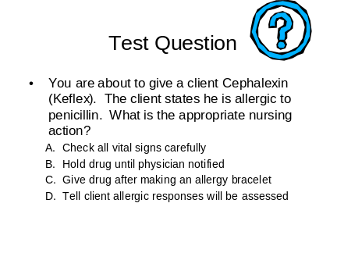
Slide 31 | 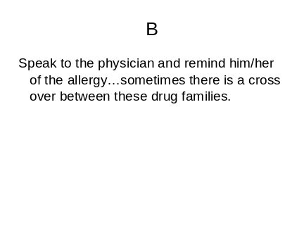
Slide 32 | 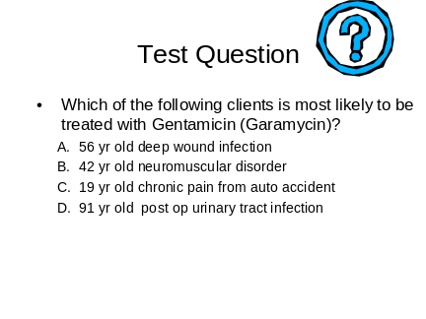
Slide 33 | 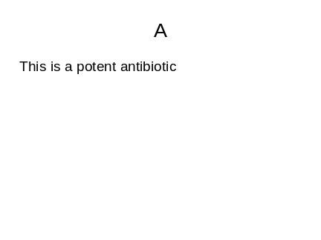
Slide 34 | 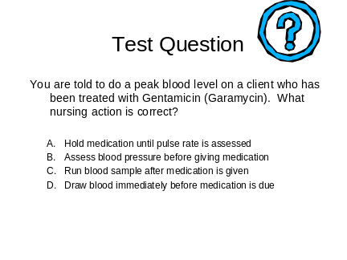
Slide 35 | 

