Slide 1 | 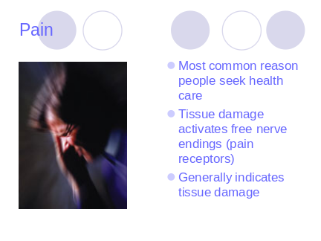 | Causes people to try to remove the cause of the pain or damage  Tissue damage may be chemical (inflammation ie bradykinen, histamine and prostaglandins or physical (heat, cold or pressure)
Slide 2 | 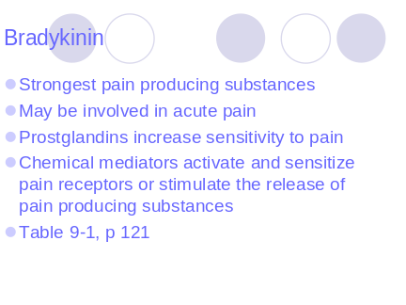
Slide 3 | 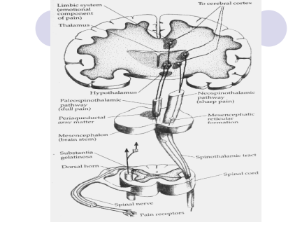 | Receptors are activated  Message transmitted to dorsal horn  Meanwhile the brain contains powerful descendint pathways that modify pain receptor input (increases in epinephrine and serotonin interupt or inhibit pain transmission)  At the thalamus pain sensation is not specific it is relayed to the cerbaral cortex for more specific analysis
Slide 4 | 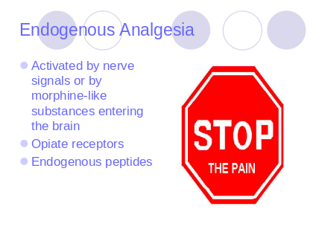 | What does endogenous mean?  The receptors are located in the CNS including ascending & decending pain pathways. Together the receptors and peptides inhibit pain transmission.
Slide 5 | 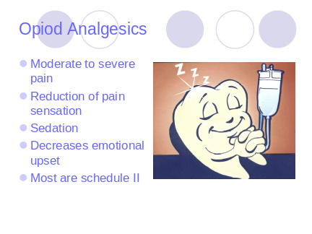 | Define schedule 2
Slide 6 | 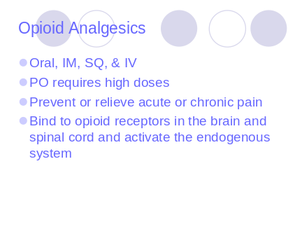 | PO first pass metabolism requires that the doses are very high, metabolized in the liver  Liver impairment may interfere with metabolism and kidney may interfere with excretion  Generally small to moderate doses relieve constant dull pain moderate to large for intermittent sharp pain  Give smaller dose if effective  More effective at the onset of pain parentaerally  Chronic on regular schedule  Give before coughing and deepbreathing or dressings  Long term use may be for malignant disease
Slide 7 | 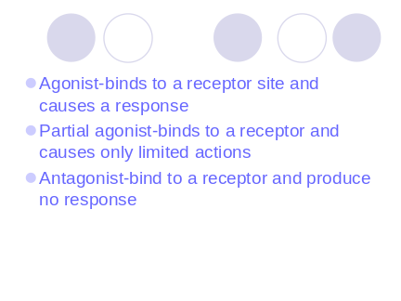
Slide 8 | 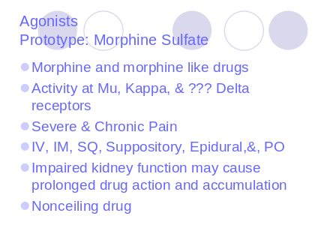 | After IV 10-20 minutes for respiratory depression and analgesia  Ineffective pain management…morphine is doc with severe pain  Nonceiling…no upperlimit don dosage for tolerance  May give non opiods with opioids in chrnic pain
Slide 9 | 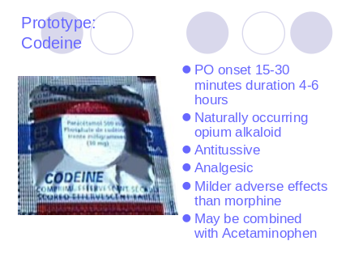
Slide 10 | 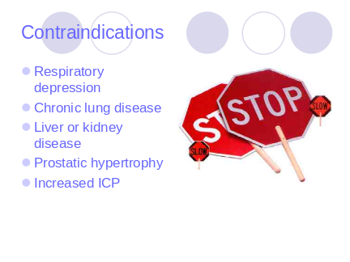 | Normal respiration?
Slide 11 | 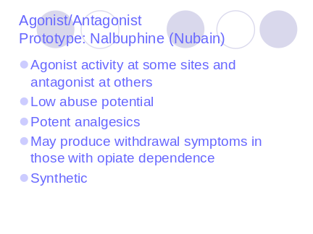
Slide 12 | 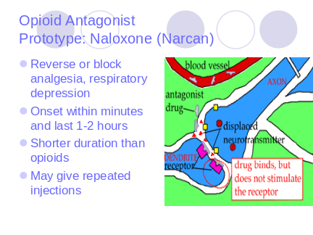 | If antagonists have a shorter duration than opioids…what does this mean in terms of dosing?
Slide 13 | 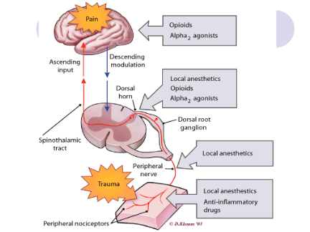
Slide 14 | 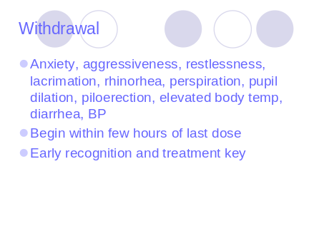 | Peak intensity 36-72 hours  May reduce dose gradually orMethadone to controle sx
Slide 15 | 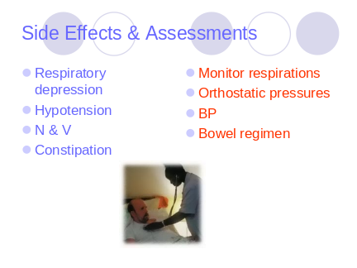
Slide 16 | 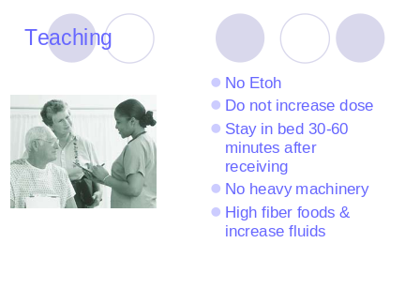 | If in hospital side rails up and call bell within reach
Slide 17 | 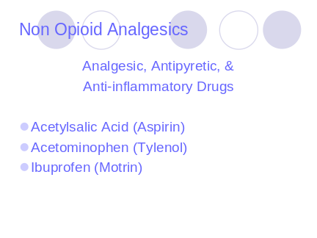
Slide 18 | 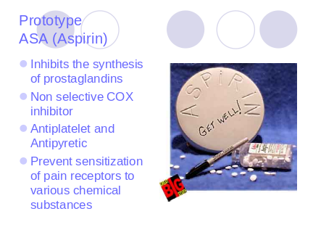 | Prostaglandins are chemical mediators that help regulated cell functions and participate in the inflammatory response to injury  Non selective…stomach upset
Slide 19 | 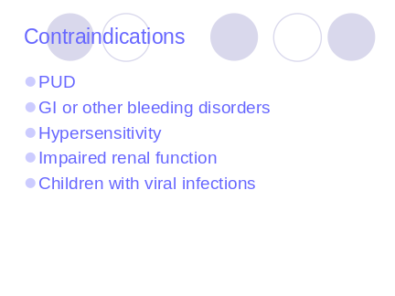
Slide 20 | 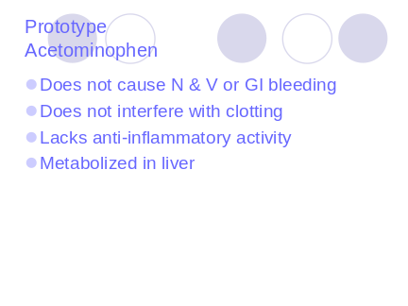 | Approximately 4 % is a toxic metabolite normally inactivated by conjoining with glutathione and excreted in a in acute or chroni or overdose glutathione may be depleted causing liver damage or fatal necrosis. ETOH amplifies the effect
Slide 21 | 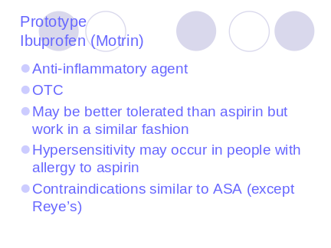
Slide 22 | 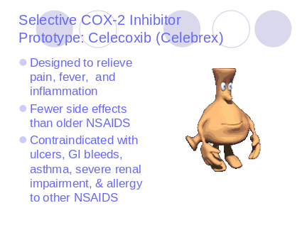
Slide 23 | 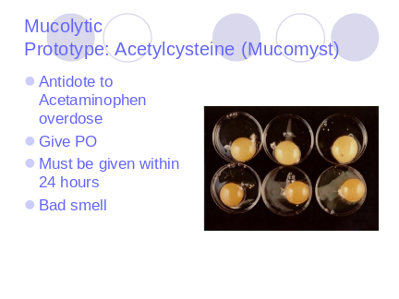
Slide 24 | 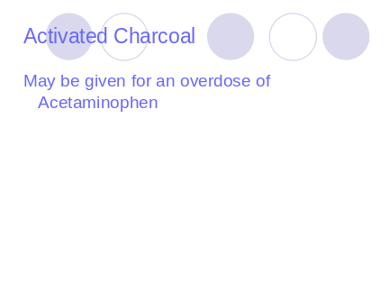
Slide 25 | 

